8thOctober 2018

S1 Parents’ Evening Thursday 25th Oct 4.30pm-6.30pm

Dear Parent/Guardian

We have introduced a new online booking system for our parents’ evenings to allow parents/guardians to book appointments with teachers.

The S1 parents’ evening will take place on Thursday 25th Oct starting at 4.30pm. Can I please ask you to follow the instructions below.

Go to https://parents-booking.co.uk/knightswood
PLEASE NOTE: You need to type this address into your website browser’s ‘address bar’. Do not try to ‘Google’ this website address or use a search engine as that will not work. This is a common mistake on phones and tablets especially.
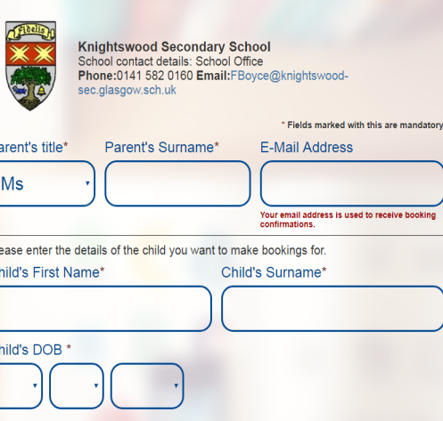

Login to see select the appointments that are convenient for you.

To login you will need to enter:
- Your Title (Mr/Mrs/Miss)and Surname
(These must match those we have on record for you for example
if you type in Ms instead of Miss you will not be able to log in)
- Your child’s first name, surname and date of birth

The system is live from 11th October and will be open to take your bookings until 24th October at 3.25pm.

Once you have logged in, we suggest you use the ‘Booking Wizard’ to make your parents’ evening appointments. Click onto the booking wizard. You will be shown your child’s name and their corresponding teachers. You will be asked to pick which appointment slots you would wish to book, before entering your availability. The wizard will use this information to calculate the best order for your appointments.

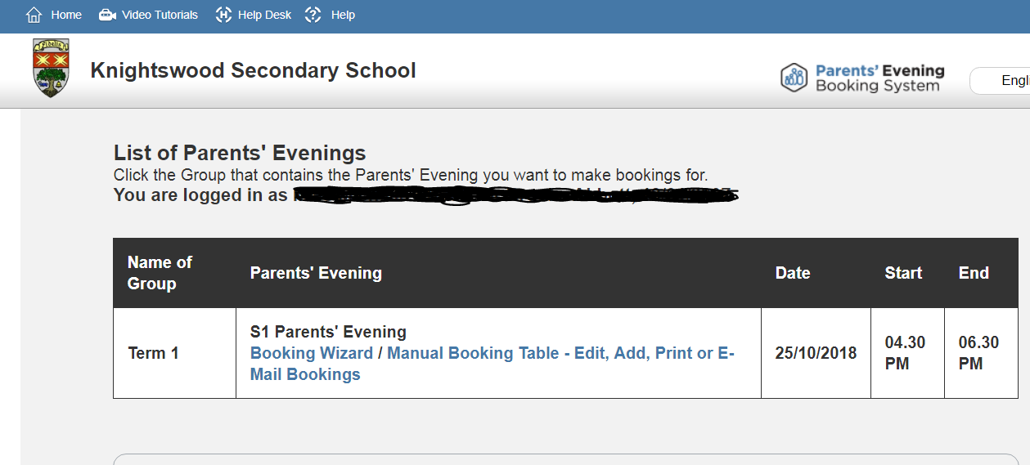

Troubleshooting Tips - please read before booking!

- To login you need to enter the details we have on record for you and your child. If you have recently changed your title or surname, for example, and not informed us, we will be expecting you to login with the details we have on record

- The email address you enter is only used to receive a confirmation of your appointment. If the system gives you an error when you login, it will not be the email address that is the problem

- If you do not want to use the booking wizard, you can make appointments one-by-one using the alternative ‘manual booking’ method listed on the page you’ll be shown after you login.

  - If you have several children to make bookings for, use the ‘Change Child’ button on the blue bar (above the school’s name) in the very top left corner of the web page to swap between your children. This is not necessary when using the Booking Wizard.

If you are unable to book your appointments at home please call the school office for help and assistance on

0141 582 0160

