Basic iPad Functions

This guide will help you when using your iPad, make sure to refer to it as many times as you need.

HOW TO MOVE APPS

You can move apps into any order by tapping and holding the app until a menu appears. You should then tap 'Edit Home Screen'. The apps will start to shake, and you will be able to drag them to anywhere on the screen.

COPY AND PASTE

To copy text, double tap on a word and use the blue dots to highlight all text you would like to copy. You should then tap the ‘Copy’ option in the bar which appears. Then tap where you would like to paste the text and another bar will appear with the option ‘Paste’.

HOW TO SPLIT YOUR SCREEN

This will allow you to view and use 2 apps at once. The second app which you wish to use must be in the Dock at the bottom of the screen.

Step 1 – Open an app.
Step 2 – Swipe up from the bottom of the screen to open the dock as shown below.
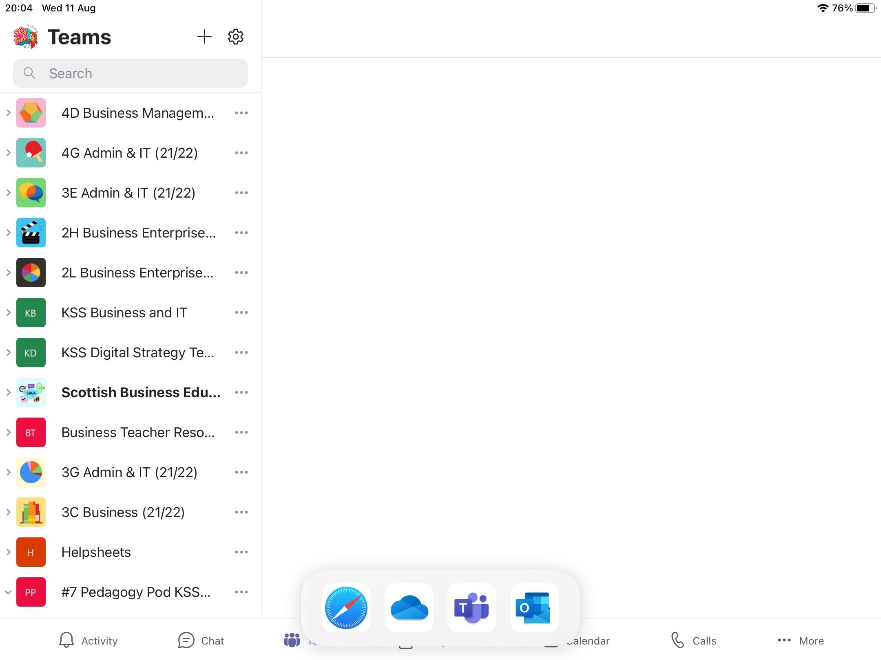
Step 3 – On the dock, touch and hold the second app you would like to open. You should then drag it onto the screen.
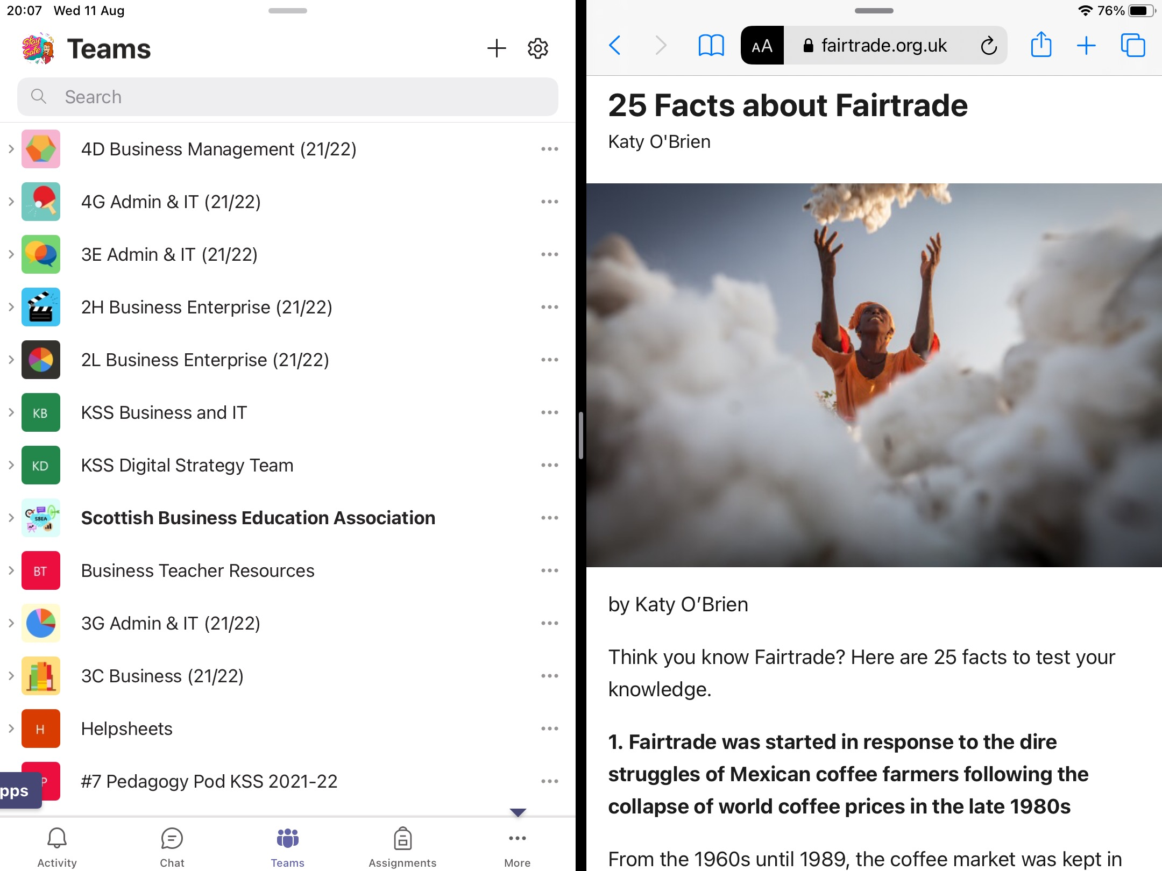

To close one of the apps, you touch and hold the black line in the middle of the screen and swipe to the left or right to close the app.

HOW TO RECORD YOUR SCREEN

You will be able to record your screen to take clips of videos or to show you completing a certain task.

To do this, you should follow the instructions below.

Step 1 – Open Settings.
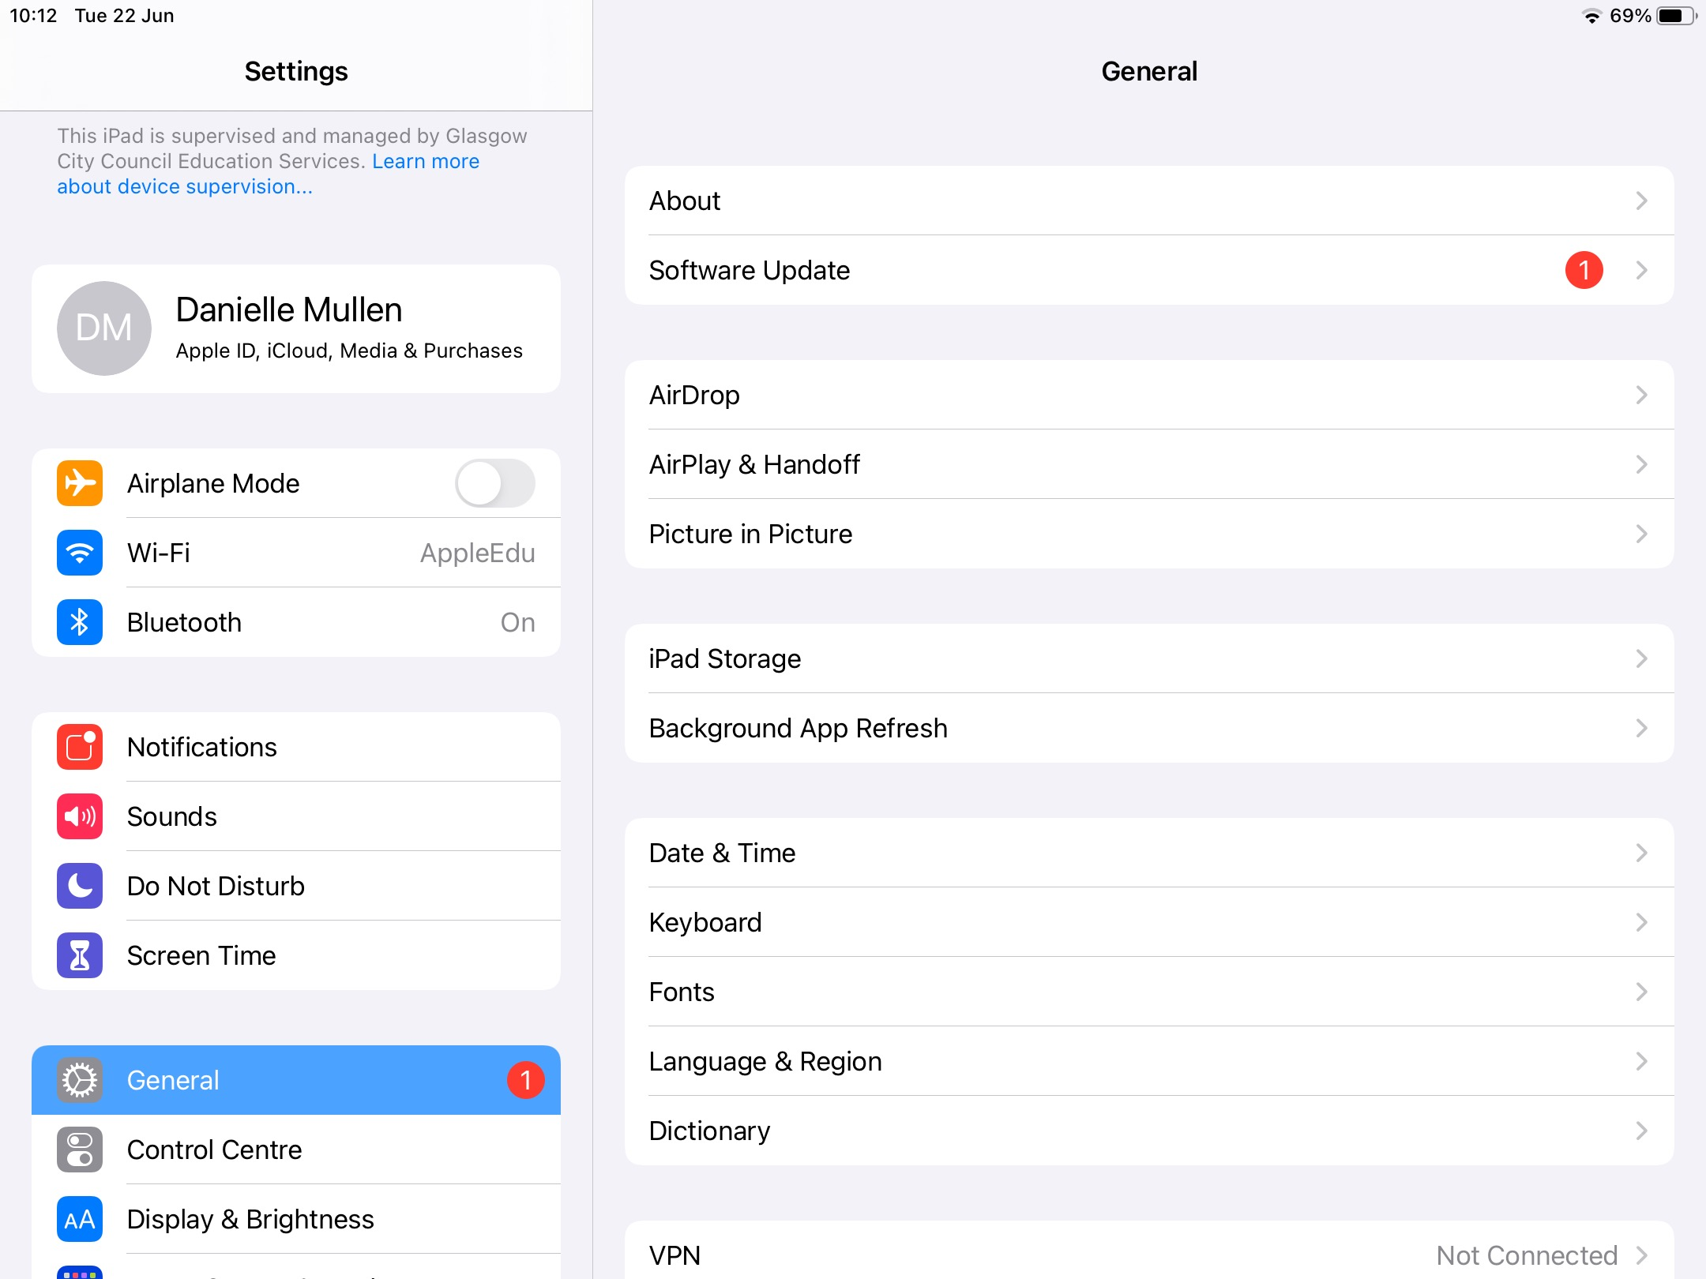

Step 2 – Go to the Control Centre and Press the '+' button beside 'Screen Recording'.
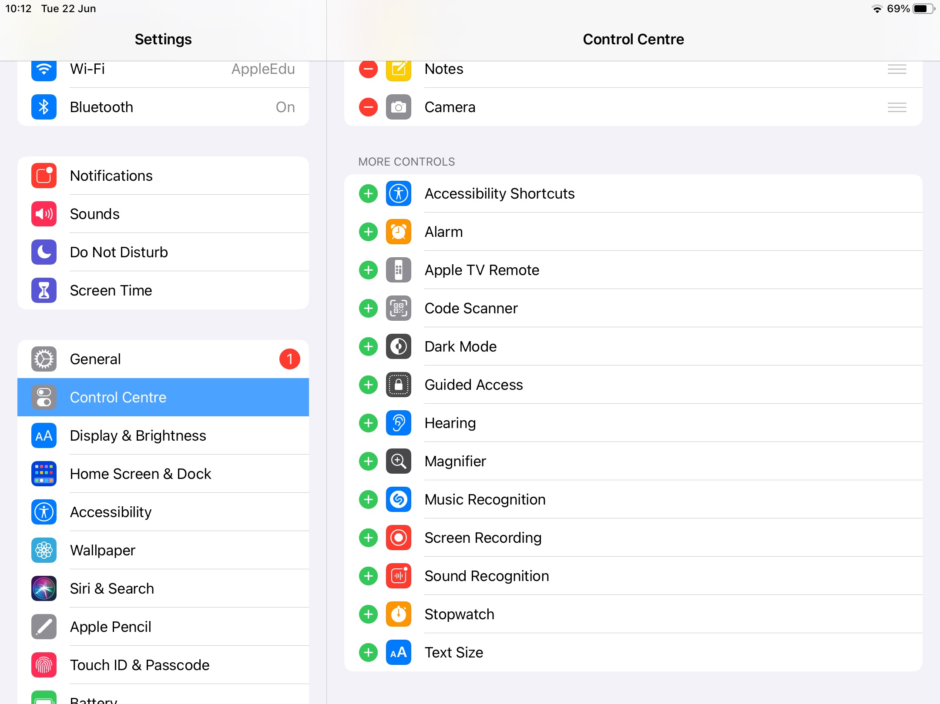

Step 3 – Pull down from the top right hand corner of your screen so that you can see the options below.
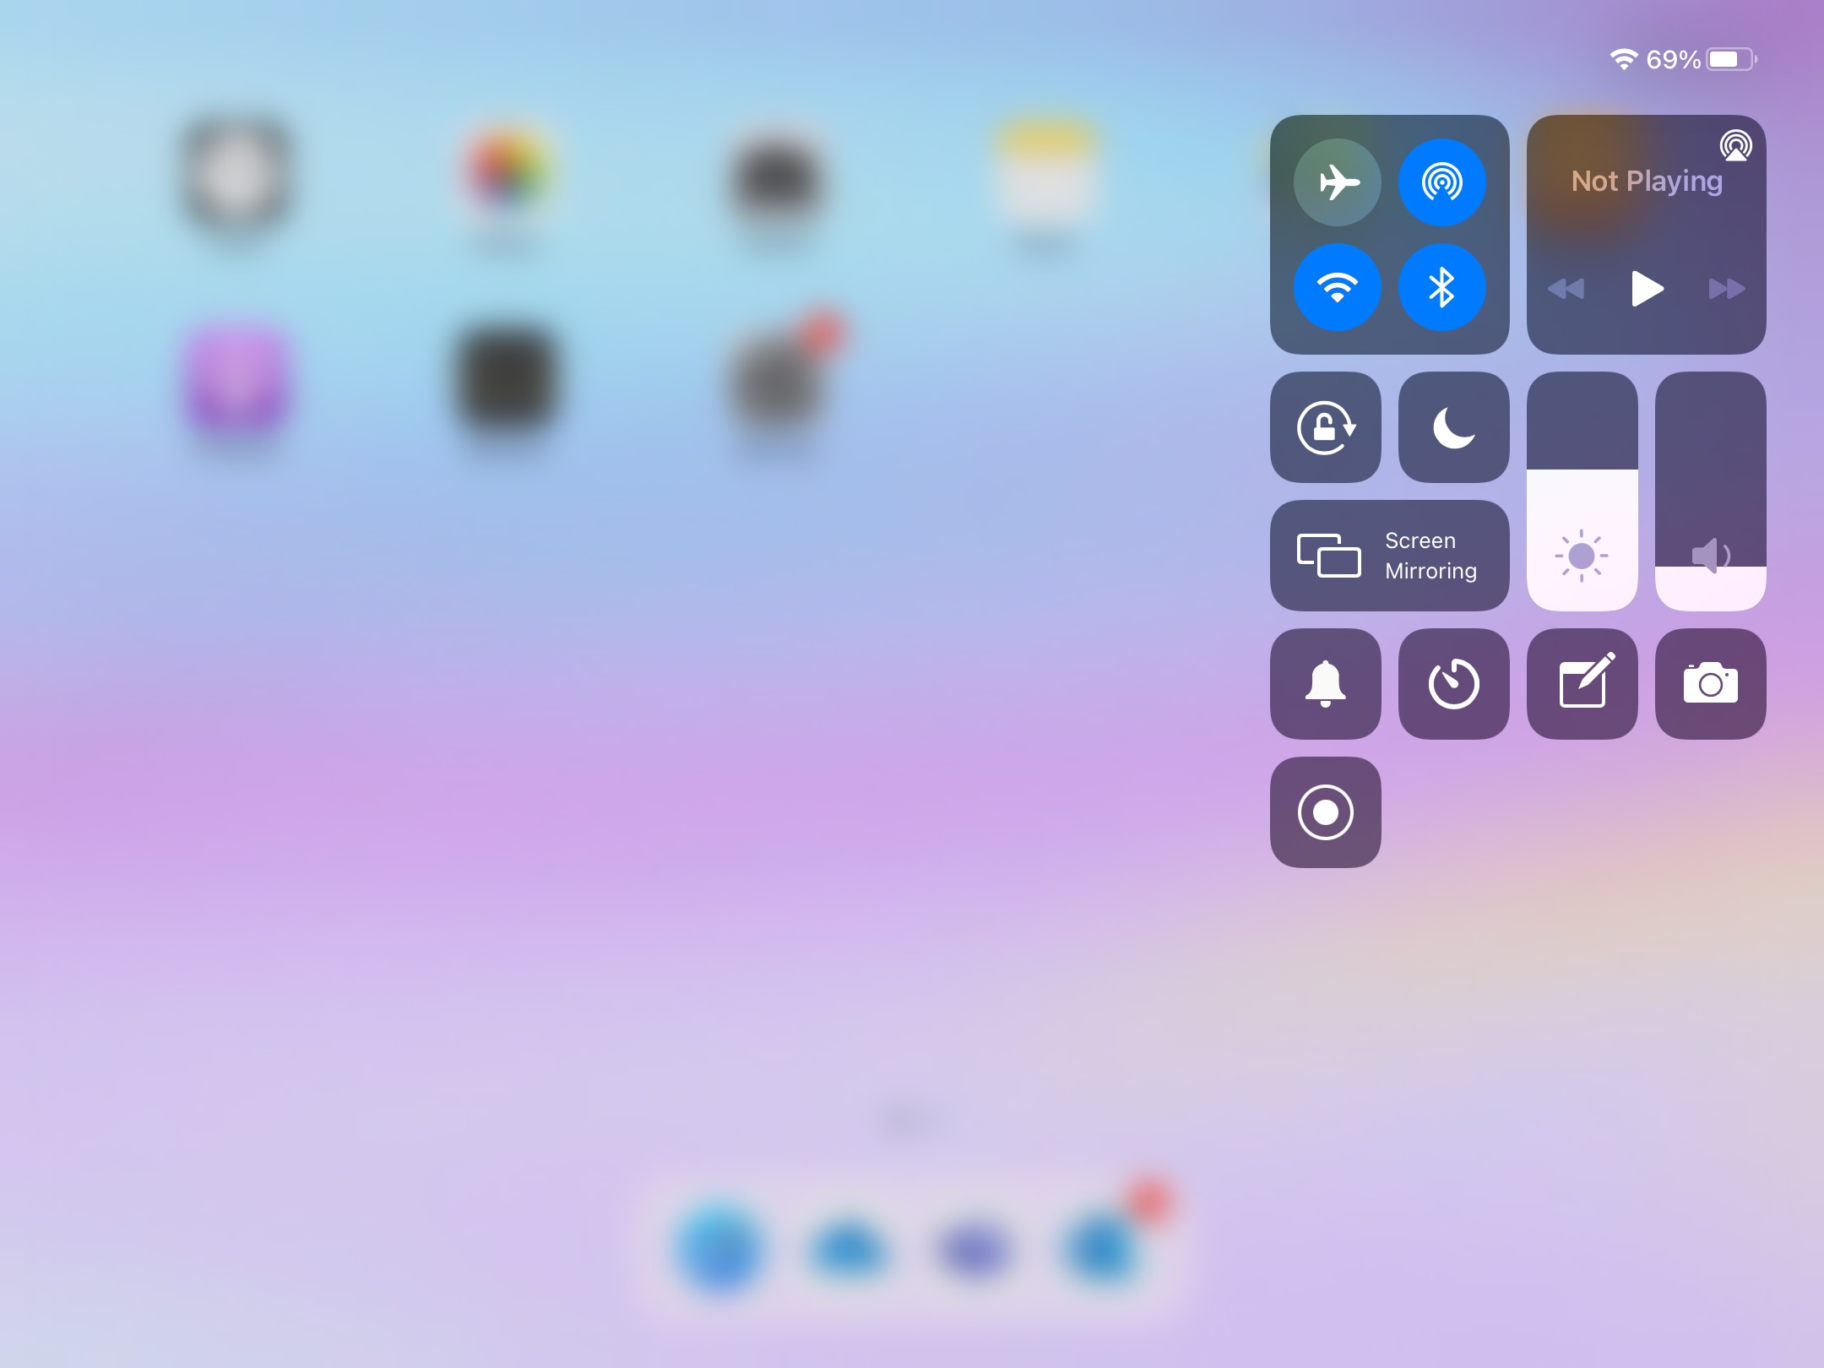

Step 4 – Tap the screen record button shown in the red circle. You will see a countdown and then your iPad will begin recording your screen.

Step 5 – When you have finished recording, press the red button at the top of your screen shown in the blue circle and press 'Stop'.
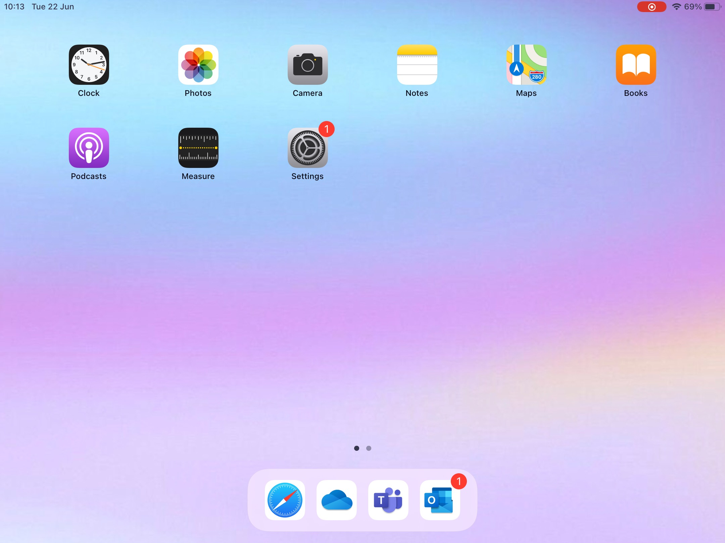
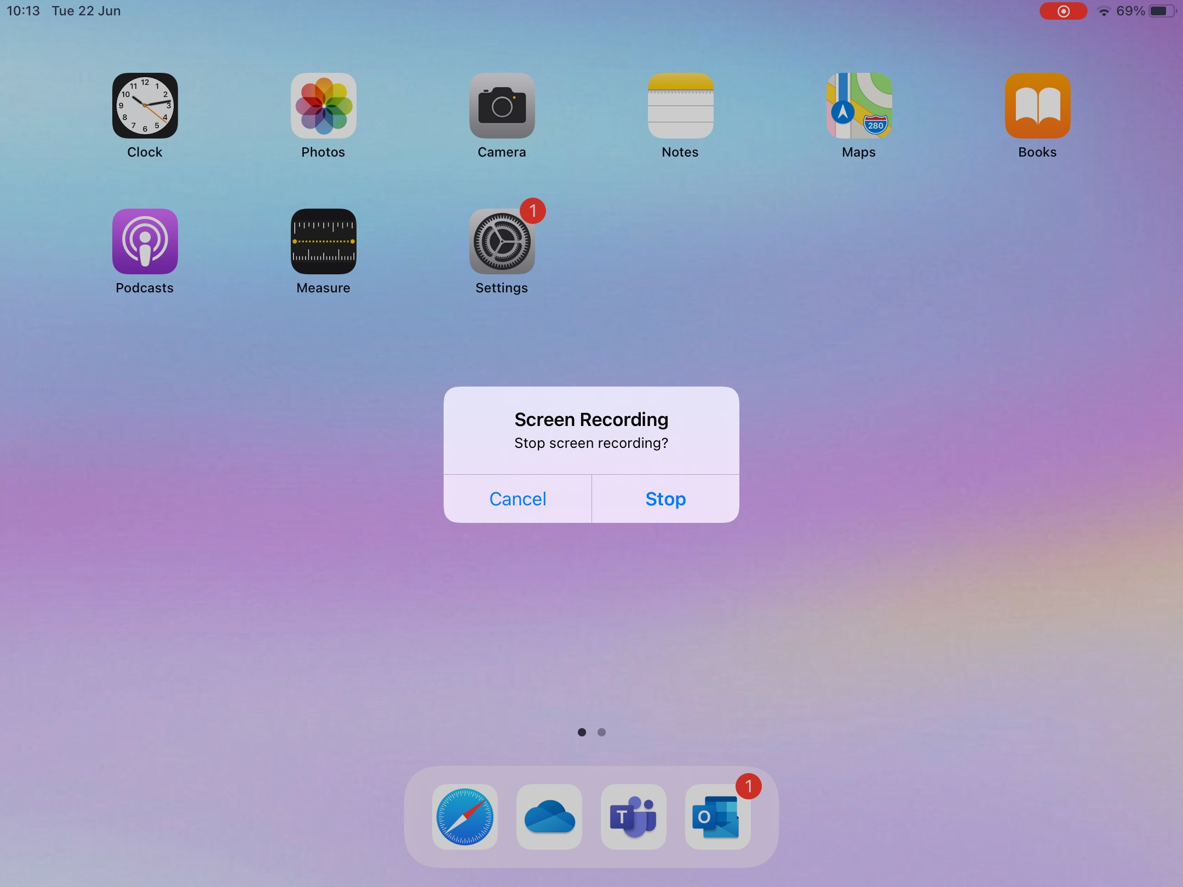

PROXY AUTHENTICATION ISSUES

IMPORTANT!
If you see this error message, do not ignore it.
You should complete the sign in using your username and password for the school computer.
This will allow you to access the internet.

SAVING FILES TO ONEDRIVE FROM MICROSOFT OFFICE APPLICATIONS

When using Microsoft apps to create documents, you should always save your files to your Glow OneDrive, this will ensure you can access them on both your iPad and any school computer.

Step 1 – Click on the 3 dots at the top to open a menu of options.

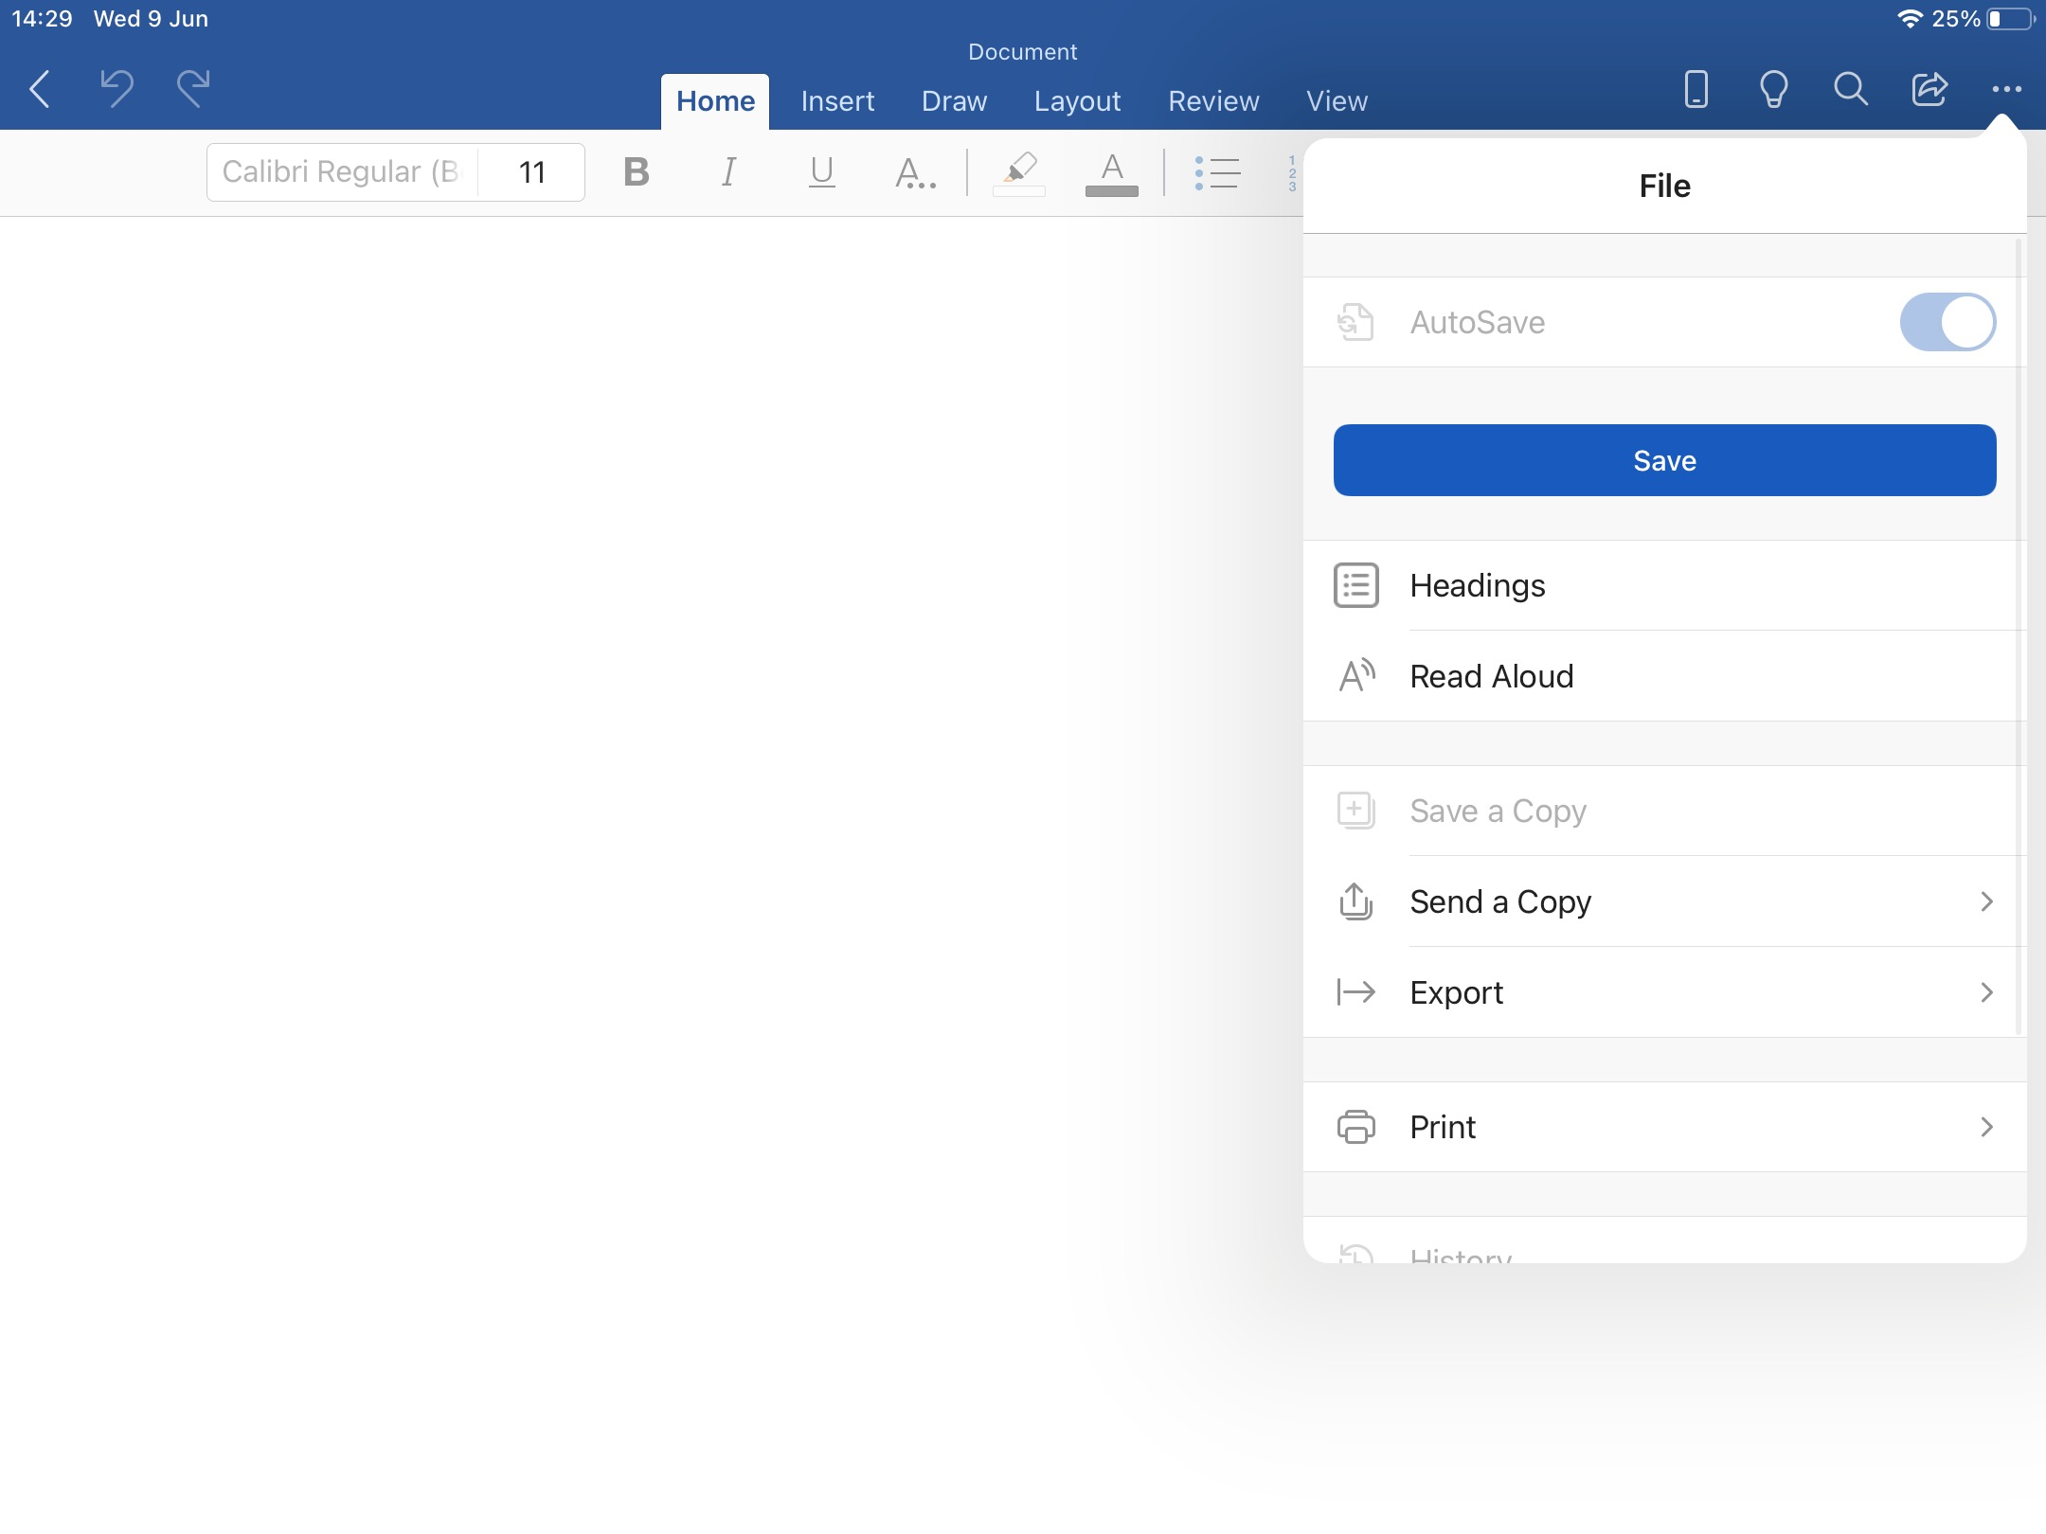

Step 2 – Click on 'Send a Copy' to see further options.
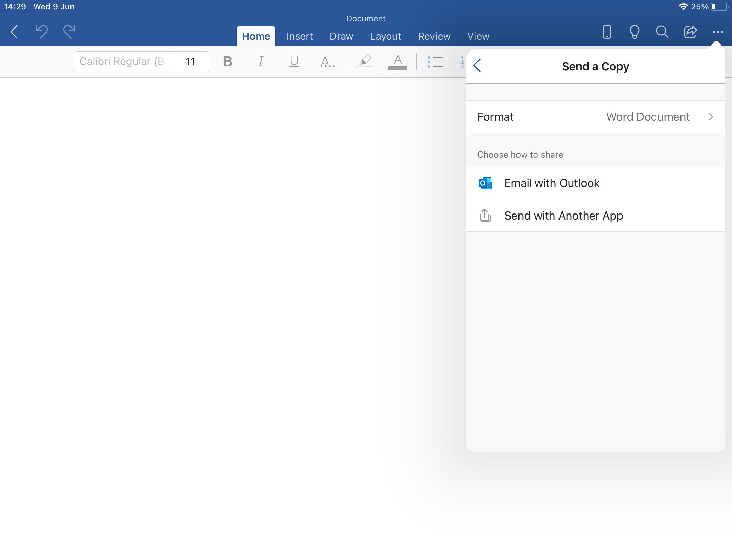

Step 3 – Click on 'Send with Another App'.
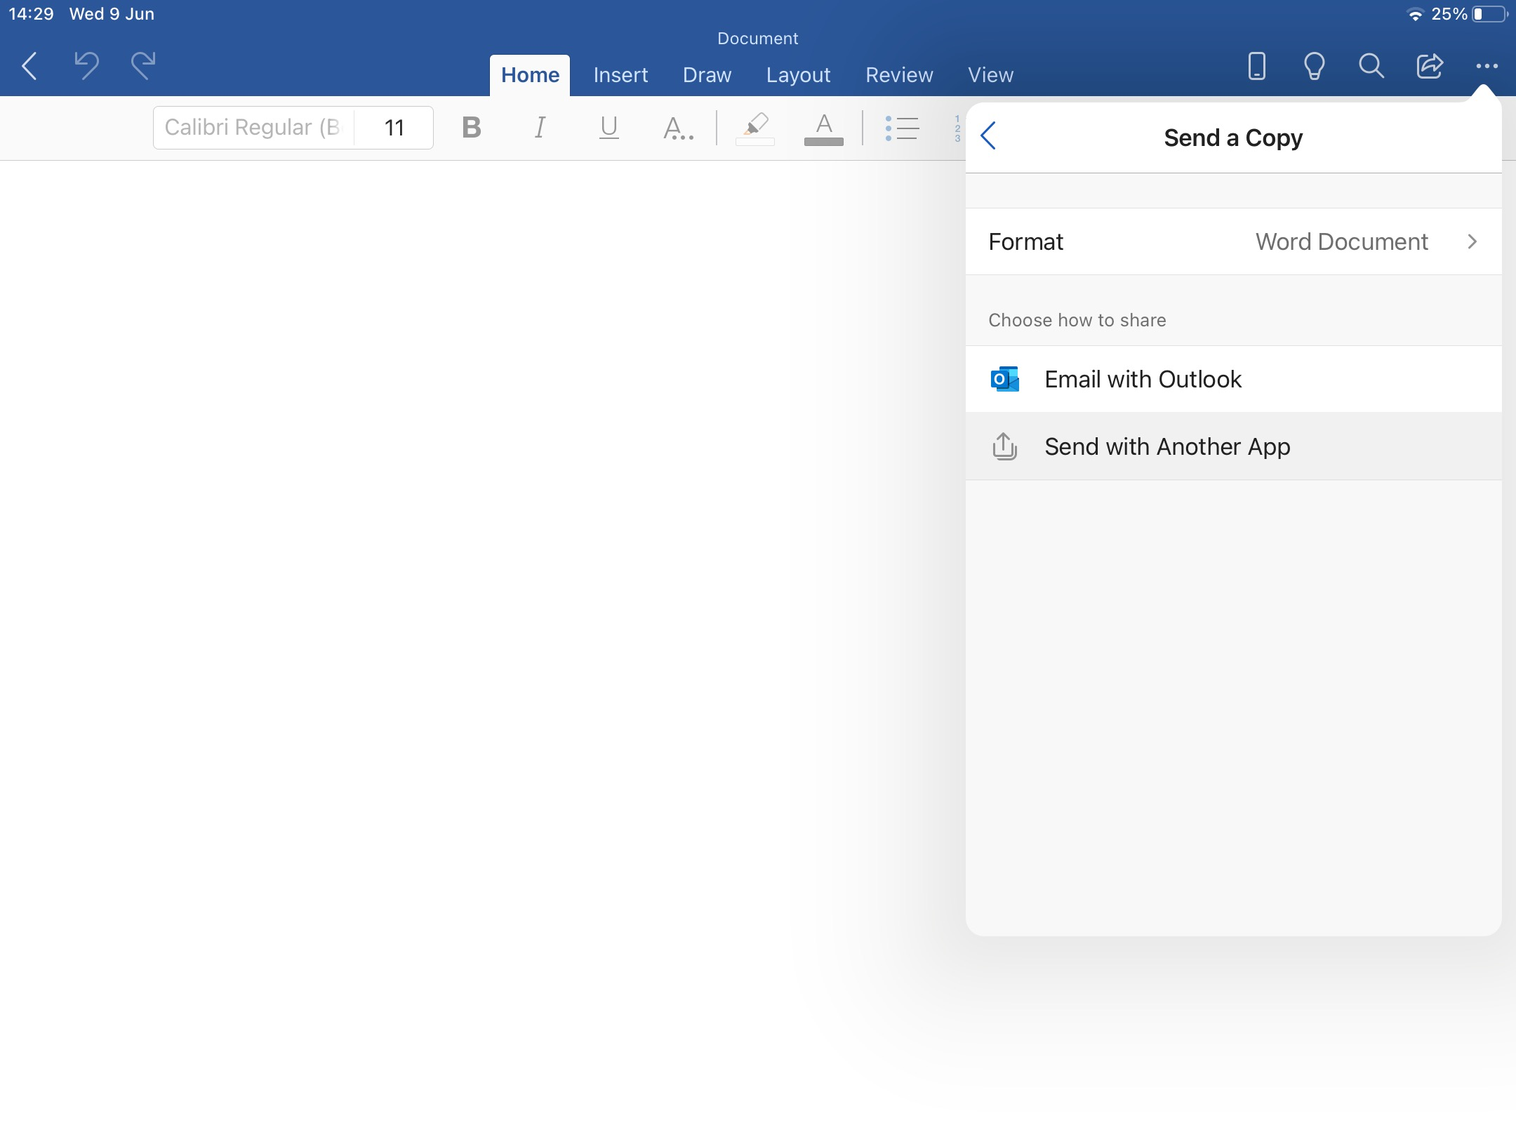

Step 4 – Choose OneDrive from the application options which appear.
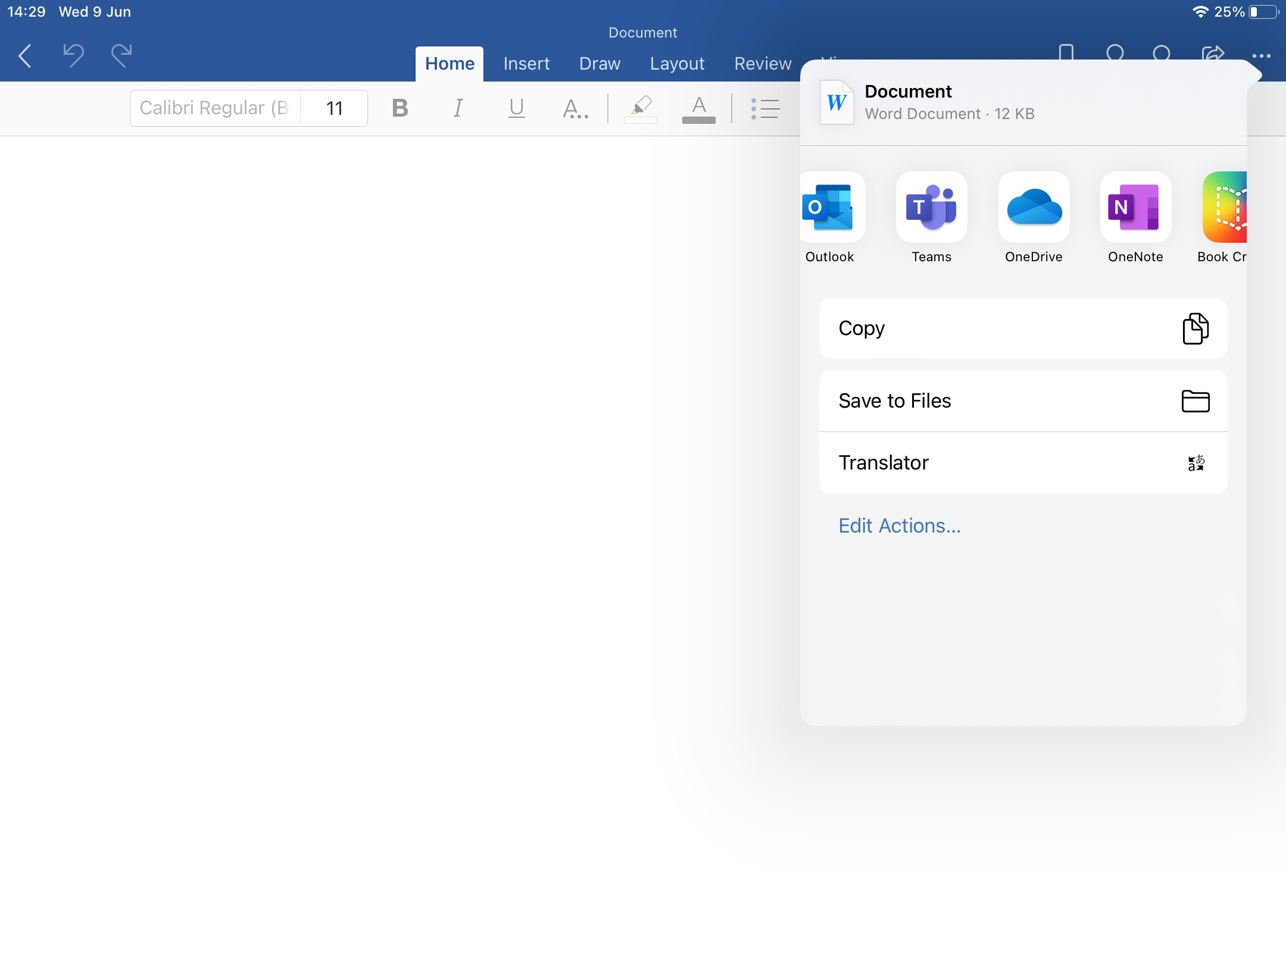
Step 5 – You will then have access to your OneDrive, you should click on 'Files' and choose the appropriate folder for the document before choosing 'Upload Here'.
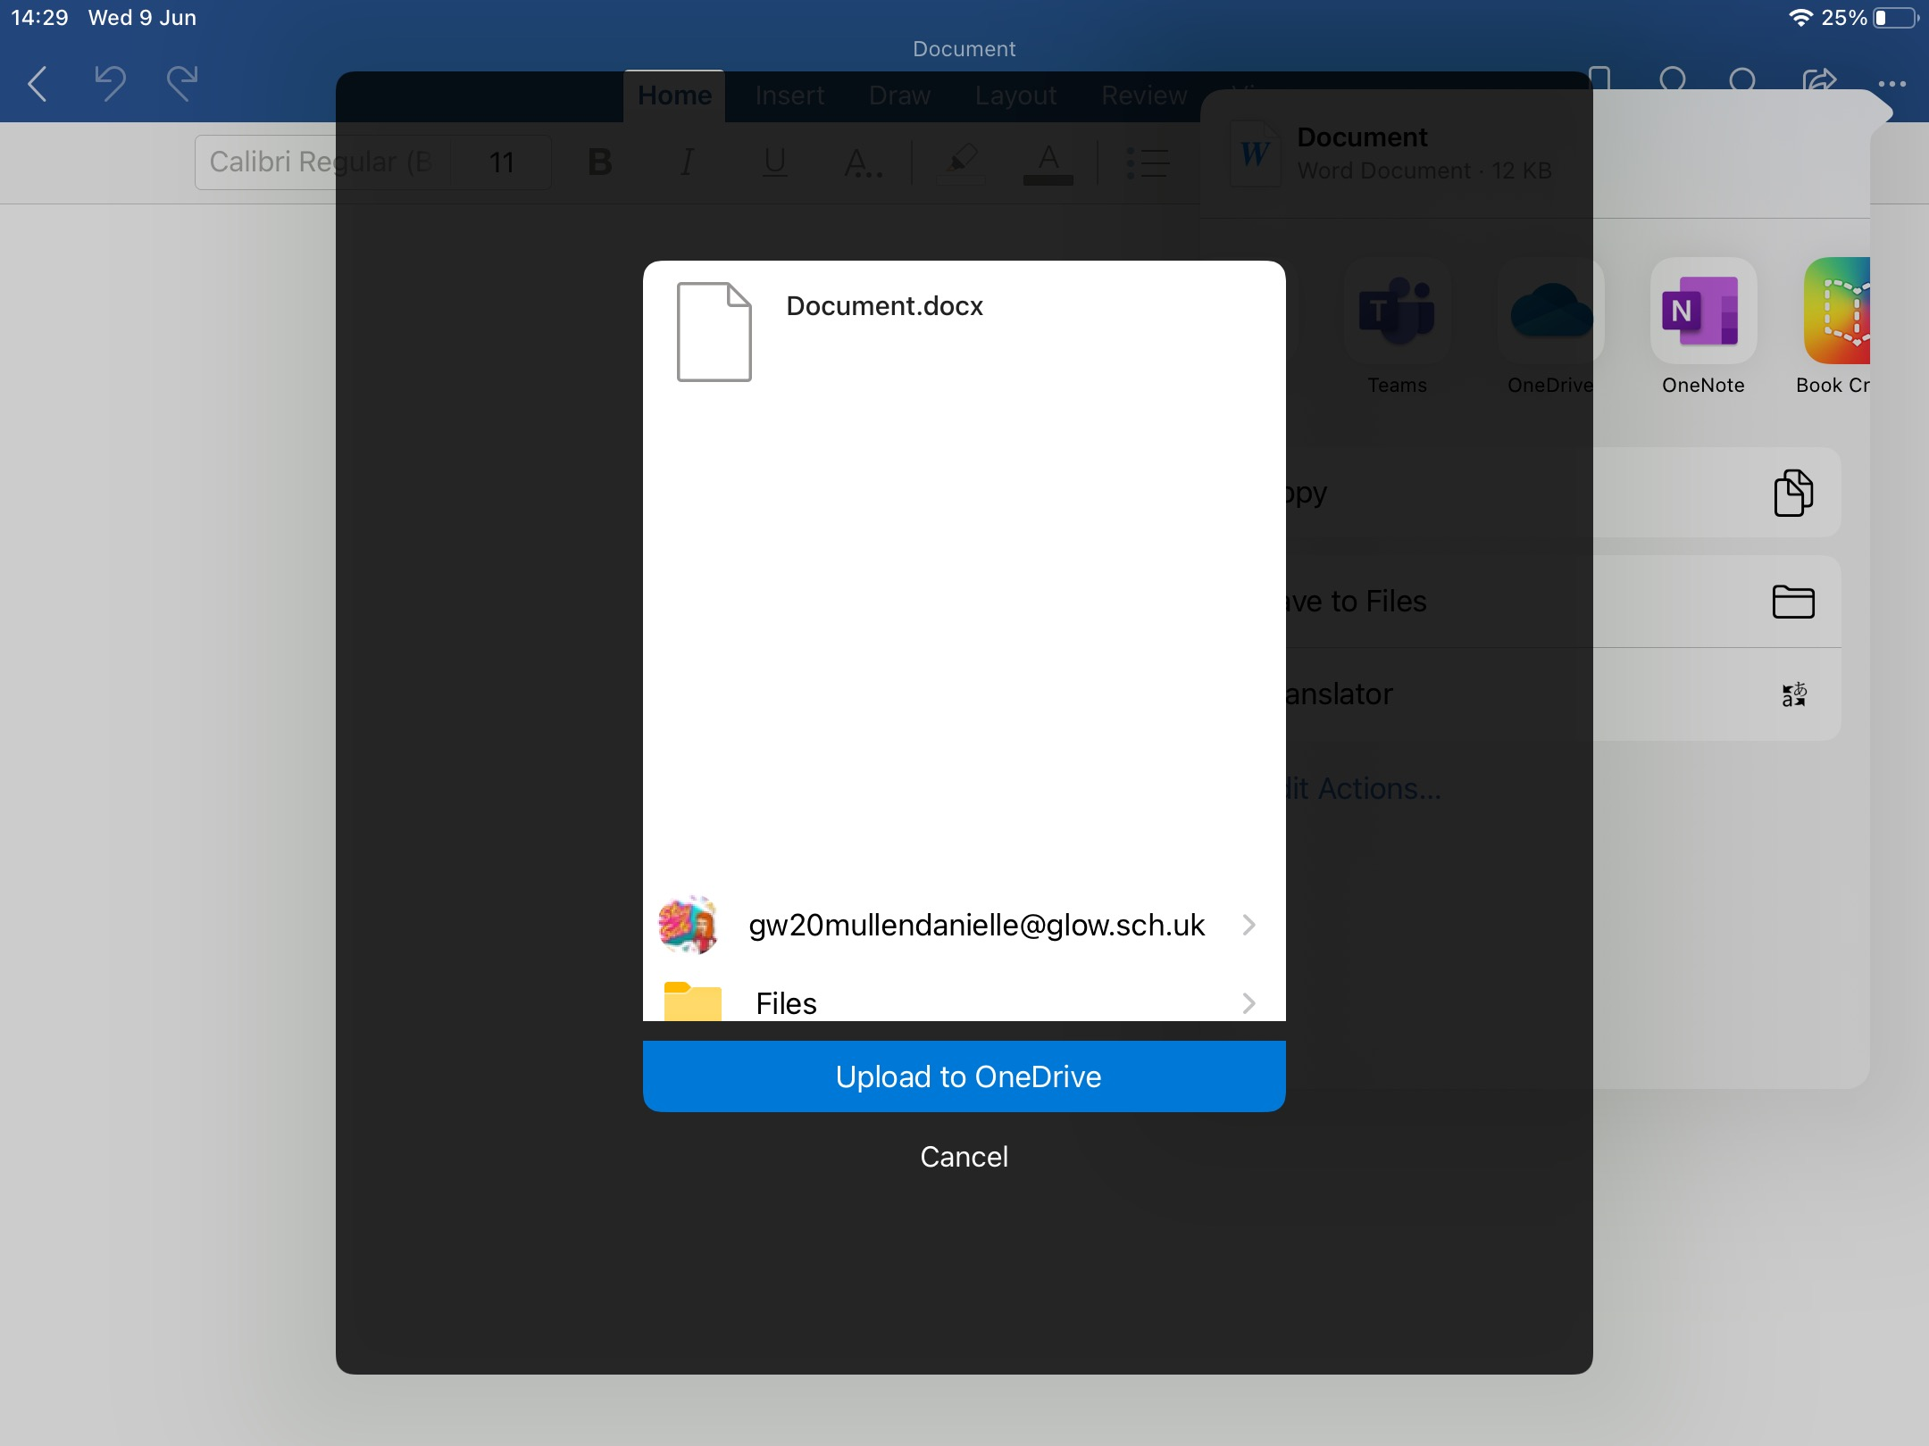

SAVING FILES TO ONEDRIVE FROM APPLE APPLICATIONS

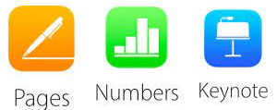

When using Apple apps to create documents, you should always save your files to your Glow OneDrive, this will ensure you can access them on both your iPad and any school computer.

Step 1 – Click on the 3 dots at the top of the screen to see a menu with options.

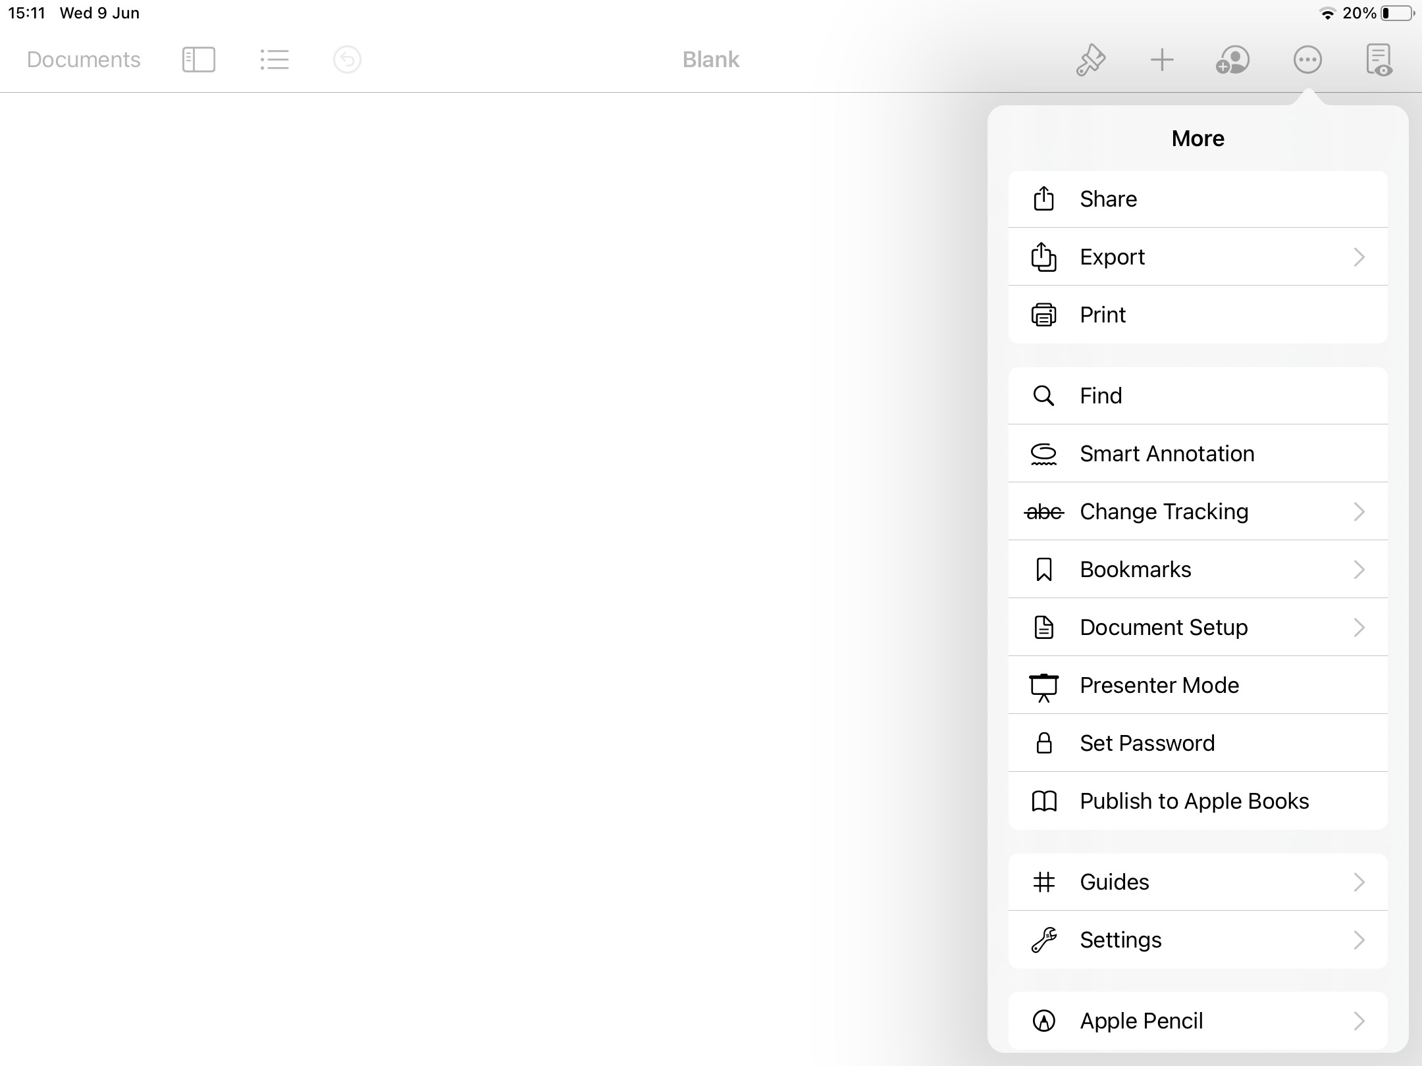

Step 2 – Click on the 'Share' option.
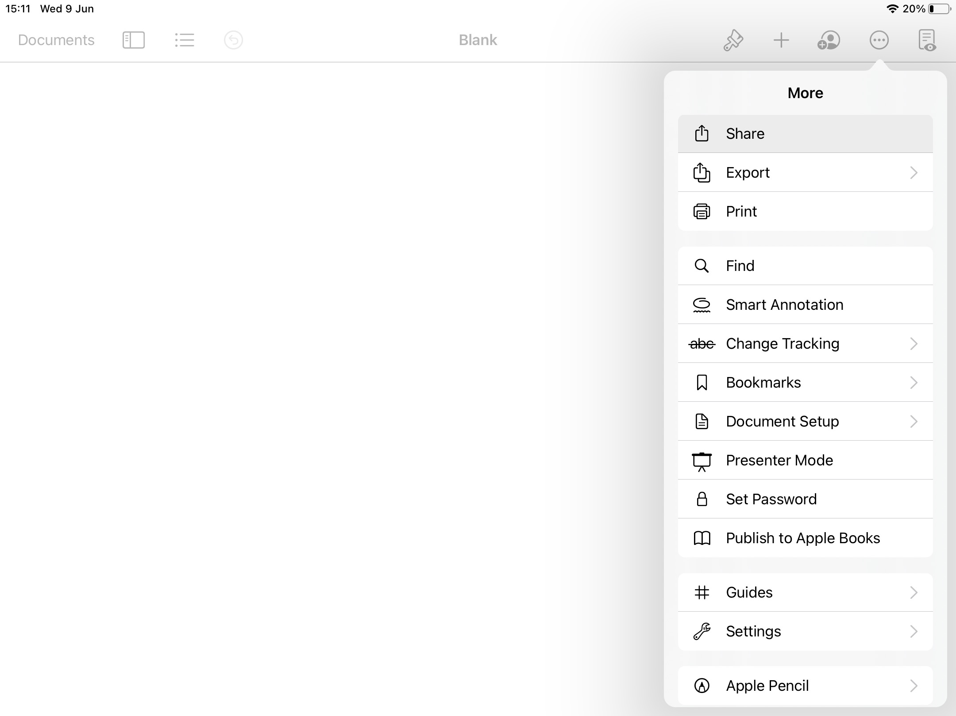

Step 3 – Choose OneDrive from the application options which appear.
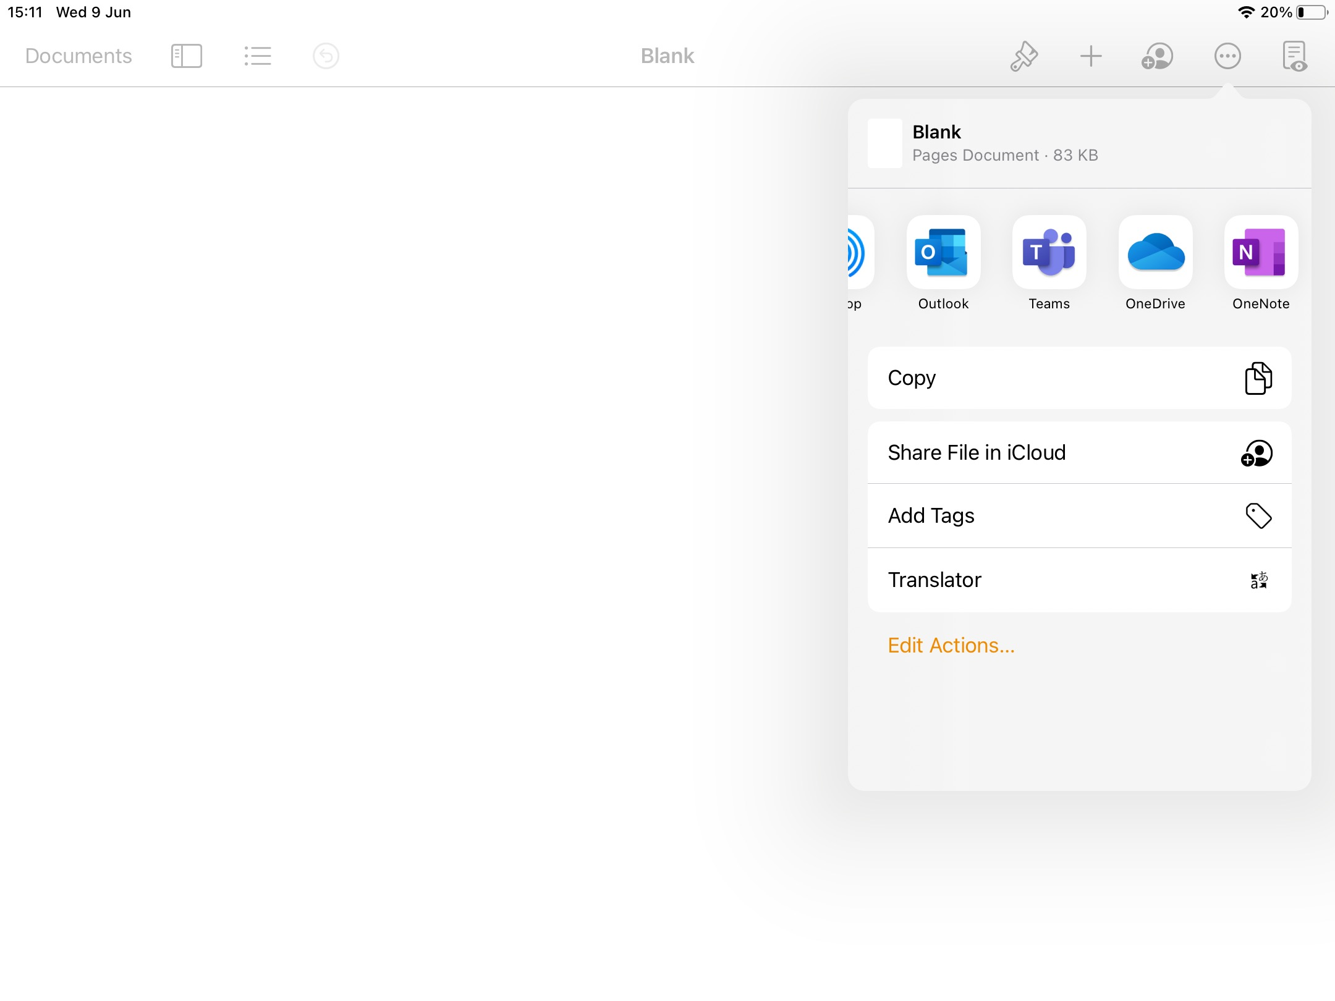

Step 4 – Click on 'Files' and then choose the appropriate folder to save your document to. Then, click on 'Upload Here'.
