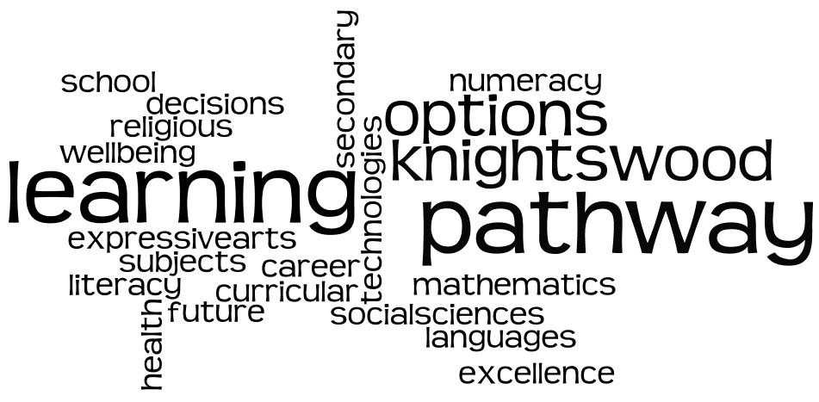

Knightswood Secondary

S2 Learning Pathway Option Booklet

##### To S2 young people and their parents/carers

This is a particularly important time for second year pupils as we prepare for the S2 into S3 Personalisation and Choice Process. This means that second year pupils choose the subjects they will be studying in third and fourth year.

This booklet gives details of the subjects that may be on offer in Third and Fourth Year at Knightswood Secondary School. Pupils should read this booklet during their Social Education class and Tutor Time Later, pupils will be given a copy to take home and discuss with their parents/carers.

Details of the following subjects are given in this booklet:

English…………………………………………………………………………………………… page 6 Maths ……………………………………………………………………………………………. page 7 Modern Languages………………………………………………………………………. page 8 Geography……………………………………………………………………………………. page 9

History…………………………………………………………………………………………… page 10 Modern Studies……………………………………………………………………………. page 11 Biology…………………………………………………………………………………………….. page 12

Chemistry……………………………………………………………………………………….. page 13

Physics................................................................................................ page 14

Administration and IT…………………………………………………………………. page 15 Business…………………………………………………………………………………………… page 16 Computing Science………………………………………………………………………. page 17 Graphic Communication…………………………………………………………………. page 18 Design and Manufacture…………………………………………………………………page 19 Music…………………………………………………………………………………………………. page 20 Art and Design………………………………………………………………………………. page 21 Dance………………………………………………………………………………………………… page 22

Drama………………………………………………………………………………………………… page 23 Physical Education…………………………………………………………………………… page 24 Hospitality …………………………………………………………………………… page 25

In Third Year young people will be achieving a Broad General Education. There are eight broad curricular areas:

•

Expressive Arts

•

Languages

•

Health & Well*-*Being

•

Mathematics

•

Technologies

•

Sciences

•

Religious & Moral Education

•

Social Studies

This allows pupils to reduce the number of subjects they have been studying in S1 and S2, and yet ensure that they are covering the broad range of curricular areas. Personalisation and Choice also allows for greater specialisation and depth of learning.

**English** and **Maths** are compulsory. Every pupil must select these subjects. Every pupil will also study courses in **Religious and Moral Education**, **Personal**

##### and Social Education and Physical Education.

Pupils will also be working towards their National 3, National 4 and National 5 qualifications and should be thinking about their ‘learning pathway’ into Fifth Year and beyond.

##### The Personalisation and Choice process:

The Pastoral Care Team within the school work with young people to ensure that young people in S2 have a good understanding of the choices they are making.

##### Initial Course Choice:

One very important process that starts soon is the Initial Course Choices for S2. The reason this is so important because the school will be organising which subjects run and how the timetable is arranged based on these initial choices. With that in mind it is vital that you think very carefully about your initial course choices. The current options are on the next page of this booklet.

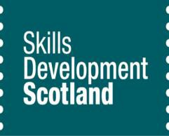

From October until January, your young person will be having one to one and small group meetings with our Skills Development Scotland (SDS) advisers in school. We are very lucky to be so well supported by Anne McMaster and her SDS team.

This note below gives you more information about the work of SDS:

Skills Development Scotland is the national skills body and we deliver Scotland’s careers ser- vice. We help people of all ages to plan their career, from school right through to retirement.

We have Careers Advisers in every state secondary school in Scotland, delivering careers guid- ance to enable young people from P7/S1 transition through to S6 to develop their Career Man- agement Skills.

Young people will meet their Careers Adviser throughout their time at school, and at key transi- tion points including starting S1, and at subject choice time. There is also more intense support during S3-S6 years for those who need it most.

As part of subject choice in S2, advisers are visiting tutor groups to explain the role of the Ca- reers Adviser in school. Over the same period, Careers Advisers are visiting PSE classes to deliv- er groupwork, again around subject choice. The work that SDS carries out with S2 pupils is to create career planning awareness.

There is also help from us online at [**www.myworldofwork.co.uk**](http://www.myworldofwork.co.uk/)- it’s your online career infor- mation and advice service and it’s packed full of activities and tools to help you confidently make the best decisions for you. There’s **a subject choice tool too.** Young people just enter their favourite subjects into the tool and get suggestions for the types of careers these could lead to.

There’s lots to do and explore and the more you tell the site about yourself, the better it is as you’ll get more career ideas tailored just for you!

Careers information can also be accessed from [**www.mykidscareer.com**](http://www.mykidscareer.com/)which will allow for parents and pupils to source information around future jobs and career paths.

**English**

**Why is it important to study English?**

The study of English helps pupils develop key communication skills, both verbal and written, which will allow them to participate to their fullest in life and work. Literature helps pupils understand the world around them, and their role in it, promoting social, political and historical awareness; and such important skills as thoughtfulness, understanding and empathy. Opportunities to write and discuss will help pupils develop confidence in articulating their own ideas and feelings.

##### What will we do in S3?



The study of English in S3 builds on the work covered in S1 and S2 and prepares pupils for further study in S4 and S5.

Work will be aimed at further developing pupils’ skills within the following three areas:

* Listening and Talking
* Reading
* Writing

Work in S3 thoroughly prepares pupils for whichever level of study they will follow in S4, whether it is National 3, National 4 or National 5. To ensure this preparation, pupils in S3 will be given the opportunity to:

* Show an increased independence in the planning and preparation of their work;
* Experience and respond to a variety of texts of increasing complexity;
* Develop and demonstrate an increased ability to understand,

analyse and evaluate literature through their written and verbal responses;

* Create a variety of texts in different genres;
* Display a more confident, purposeful and varied use of language in their own writing;
* Discuss and present effectively with greater fluency and confidence.

6

### Mathematics



**Why is it important to study Mathematics?**

Mathematics is important in our everyday life, allowing us to make sense of the world around us and to manage our lives.

Using mathematics enables us to model real*-*life situations and make connections and informed predictions. It equips us with the skills we need to interpret and analyse information, simplify and solve problems, assess risk and make informed decisions.

**What we will do in S3?**

The study of mathematics builds on the work covered in S1 and S2.

Pupils will continue working on the Mathematics / Numeracy experiences and outcomes at Levels 2, 3,4 and work extending into 4th level. To aid this, students will be placed in broad*-*banded classes based on their previous performance and their teacher’s professional judgement.

How well pupils perform in S3 will determine the course recommendation that is made for S4.



**Why?**

Mathematics has a wide range of individual skills which are acquired and developed

throughout the curriculum.

**Operational Skills:**

* Numerical
* Measurement
* Financial
* Algebraic
* Geometric
* Trigonometric
* Statistical

**Reasoning Skills:**

* Investigative
* Problem solving
* Analytical Applications

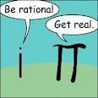

**Expectations**

Pupils must bring with them all basics items, pencil, ruler etc as well as a scientific calculator. Homework is also an essential part of a successful pupil’s mathematics course with formal homework issued approximately every 2 weeks..

**Modern Languages**

Why study Modern Languages? ‘Learning a new

language encourages young people to broaden their horizons as they explore the lan- guage and its associated culture.’

(Education Scotland) These celebrities speak French! These celebrities speak German!

In S3, Modern Languages will play an important part in your son or daughter’s Broad General Education. Pupils will now have a choice to study French or German in S3. We aim to deliver an engaging, fun and challenging course where pupils develop their skills in Listening, Talking, Reading & Writing in the foreign language, study topics in more depth and continue to develop transferable skills such as communication, presentation, teamwork, critical thinking and ICT skills. This will prepare all learners

for the new qualifications. The new SQA courses at National 3,4 & 5 will offer learn- ers the opportunity to develop detailed language skills using meaningful, real*-*life con- texts. These contexts include Society, Learning, Employing and Culture.

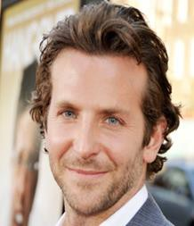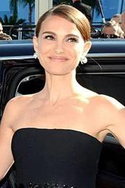

**Having a language qualification will help you find a job in the following areas:**

Journalism Broadcasting The Armed Forces Teaching Banking Export Sales and Marketing Publishing

Work Tourism Interpreting & Translating

The Civil Service Secretarial Social Work Diplomacy

**Foreign languages enrich lives…**

If you talk to a man in a language he understands, that goes to his head. If you talk to him in his own language, that goes to his heart." **(Nelson Mandela)**

**…and improves your market value**

‘At the pace with which businesses are ex- panding the world over, this is not the time for you to remain a monolinguist’ **(Forbes Magazine)**





# Geography

Geography is the study of Earth's landscape, people, places and environment. It is, quite simply, about the world in which we live. You will study the subject at National Qualification level in S4 (N4 or N5) but in S3 we will build your skills, values and interests first. Studying Geography equips you with key skills for the future.



## Progression

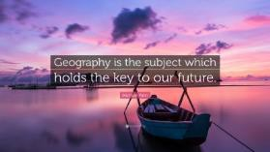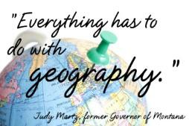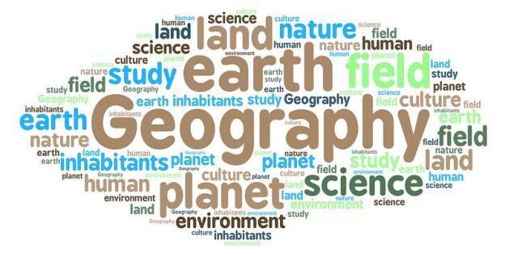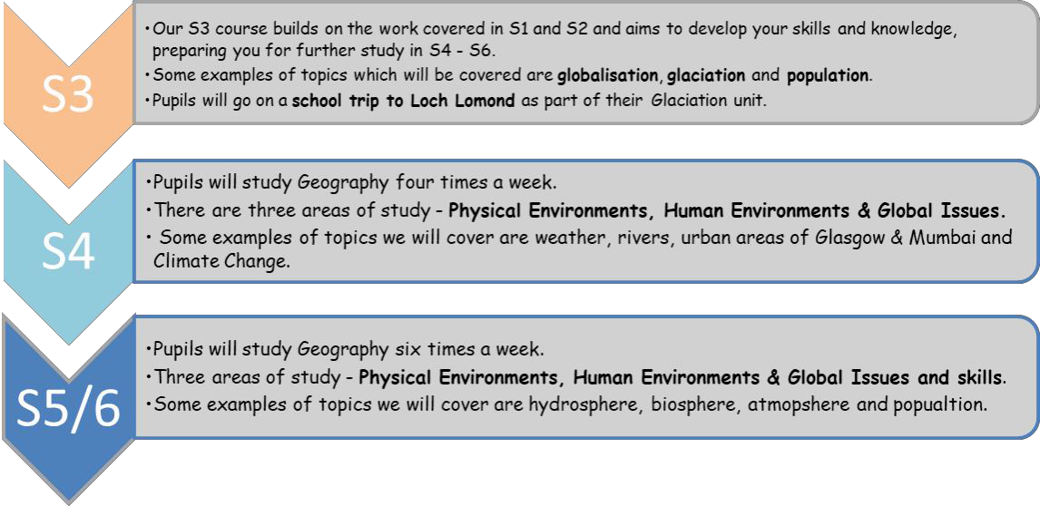

Skills developed

Describe Explain

Drawing maps & diagrams

Compare & contrast Draws conclusions Contributes to discussion

Team work

Careers

Civil Engineer Travel Agent Pilot

Land Surveyor Countryside Ranger Astronomer Merchant Navy

Air cabin crew Estate Agent

Environmental Consultant And many more…

Continue Geography at Higher N5 level

Become a Geography Ambassador

S6 Advanced Higher options

Complete another Humanities Subjects at Higher/N5 Level

Utilise skills learned in Geography in a working environment/Higher Education

For further details about Geography in S3, please speak to Miss Heafey (T01), Miss Sneddon (T02) or the Faculty Head, Mr Oakes (T07)

        

# History

History is the study of people, past events and societies. It is, quite simply, learning about the past and how people have interpreted what has happened. You will study the subject at National Qualification level in S4 (N4 or

N5) but in S3 we will build your skills, values and interests first. Studying History equips you with key skills for

## Progression

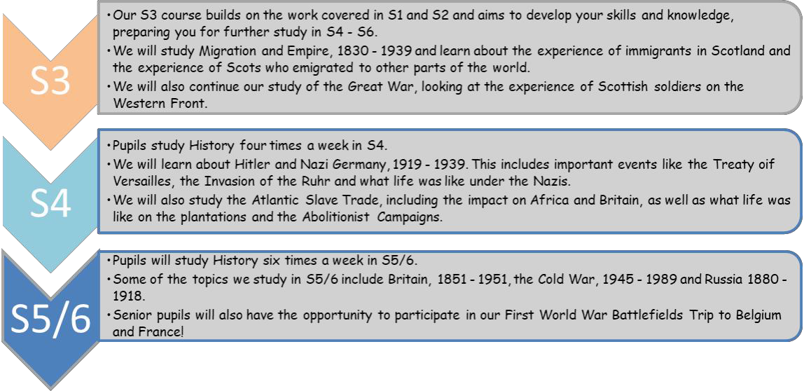

Continue to study History at N5 / Higher level

Become a Social Subjects Ambassador

Complete another Humanities subjects at N5 / Higher Level

Utilise skills learned in History in a working environment/ Higher Education

## Skills developed

Describing Explaining Analysing

Comparing & contrasting Evaluating

Contributing to discussions Researching Handling Sources

## Careers

Archaeologist Archivist Broadcaster Civil Service Librarian Teacher Solicitor

Town planner Writer Journalist

And many more…

       

# Modern Studies

Modern Studies is the study of modern*-*day social and political issues. Modern Studies teaches pupils to make their own decisions and have confidence in expressing their opinions to others. You will study the subject at National Quali- fication level in S4 (N4 or N5) but in S3 we will build your skills, values and interests first. Studying Modern Studies equips you with key skills for the future.

## Progression

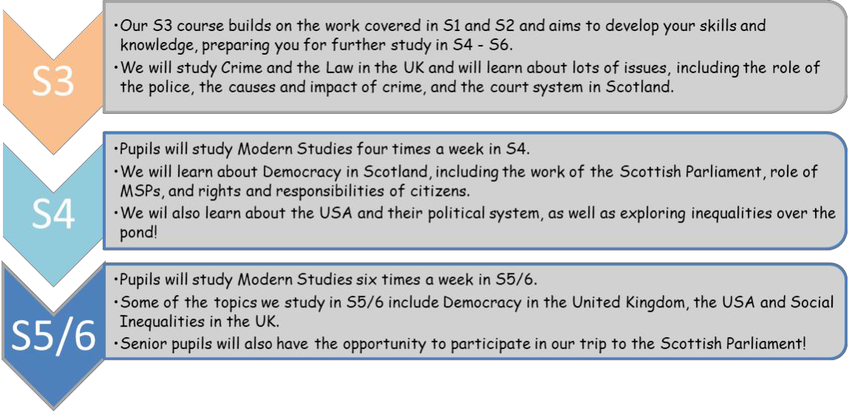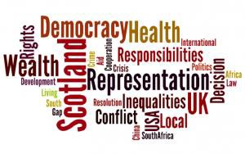

Continue to study Modern Studies at N5 / Higher level

Become a Social Subjects Ambassador

Complete another Humanities subjects at N5 / Higher Level

Utilise skills learned in Modern Studies in a working environment/Higher Education

## Careers

Journalist

Diplomatic Service Officer Member of Parliament Social Worker

Solicitor Newspaper Editor

Social Media Analyst Careers Adviser Police Officer

Criminal Intelligence Analyst And many more…

### Biology

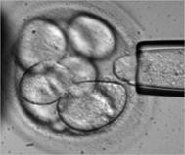

The S3 course is built around a number of expe- riences and outcomes which are part of the BGE. 2 broad units of work are covered to prepare pu- pils for National Qualifications at the end of S4. The concepts of biodiversity, adaptations inter- dependence, cells, DNA, inheritance and proteins are developed throughout course.

There will be opportunities for pupils to be in-

volved with research projects into topical areas of science and develop higher order thinking skills.



The aims of the S3 course are to develop the following skills:

⇒ scientific and analytical thinking skills in a biological context.

⇒ understanding of biological issues

⇒ acquire and apply knowledge and under-

standing of biological concepts

⇒ develop understanding of relevant appli- cations of biology in society

⇒ gain valuable skills for learning, skills for life, skills for work. They will develop their skills in literacy, numeracy and health and wellbeing

Biology is a very popular choice of science subject. It is interesting, relevant and stimulates learners to develop a lifelong interest in Biology. Through the S3 course, learners will recognise the impact biology makes on their lives, the lives of others, the environment, and on society.

Through the study of biology, learners can develop relevant skills for learning, for use in everyday life and in employment. Due to the inter*-*disciplinary nature of sciences, learners benefit from studying biology along with other science subjects, as this enhances their skills, knowledge and understanding.

Scientists play a key role in meeting society’s needs in areas such as medicine, en-

ergy, industry, material development, the environment and sustainability.

As the importance and application of science continues to grow and develop, more highly trained scientists will be required to meet the current and future needs of the 21st century society .

12

**All courses cover similar topics including: fuels, chemical reactions, plastics & metals.**

For more information on Chemistry & chemistry careers you could visit

the following web sites::

[www.rsc.org](http://www.rsc.org/) [www.ch e m so c.o rg](http://www.chemsoc.org/)

### Chemistry

Chemistry is a subject of global impact. As a fundamental science it has a profound effect on our planet and is involved in nearly eve- ry part of everyday life. Almost every new technological change and important discovery has its foundation in chemistry.

**Chemists influence our lives and make the world a better place to live in.**

Chemists make medicines that help fight disease & pain. They in- vented plastics like Nylon, Lycra and other clothing fibres. They help feed the world by making plant food called fertilisers. Chem- ists also help to make our environment cleaner by monitoring the atmosphere and the sea for pollutants.

##### Why should I choose Chemistry?



If I choose Chemistry will I end up in a job with wearing a white coat? For some jobs the answer is yes – Forensic scientist, Doctor, Pharmacist. These are jobs using Chemistry itself but there are many other jobs which chemistry is useful for. Not all chemists wear white coats!

##### Many employers recognise the value of training in logical thought, numerical and communications skills and the general science education that a Chemistry course provides.



**What will I do in Chemistry?**

Experimental work is a major part of learning chemistry Pupils will have regular use of ITC in small project tasks Creative homework includes making personal topic summaries.

**Physics**

Physics is the subject that explains how the world around us works, using experi- ments to try to understand and predict what will happen.

The physics course does have some number work.

**Some of the topics covered in the course will be:**

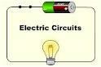

**Electricity and Energy**

This topic will include types of energy and how energy is generated and conserved. Heat energy and changes in temperature are important for us all. Electricity is a type of energy that we use for thousands of things every day. This topic will look at electrical circuits and electrical safety.

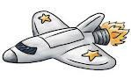

**Dynamics and Space**

Of course it will look at space science but it also includes movement and forces. How we can put rockets in space and how satellites orbit the earth. Telecommunications and information from satellites and space.

**Waves and Radiation**

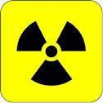

Ideas covered in this Unit will include the physics of waves, sound and light, nucle- ar radioactivity.

Light and sound are waves and we study how waves behave. We include how lenses and satellite dishes work and also learn about the many medical uses for waves.

Nuclear power has been a controversial idea for years. We examine nuclear radiation and safety in detail.

##### Expectations

Pupils must bring with them all basics items, pencil, ruler etc as well as a scientific calculator. Homework is also an essential part of a successful pupil’s physics course.

### Administration and IT



***Business and Administration*** continues to be a growing sector which cuts across all job markets e.g. retail, leisure and tourism, childcare and education, construction, communication and media.

Colleges, Universities and Employers now demand and expect young people to have a range of employability knowledge and soft skills:

Administration is one of the most versatile subjects within the curriculum – as the skills are used in all walks of life. It is a valuable qualification to gain a job or a place at college/university.

Building upon your work from S1 and S2 Business Enterprise, Administration and IT will allow you to complete your broad general education, and provide progression to the National 3, National 4 or National 5 courses in S4 and Higher courses in S5 and S6.

|  |  |
| --- | --- |
| Communication | Team working |
| Problem solving | Decision making |
| IT  Managing your time | Managing your workload and meeting deadlines |



Pupils will be involved in a range of learning activities that are designed to

inspire, challenge and motivate them.

These activities can be individual, paired, group or co*-*operative to engage all pupils.

The areas of study are:

* ***IT Solutions for Administrators***
* ***Communication in Administration***

(both using Microsoft Office packages)

* **Administration Practices** – customer care,

event planning, online research and legislation

**Business**

Colleges, Universities and Employers now demand and expect young people to have a range of employability knowledge and soft skills:



Building upon your work from S1 and S2 Business Enterprise, ***Business*** will allow you to complete your broad general education, and provide progression to the National 3, National 4 or National 5 courses in S4 and Higher courses in S5 and S6.

Pupils will be involved in a range of individual, group and co*-*operative activities and will be encouraged to link their learning to their experiences as consumers.



The areas of study are: ***Understanding Business, Marketing and Operations, People and Finance*** and ***Influences on***

***Business***, as well as, an assignment for **Business in Practice.**

Pupils will be involved in learning that is designed to inspire, challenge and motivate them.



***Business* plays an important role in society, as we all rely on companies and entrepreneurs to create wealth, prosperity, jobs and choices for us as customers.**

By choosing Business, you will give yourself a great opportunity to develop your understanding of how businesses operate in the global market – and to encourage your entrepreneurial spirit!

In today’s market, with the limited job opportunities – it is vital to develop your knowledge and skills so that you may not only look for a job, but, think about being your own boss and having your own team of staff, whether you would like to work in childcare, hair and beauty, leisure and tourism or the construction industry.

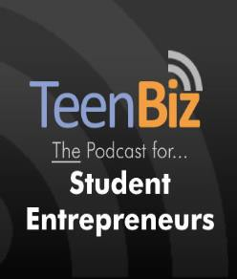

|  |  |
| --- | --- |
| Enthusiasm | Communication |
| Team working | Decision making |
| Problem solving | Risk taking |
| Organisational | ICT |
|  | |

### A screen shot of a white board Description automatically generatedComputing Science

Technology advances constantly and we are living in the digital age, where we use computer programmes every day – mobile phones, tablet computers, smart watches and voice recognition are just some of the technology we use on a day to day basis.

Computing Science is a STEM subject where you will gain a wide range of employability skills through the use of computational thinking to solve problems and the further development of your analysis, design and evaluation skills.

*A qualification in Computing Science is highly regarded.*

All levels of the Computing Science course aims to provide pupils with a sufficient grounding in the knowledge and theory of computing science to progress either through the National courses, to College, University or into a career in the computing industry.

Building upon your work from S1 Digital Literacy and S2 Computing Science, Computing Science will allow you to com- plete your broad general education, and provide progression to the National 3, National 4 or National 5 courses in S4 and Higher courses in S5 and S6.

##### The course has four areas of study:

* Software Design and Development
* Database Design and Development
* Web Design and Development
* Computer Systems

The course is designed to provide pro- gression to the National 3, National 4 or National 5 courses.

Learners will develop an understanding of the central role of computer scientists as problem*-*solvers and designers, able to design, implement and operate hardware and software systems, and the impact of IT on our environment and society.

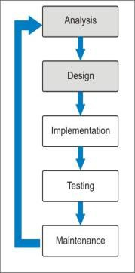

Computer scientists analyse, design, develop, and apply the software and hardware for the programmes we use day in day out.

Computer scientists are needed in every type of industry – Science,

Engineering, Finance, Games Industry and Health Care are just some of the career

pathways available to the computer scientist.

### Graphic Communication

**The Graphic Communication course aims are to enable learners to:**

•Develop skills in graphic techniques, including the use of equipment, graphics materials & software

•Extend & apply knowledge and understanding of graphic standards and protocols, where these apply

•Develop an understanding of the impact of graphics on our environment & society

**Course outline**

There are two units in the course, each designed to develop various graphic skills & knowledge so that learners gain enough experience to complete their final Graphic assignment. In both Units, learners will develop an understanding of how graphic communication technologies impact on our environment and society.

**What will you learn in Graphics?**

Both internal units and the final assignment are a mix of Manual graphics, Computer Aided Drawing (CAD) and Desk Top Publishing (DTP) tasks.

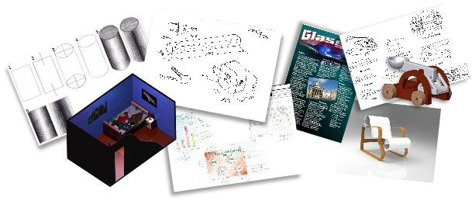

**Examples of manual & computer generated 2D & 3D folio work**

**What happens in S4 Graphics?**

You have a final assignment to complete which is 33% of your final grade. The other 67% is an SQA exam. After studying the Graphic Communication course you can go on to study the subject at Higher & Advanced Higher level.

**Career opportunities**

Graphic communication is the second largest industry in the UK and holds great opportunities for students to venture into any many areas of employment, such as; Engineering & Architecture, Internet page design & Advertising, Publishing & Graphic art. This course prepares students for a career in these industries and more but also equips them with analytical, investigative and problem solving transferable skills which are the building blocks for many successful careers.

**With a National 4 or 5 qualification**

Advertising industry CAD 3D Modeling Industry Construction industry Manufacturing industry

**With a Higher or Advanced Higher qualification**

|  |  |  |  |
| --- | --- | --- | --- |
| Architect | Civil Engineering | CAD Technician | Draughts person |
| Environmental Engineering | Graphic Artist | Interior design | Internet/Web page designer |
| Mechanical Design & Engineering | Printing Industry | Product design | Technical illustrator |
| Set & stage design | | | |

### Design and Manufacture

**The Design and Manufacture course requires learners to develop:**

•Skills in design and manufacturing models, prototypes & products

•Knowledge and understanding of manufacturing processes & materials

•An understanding of the impact of design and manufacturing technologies on our environment and society

**Course outline**

There are two units in the course, each designed to develop various design skills & knowledge so that learners gain enough experience to complete their final design assignment. Details of each unit are as follows:

**Design unit**

This unit covers the product design process from brief to resolved design proposals, including specification. It helps learners develop skills in initiating through to communicating their design proposals. It allows them to develop an appreciation of design concepts and the various factors that influence the design of products. **Materials and Manufacturing unit**

This unit covers the product design process from design proposals through to prototype/evaluation stage. It allows learners to develop practical skills that are invaluable in the design & evaluation process. It helps them gain an appreciation of the properties and uses of materials as well as a range of manufacturing processes and techniques.

**Design assignment**

When the unit work is completed learners will start their final Design assignment. This assignment offers learners the chance to further develop their abilities through new challenges and the application of the breadth of knowledge gained in the course units by producing a design folio & prototype model.

 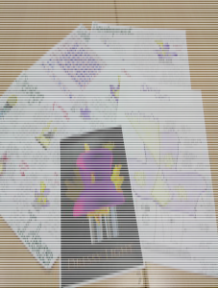

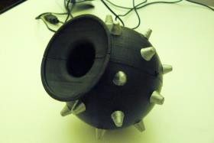

**Examples of design assignment folios & prototype models**

**Course assessment**

There are two levels of study in this course dependant on the ability of the learner – National 4 or 5.

**Career opportunities**

There is progression after studying the Design and Manufacture course *-* learners can go on to study the subject at Higher & Advanced Higher level. Beyond school the Design & Manufacture qualification can lead to a career in the following vocations:

Modern Apprenticeships Product Design Interior Design Mechanical engineering Civil engineering Architecture Construction industry Armed Forces



**Music**

**The Music course in S3 and S4 is very practical and builds on skills and knowledge and understanding from S1 & S2.**

Pupils who pick music will:

* continue to develop skills on two different instruments (eg **drum kit** and

**keyboard**)

* further experience the opportunity to be creative by **composing** and
* **recording** their own music using their iPads.
* **listen** to many kinds of music, identifying musical concepts in a variety of contexts.

##### Why would a qualification in Music be useful?



* + It is a **qualification** recognised by employers, universities and colleges. (You can continue your studies to Higher level and beyond).
  + It is **directly** related to the following careers:

professional musician dancer/actor

film/tv score writing music teacher

music therapist Sound engineer

primary teacher instrument repair

In addition, you will also develop many ‘non*-*musical’ skills including :

* + - cooperation with other people/teamwork
    - self*-*discipline
    - self*-*confidence
    - goal setting/motivation

**What are the employment prospects like in the Music Industry?** The entertainment business is one of the fastest*-*growing in Brit- ain. Because of the widening choice of Higher and Further Educa- tion options, more and more areas of employment in the Music In- dustry are available than ever before.

Art and Design

Art and Design plays an increasing role in all our lives and the creative indus- tries in Britain are seen as economically essential for the future. Whether or not you are considering pursuing a career in art and design the qualification is highly regarded by employers and universities. It demonstrates that the individual has acquired transferable skills, the ability to think creatively and problem solve and that is unique to the subject.

**Architecture • Interior Design • Computer Games Design • Stage/Set Design**

* **Ceramics • Animation • Graphic Design • Jewellery Design • Primary Teaching • Beautician • Child Care • Catering • Film Making • Photography**
* **Hairdressing • Fashion Design • Textile Design • Product Design • Web Design**



The S3 course in Art and Design builds upon the experiences you had in S1/S2. The structure of the course should feel very familiar to you, as you have already engaged in many of tasks.

***The course is made up of three components:***

**Expressive Activity** *- Drawing and painting, sculpture*, *printmaking.* You will experiment with a range of media, developing your analytical and technical skills and ability to express personal feelings and visual ideas. By studying artists and their working methods and techniques you will gain a greater appreciation and understanding of your own work and the role artists play in reflecting society.

**Design Activity** *- Graphics, fashion, jewellery, product* design You will be asked to solve a particular design problem. By studying the work of relevant designers you will learn about the design process and the impact and influence that design has in your life.

**Critical Activity** *-* You will have the opportunity to study selected artists and designers relating to your chosen area of interest. This element of the course will introduce you to particular art and design terminology as well as the working methods and inspiration behind particular pieces of art and design.

#### Photography NPA 4 or 5

Photography plays a vital role in today‘s society and enables us to communicate thoughts, feelings and information effectively with others. In Photography pupils will be required to undertake a series of practical projects where basic camera techniques are taught as well as researching and commenting on the work of other photographers. This Course encourages learners to be creative, reflective practitioners, who are critically self-aware and who can express themselves and use photography in visually imagina- tive ways.

**Photography • Interior Design • Computer Games Design • Stage/Set Design**

* + **Ceramics • Animation • Graphic Design • Jewellery Design • Primary Teaching • Beautician • Wedding photography • Catering • Film Making • Photography . Head shots .Hairdressing • Fashion Design • Textile Design • Product Design • Web Design**

**The S3 course in Photography covers areas such as:**

* **understanding different photography genres and**

**concepts**

* **practical skills in photographing people and places organising and working with photographic images**

**You will learn about lenses, focus, exposure, shutter**

**speed, aperture, white balance and the properties of light.**

**You will study the composition of photography and look at outdoor portraits and improving image quality.**

**There is also an opportunity to achieve a NPA in Visual Communication**

 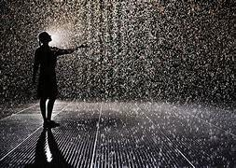

*a*

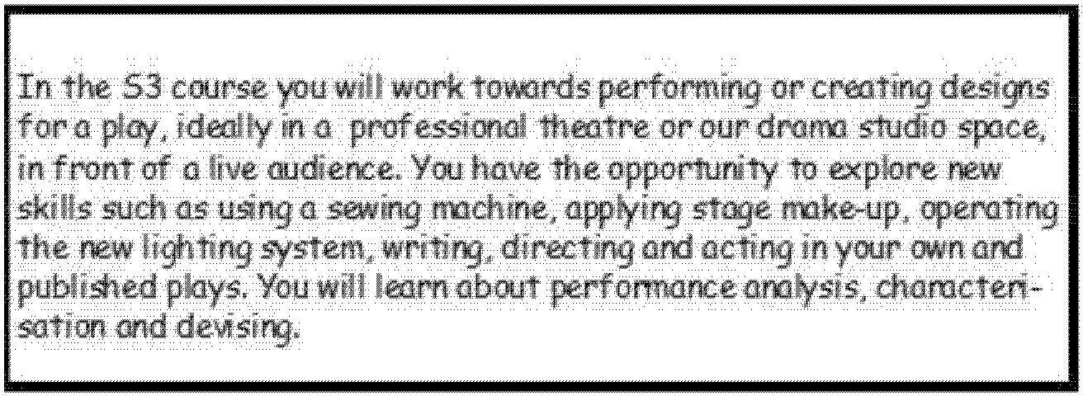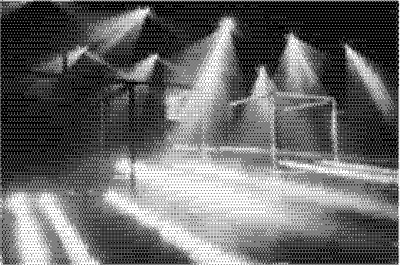 *a *

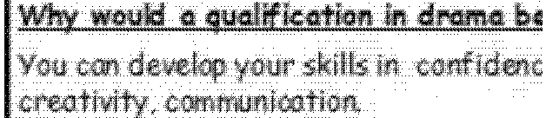





=

=



### Dance



The course includes Contemporary Dance, Jazz Dance, Tap Dance, Yoga and Choreography. While the majority of the class work is practical, there is some theoretical input.

On successful completion of course requirements, pupils are awarded SQA certification. Thereafter they may progress to National 5 Dance and Higher Grade Dance

Assessment is both internal and external.

During the session, a variety of guest teachers from the professional world of dance are invited to teach classes and there will be numerous opportunities to participate in theatre trips, performances and choreographic workshops.

The SQA certification gained will be helpful for those wishing to pursue a career in dance or a dance related area e.g. :

•NC/HNC/HND Dance Artists courses and NC/HNC/HND Health and Fitness courses at various Further Education Colleges.

•NC/HNC/HND Drama courses at various Further Education Colleges.

•Dance/Drama Degree courses at various Universities.

•Working within the sport and leisure industry.

•Nursery and primary teaching.

For further information Contact:

Miss Eyre

Health and Well*-*Being Faculty Head



Physical Education

The course will allow you to complete your broad general education and prepare you

for the new courses that are now offered at National 4 and National 5. The activi- ties completed will include a range of individual and team activities including hock- ey, basketball, volleyball and badminton (football is not an activity covered during National 4 or National 5 coursework). Your time will be split between practical les- sons and theory classes in the classroom. You will use the theory classes to apply the knowledge you gain in practical to developing and apply your knowledge of im- proving performance by completing a portfolio. Teachers will set homework tasks, on a regular basis.

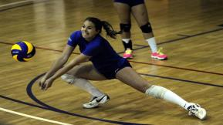

On successful completion of course requirements, pupils are awarded SQA certifi-

cation in either National 4 or National 5 PE. Assessment is based on practical per- formance and the completion of a portfolio. The course leads onto further qualifi- cations in S5/6 in Higher Physical Education.

The SQA certification gained is accepted for entry into all Universities and Further Education colleges. Studying PE will help with a wide range of careers, including the following:

* Leisure and recreation management
* Sports Journalism / Broadcasting
* Sports science
* Armed forces
* Physiotherapy
* Police
* Teaching (Primary and Secondary)
* Coaching



Skills for Work Hospitality provides an introduction to the different sectors of the hospitality industry. To achieve the award, learners must achieve all the required units. These are: Hospitality: Developing Skills for Working in the Professional Kitchen, Hospitality: Front of House Op- erations, and Hospitality Events. There is no external exam for this course and pupils will be assessed pass/fail throughout their time com- pleting the course. Skills for Work Courses are not graded (A*-*D) but successful candidates would receive a National 4/5 qualification and 24 SCQF credit points.



This course will provide young people with employability skills and al- lows them to gain practical experience in: menu planning; preparing, cooking and presenting a range of foods in a professional kitchen; serv- ing food and drinks; undertaking reception duties and customer care; and planning, organising and running a small hospitality event. Pupils will work alongside restaurants and other hospitality industries to build skill. All Units in the Course place emphasis on the employability skills and attitudes which will help to prepare candidates for the workplace. Candidates will have the opportunity to prepare for, and take part in, a job interview.



Assessment of this Course is based on a range of practical activities. Performance evi- dence will be supported by assessor observation and pupils reflections and reviews. For the Employability Skills, candidates will be required to carry out self*-*evaluation on a range of skills, review progress and identify action points. Pupils are expected to be- have professionally and be prepared and ready to learn.



The Scottish food, drink and hospitality industries are huge. They collectively employ a significant proportion of the nation’s workforce. Hospitality allows for a range of pro- gression routes to further education, including NQs, SVQs, HNCs and degrees in hospi- tality related subjects. It may also lead to employment and/or training in the sector.

Some possible careers include: **teaching, food product development,agriculture, quality cotrol, food journalism, hotel or restaurant management, events and planning, professional cookery (army/restaraunt chef), catering, HR, concierge, marketing and more!**

26