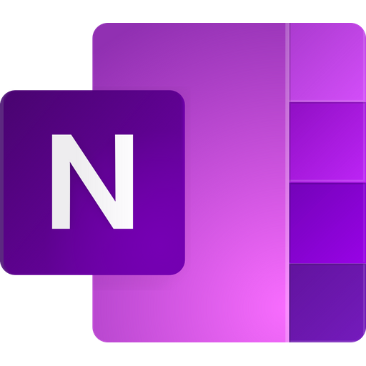
Using Microsoft OneNote

OneNote will allow you to complete tasks and activities within your own digital notebook.

Your teacher will be able to access your work and provide you with feedback.

ACCESSING ONENOTE FOR THE FIRST TIME

If you have never used OneNote before, follow the steps below to access your notebook.

Step 1 – Open Microsoft Teams.

Step 2 – Click 'More' at the top of the screen.

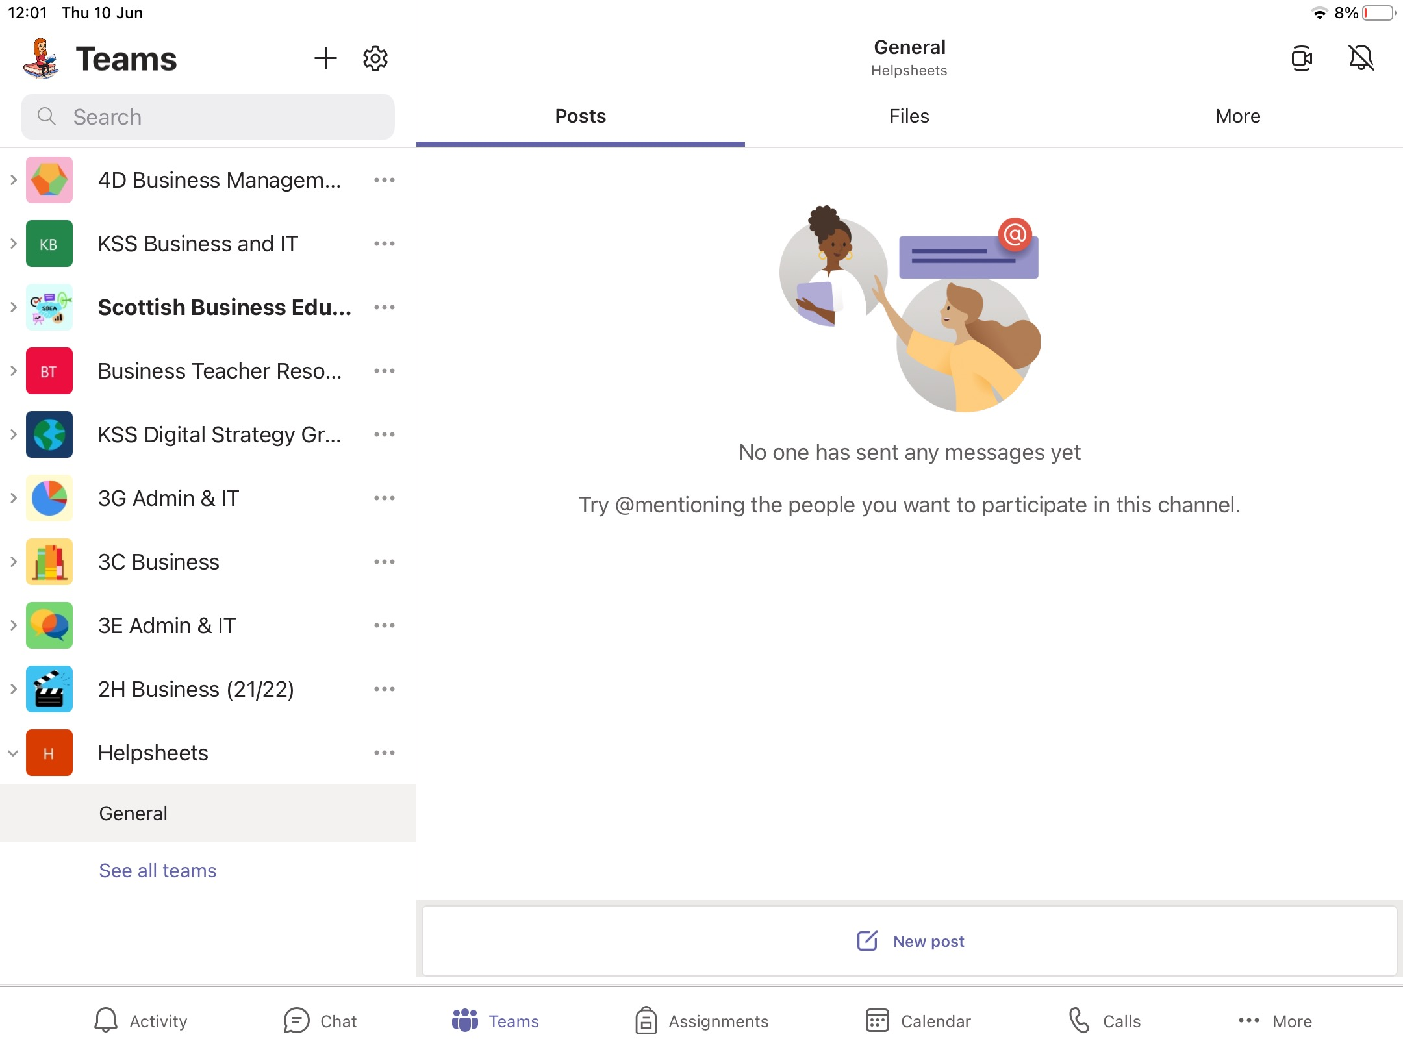

Step 3 – Click 'Class Notebook' which will open the OneNote app on your iPad.

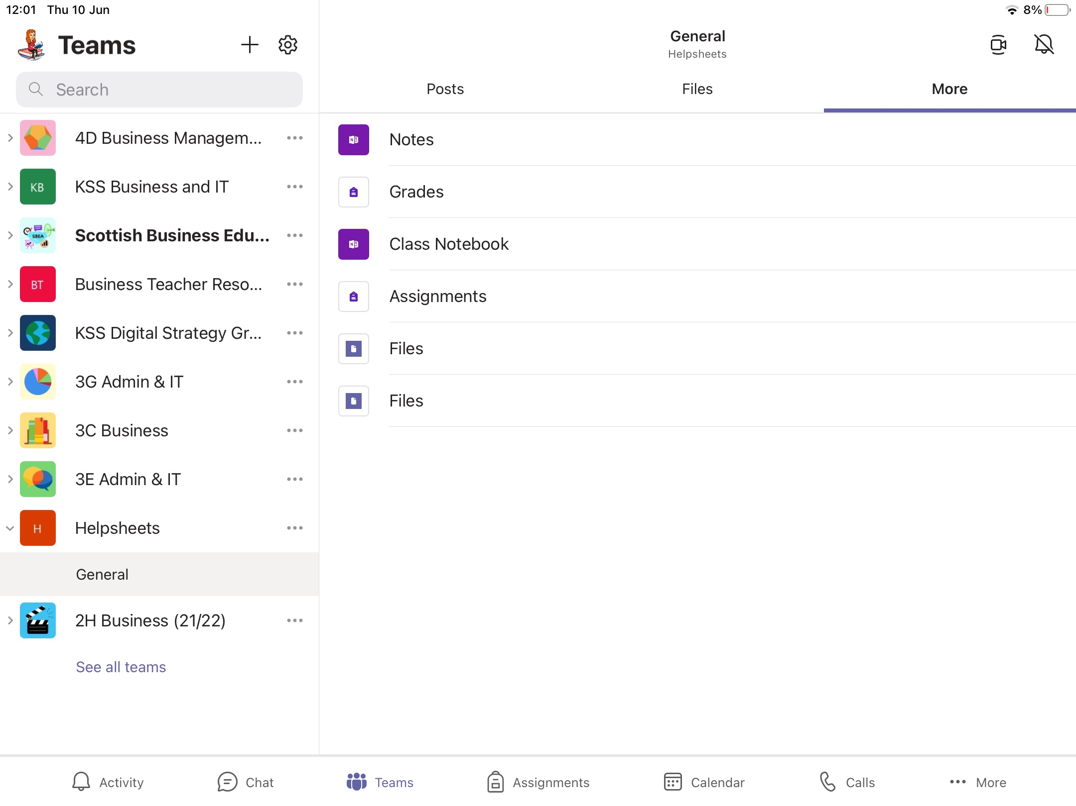

Step 4 – Click the purple arrow at the left side of the screen.

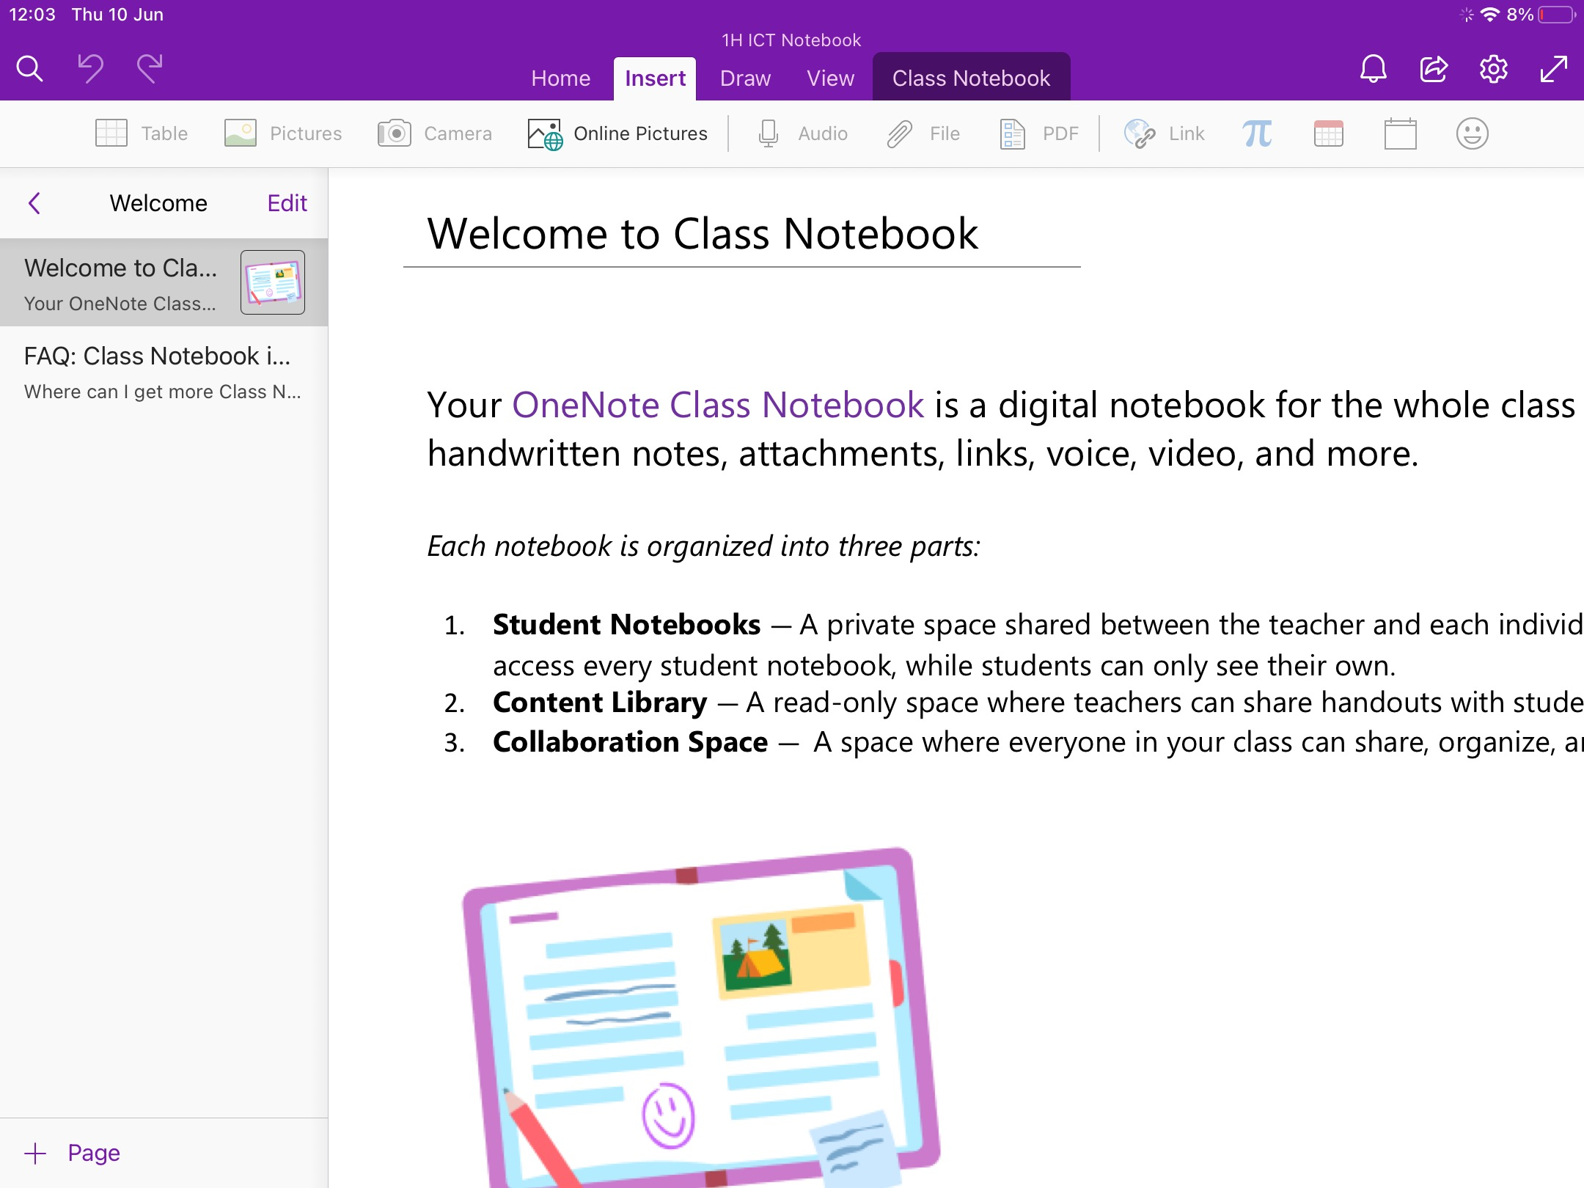
You will now be able to see the different sections of the notebook and next time you use it, you can access it directly from the OneNote app.
USING YOUR NOTEBOOK

Your Notebook will have sections and pages for you to use. You access your notebook by clicking on your name at the left side of the screen.

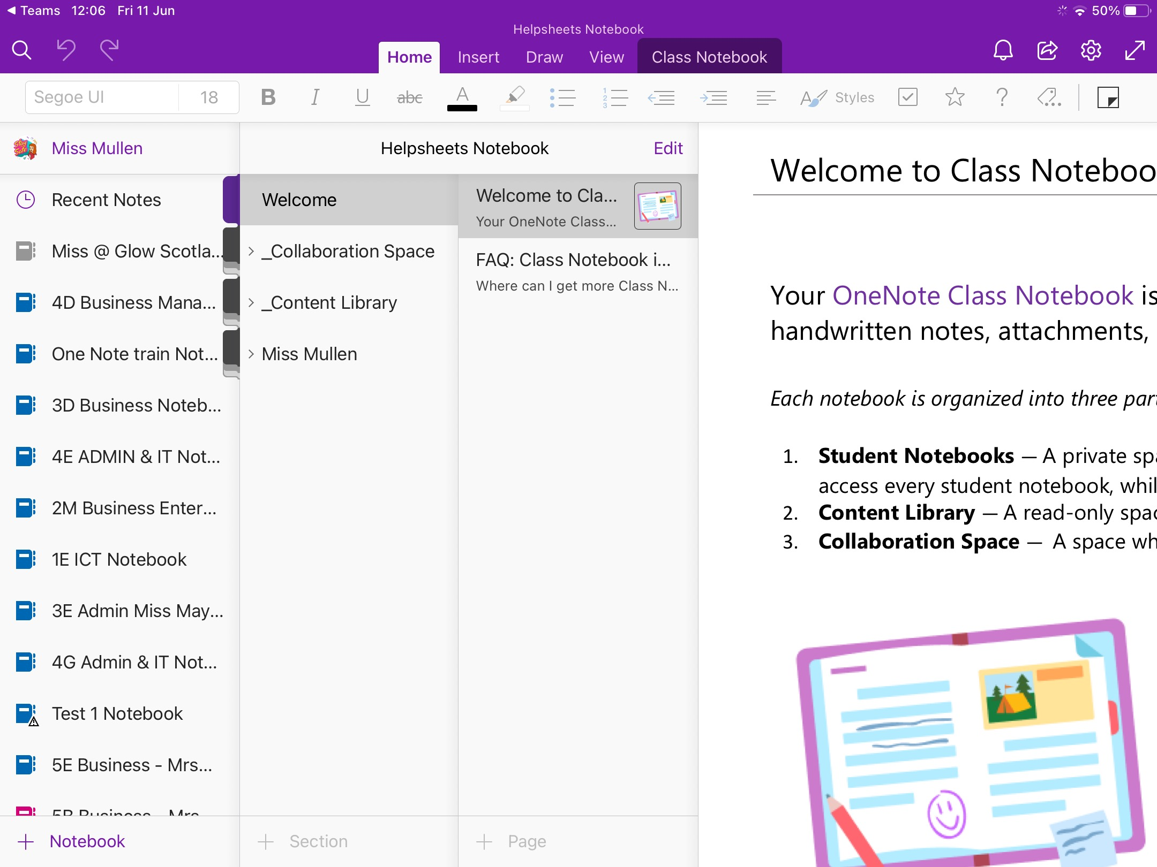
A section can be seen in the blue box.
A page can be seen in the red box.

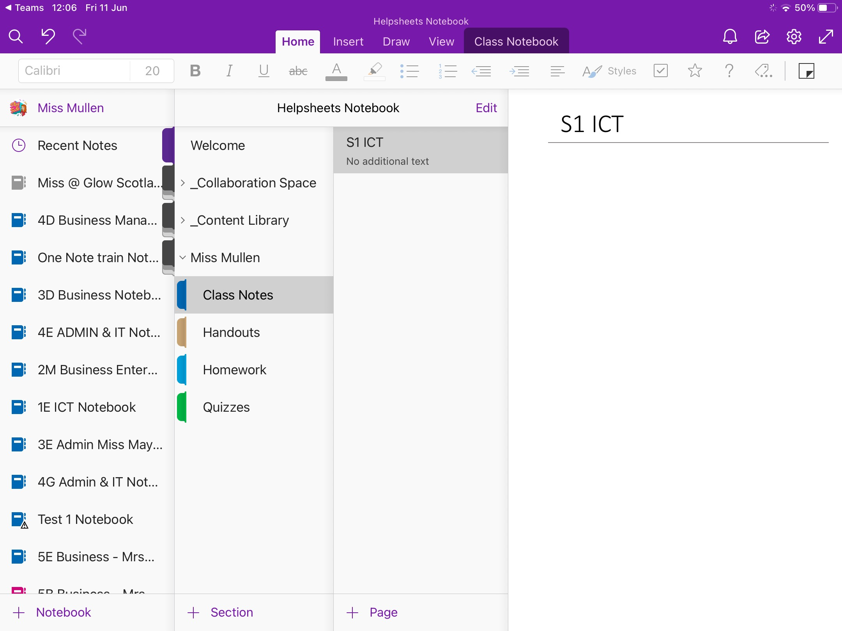
You will be able to create your own pages within your notebook. The pages in your notebook are never-ending.

You should make sure you name your page appropriately so that it is easy to find the information you are looking for in future.

In the screenshot below, you will see the Content Library in a green box, this is where your teacher will store notes and resources. You cannot edit pages in the content library.

USING THE INSERT TAB

Table

By inserting a table, you will be able to organise text easily.

You can choose how many rows and columns your table should have by clicking on the appropriate number of boxes.

Pictures/Camera

These buttons will allow you to insert photos from your camera roll or take a new photo.
This can be useful for inserting screenshots of your work into your notebook.

File

This button will allow you to insert a file from your OneDrive.
This can be useful for uploading your work as an attachment to your class notebook.

USING THE DRAW TAB

Text Mode

When using the draw tab, you will need to use this button to go back to normal use of the notebook.

Lasso Select

This button will allow you to select drawings or shapes and change their size or position.

Choosing Pen Colour

Any of these buttons will allow you to change the style and colour of the pen to make your drawings stand out.

Eraser

This button will allow you to erase any drawings/shapes you no longer want.

Shapes

This button will allow you to insert different shapes into your notebook to create drawings.
USING THE VIEW TAB

Immersive Reader

By clicking on this button, the entire page can be read aloud to you.

You can change the size of the text, change the page colour, highlight parts of speech like nouns, verbs etc. and translate the information into another language.

Paper Colour

This button will allow you to change the colour of the page in your notebook.

Paper Style

This button will allow you to change the page to have lined or squared paper which might be useful for some of your subjects.

