Mental Health Bulletin – February 2023
Children’s Mental Health Week is 6th-12th February. The theme is ‘Let’s Connect’.
We plan to raise awareness of this at year group assemblies for S1-S3. Previous supports that we have offered to each year group are detailed as follows:
Year Group | Activity | Details
S1 | Outdoor learning and team-building day  Pastoral Care ‘Settling In’ Meeting  Reflective Space  Spring- fest: Happiness focus | All pupils were out of school for a day of outdoor learning at Kelvingrove Park and Art Galleries followed by team building sessions.  All young people have had the offer of a 1-2-1 meeting with their Pastoral Care teacher.  All pupils had a reflective space period which was led by our Chaplaincy Team and focused on mindfulness and reflection.  All pupils will have the opportunity to participate in an afternoon of Health and Wellbeing in March 2023.
S2 | Reflective Space  Pastoral Care ‘Personalisation and Choice’ Meeting  Blues Programme  Spring- fest: Happiness focus | All pupils had a reflective space period which was led by our Chaplaincy Team and focused on mindfulness and reflection.  All pupils will have a 1-2-1 meeting this term with their Pastoral Care teacher to support them as they embark on the Personalisation and Choice process.  Action for Children visited all classes.  Pupils participated in a screener which helped to identify those who will participate in further sessions in Feb-March  All pupils will have the opportunity to participate in an afternoon of Health and Wellbeing in March 2023.
S3 | Blues Programme  Spring- fest: Happiness focus  Anxiety and Stress Management workshop | Action for Children led an assembly with all S3 pupils to outline this support programme.  Pupils participated in a screening process. 3 groups ran in Nov-Dec. 2 groups are currently running.  All pupils will have the opportunity to participate in an afternoon of Health and Wellbeing in March 2023.  All pupils will participate in a workshop during PSE time in May 2023. This will be delivered by our Health and Well-Being Support Officer.

Supports at KSS:
There are a number of supports at KSS which are available for all young people including:
- Personal and Social Education (PSE) programme to raise awareness and signpost to universal supports
- Principal Teacher of Pastoral Care (PTPC) support: 2 periods of contact with PTPC weekly
- Year Group Head (YGH) support
- Safe Place/Quiet Club/Chill out club
- LGBT safe space
- Extracurricular clubs
- Volunteering and leadership opportunities to empower young people and support wider achievement for improved self esteem
- Mental health first aid trained staff on campus
- FARE youth workers and clubs
- Breakfast club
- All behaviour is Communication - all staff are trained at TLCs to understand a young person’s emotional processes
- Captains corner: capturing pupil voice

In addition, young people can access the following targeted supports:
- Action for Children counselling
- Health and Well-Being Support Officer (therapeutic support)
- Nurture Groups
- ASC Group
- Seasons for Growth
- Home School Support Workers
- Group work – Farebear Youth Workers and Rangers Community Worker
- Group work – Glasgow Life
- Fidget toys /calm boxes
- KIIM/SIIM/LC-JST
- REACH service

These supports would be discussed with a young person and their PTPC in the first instance and agreed with parents and carers as part of an Individual Education Plan.

Well-being indicators:
All young people have participated in lessons focussing on the well-being indicators known as SHANARRI indicators. The well being web below will be completed several times a year and the information gathered will help us to identify any supports that your young person may need.
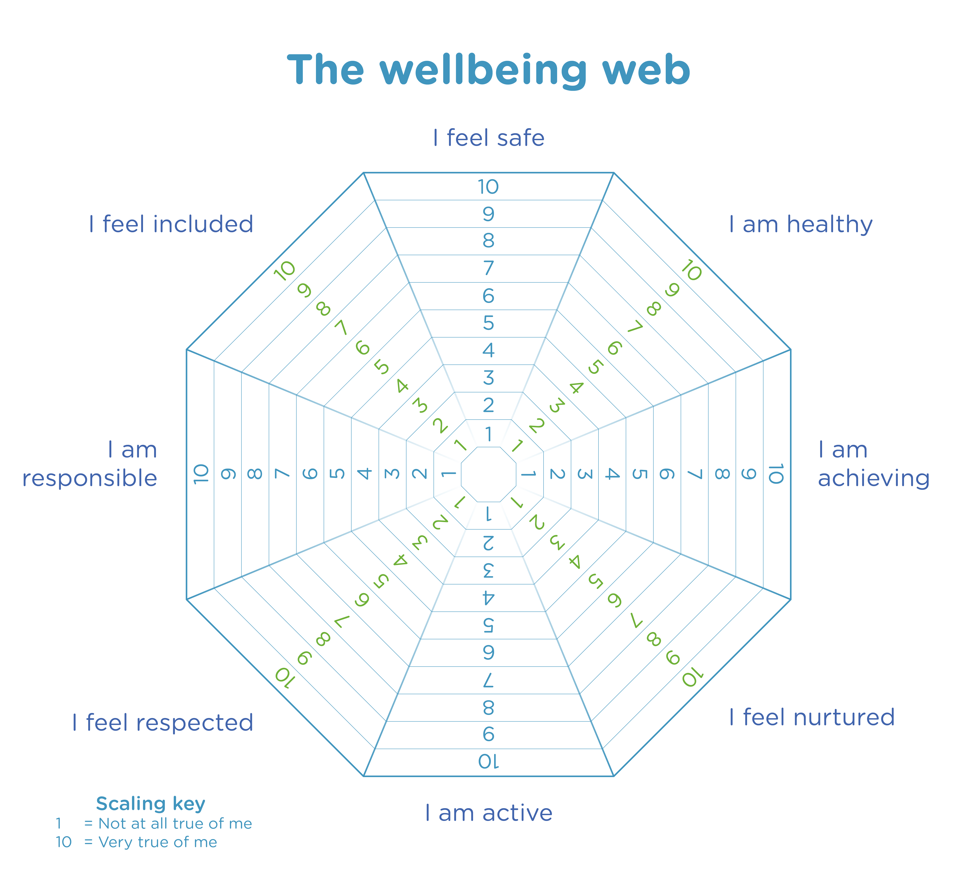

Supports for parent/carers:
Some excellent supports for parent/carers are linked below:
https://www.place2be.org.uk/our-services/parents-and-carers/
https://www.youngminds.org.uk/parent/
https://sleepscotland.org/
https://www.mentalhealth.org.uk/our-work/programmes/families-children-and-young-people/resources#:~:text=Education%20Support%20%E2%80%93%20Education%20Support%20provides,you%20immediate%2C%20confidential%20emotional%20support.
Future plans:
A staff Mental Health and Well-Being Strategy Group has been established at KSS. We are hoping to progress with:
- KSS Mental Health and Well-Being Policy
- Pupil Mental Health Ambassadors
- Mental Health Hub section on our school website
- ‘Spotlight’ sessions to support parents
- A weekly reflective space for pupils

If you have any ideas or wish to become involved in any way, please complete the Microsoft form at the link below:
https://forms.office.com/r/UKpazRChJC

