How to join a ‘live lesson’ – Knightswood Secondary School

- Open up the Teams app on your iPad.
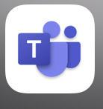

- Go to your Calendar to find the meeting/live lesson set by your teacher.

- Click join now
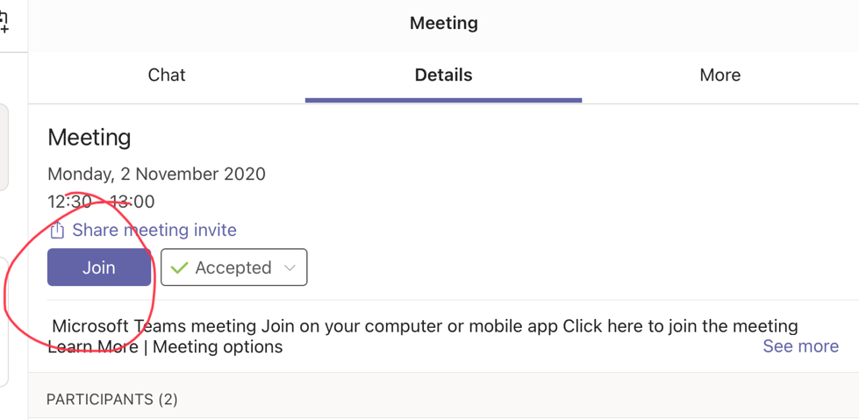

- Make sure you camera and microphone are off
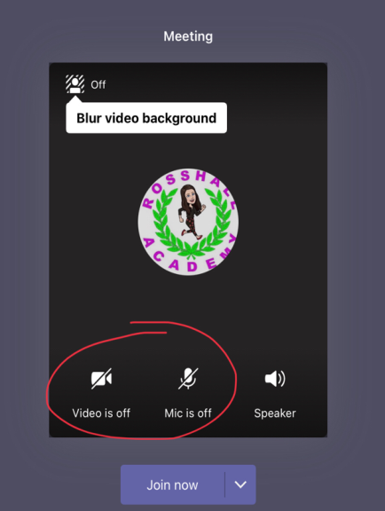

- Once in the meeting, you can use the chat function to ask any questions you have.

