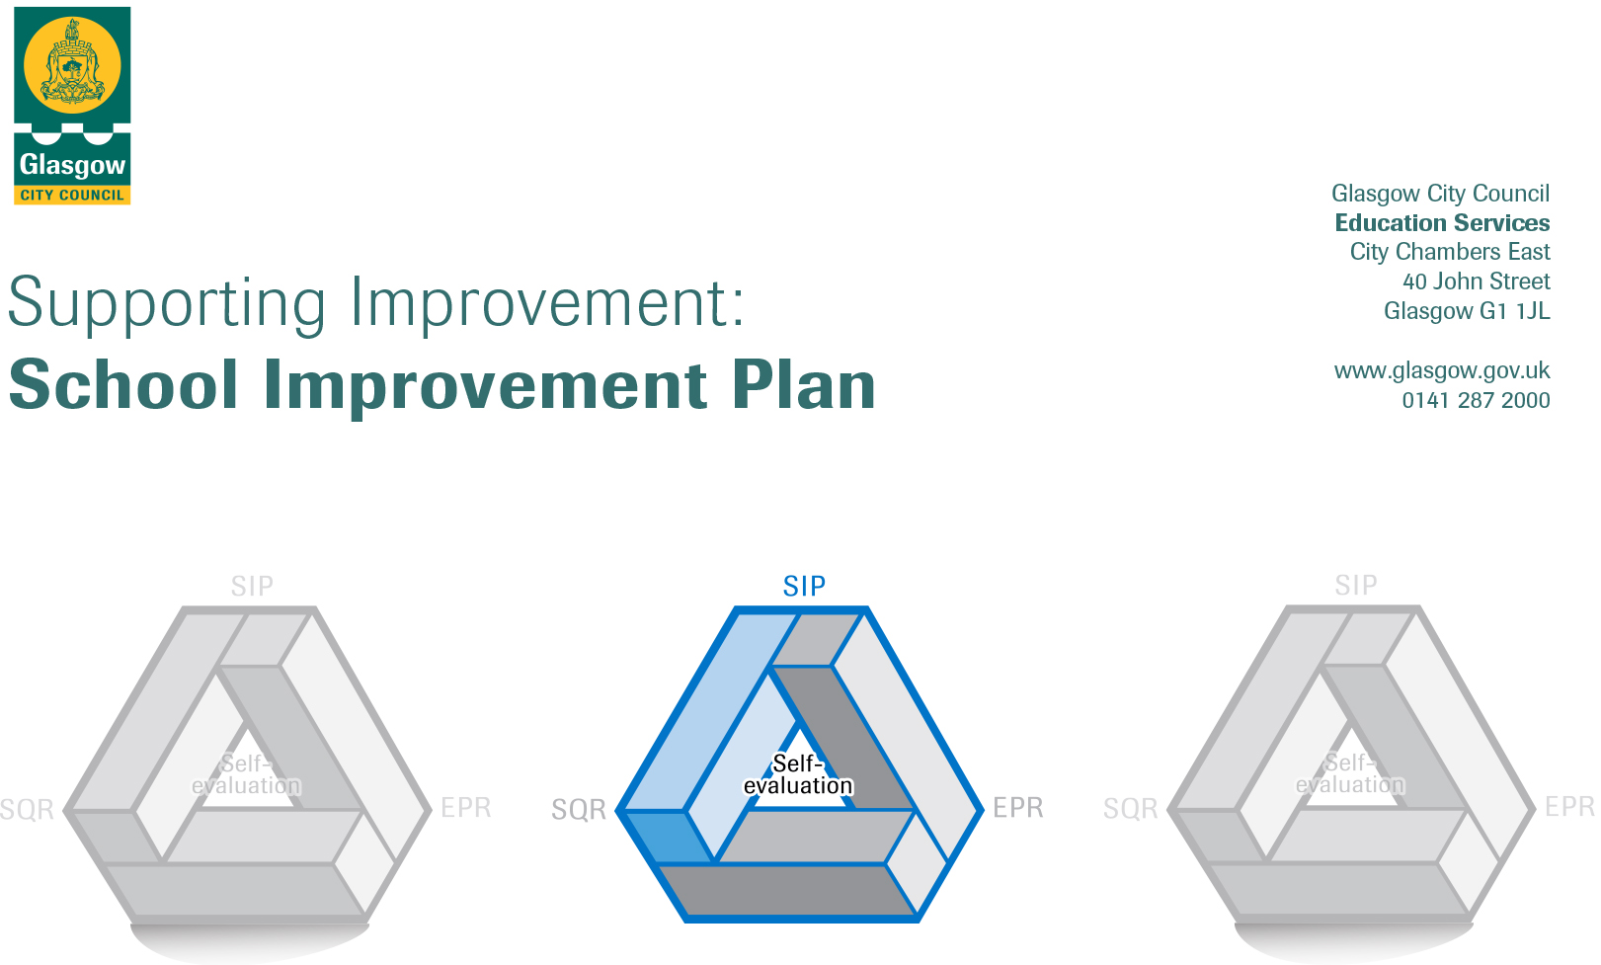

Session: 2021 - 22

Establishment |  | Knightswood Secondary School
Head of Establishment |  | Maura McNeil
Area/Local Improvement Group |  | NW2

Head of Service
Area Education Officer/ Quality Improvement Officer

CONTENTS
1. Vision, Values and Aims
2. Summary of Self-Evaluation Process / Priorities for Improvement in the current session
3. Action Planning

Action Plan Summary for Stakeholders

1. Our Vision, Values and Aims
Our Rights Respecting Group led the review of our Vision, Values and aims. They consulted all members of our school community – young people, all staff, parents / carers and partners.

Our new Vision, Values and Aims will underpin all aspects of school life.

2. Summary of our self-evaluation process.
All of our staff and young people have been involved in the consultation for our school improvement plan. Staff took part in workshops which identified our priorities and reviewed our plan for last session. Through our newly established Senior Conferences the views of S5-6 young people were sought and S2-4 gave their thoughts through interactive tasks during Assemblies. At present we do not have a Parent Council and re-stablishing our links with Parents / Carers post-Covid is a priority for next session. We have sought Parents / Carers views at recent Parents/Carers Evenings but this consultation requires to be wider going forward. We also sought views of partners through an MS Form.
Priorities for development:
- Learning, Teaching & Assessment
- Improving wellbeing, equality & inclusion
- Raising attainment and achievement
- Family Learning
- Curriculum
- Transitions

Glossary of terms:
SLT – Senior Leadership Team  PT – Principal Teacher  PT RA – Principal Teacher Raising Attainment (PEF Funded) | LAC – Looked After and Accommodated Children  SIMD – Scottish Index of Multiple Deprivation  PEF – Pupil Equity Fund | SQA – Scottish Qualifications Authority  CfE – Curriculum for Excellence  RWI – Read Write Inc  DYW – Developing the Young Workforce | STEM – Science, Technology, Engineering and Mathematics  BGE – Broad General Education  SEAL – Stages of Early Arithmetical Learning | SDS – Skills Development Scotland  PPR – Promoting Positive Relationships  HSSW – Home School Support Worker

3. Action Planning

No. | Quality Indicator | Priority
1 | 2.3 | Learning, Teaching & Assessment

Tasks to achieve priority | Timescale  and checkpoints | Evidence of Impact > (data, observation, views)
- Embed our new Learning and Teaching policy ensuring that all staff have a secure a shared understanding of the features of high quality learning to bring greater consistency to classroom practice  - Continue to provide training on classroom strategies such as MTV, AIFL, questioning and use of Learning Intentions and Success Criteria through the Pedagogy Pods to support this.  - Review our approaches to planning learning to ensure all lessons are well planned to provide high quality learners experiences with appropriate challenge and taking account of the needs and interests of all young people whilst providing opportunities for young people to be responsible for their learning and have opportunities to lead their learning.  - Continue to embed our refreshed Vision, Values and Charter consistently across our school.  - Continue to embed our Strive for 7 to support the use of the ipad and digital technology in classroom.  - Further develop our approaches to feedback and learner conversations to inform and support progress in learning ensuring Young people understand where they are in their learning and how they can improve.  - Develop our approaches to tracking pupil progress so that we have a clear overview of the progress of all young people as well as specific groups of young people eg LAC, Young Carers and have a range of appropriate interventions to support those not making progress.  - Continue to work with our associate primary schools and secondary trio colleagues to develop a shared understanding of standards through joint planned moderation activities | September  October  November  December  January  February  March  April | All staff are engaging with our new Learning and teaching policy and there is a consistency in pupil experiences Classroom observations, Pupil focus groups, Feedback from Pedagogy Pods  There is consistent approach to planning learning within departments, Classroom observations, Pupil focus groups, DM minutes, Records of work  Our Vision, values and charter underpins all lessons.  Classroom observations, Pupil focus groups, DM minutes, Records of work  The planned, consistent use of digital technology is enhancing the learning experience in all classrooms Classroom observations, Pupil focus groups, DM minutes, Records of work  Increased staff confidence in carrying out high quality learner conversations with young people with young people being able to articulate where they are in their learning and their next steps in learning. Pupil focus groups, Feedback from PTS/FHs at SLT Link Meetings TLCs Departmental Learner Conversations  Successful introduction and whole staff use of GCC tracking system to support learning and teaching. Feedback from pupils, staff and parents. cares. SLT Link Meetings.  All staff are using available tracking data to ensure all learners as well as specific groups of learners are making appropriate progress from their prior levels of attainment and there are appropriate interventions in place where this is not the case. Departmental Meeting Minutes SLT / PT / FH Link Meeting minutes Departmental system of tracking interventions  All staff have a secure understanding of standards across the BGE and National Qualifications DM Minutes, records of moderation activities

Staff leading on this priority – including partners | Resources and staff development
- K. Anderson, C. Docherty, L&T Strategic Group and all staff.  - K. Anderson, C. Docherty, L&T Strategic Group and all staff.  - All teaching staff led by PTs/FHs  - All staff  - L. Seagrave & the digital strategy group and all staff  - K. Anderson, C. Docherty, The L&T Strategic Group and all staff.  - L. Seagrave & Tracking & Monitoring Group  - M. McCreaner, G. Frizell & Transitions Group | WTA / In-service time

No. | Quality Indicator | Priority
1 | 3.1 | Improving wellbeing, equality & inclusion

Tasks to achieve priority | Timescale  and checkpoints | Evidence of Impact > (data, observation, views)
- Further development of Promoting Positive Relationships including continued development Rights Respecting Schools Programme and development of a Promoting Positive Behaviour Policy as well as reviewing our Bullying and Equalities Policy in line with recent changes to legislation.  - Continue to review attendance procedures and flexible support to increase engagement of young people  - Embed a nurturing approach across our school and increase nurture provision.  - Develop a whole school approach to supporting the mental health and wellbeing of young people  - Continue to develop our PSE course in line with national expectations ensuring Young people gain an understanding of the wellbeing indicators.  - Develop a systematic method of tracking young people’s progress in wellbeing to identify and address their needs. | September  October  November  December  January  February  March  April | All members of the school community will be aware of the Rights Respecting School Award and the progress we are making towards achieving the Silver Award Pupil, staff, parents and partners views records of meetings  The Promoting Positive Relationships strategy will be developed to reflect embedding the nurture principles and Rights Respecting Schools Award Promoting Positive Relationships strategy Pupil, staff, parents and partners’ views  Bullying Policy and Equalities policy updated to reflect recent changes in legislation. Updated Bullying and Equalities Policy Pupil, staff, parents and partners’ views  Strategies established during session 2021-22 to support attendance will continue to be embedded Pupil, staff, parents and partners views Attendance Statistics  A range of supports including Farebear groups and working with partner agencies will be developed to support the needs of young people unable to access the curriculum on a full time basis to support their attendance Bespoke timetables, Pupil, staff, parents and partners views Attendance Statistics, Group work plans, feedback from external agencies  All staff will be aware of the nurture principles and these will be embedded in all areas of the school Pupil, staff, parents and partners views  Departments will develop a consistent approach to the nurture principles within their classrooms Pupil, staff, parents and partners views  There will be Mental Health Policy in place which is effectively supporting the needs of young people. Pupil, staff, parents and partners views  PSE courses will be in place which reflect national guidance as well as priorities identified through the tracking of wellbeing and other areas. Course plans, Pupil, staff and parent feedback  Wellbeing tracking system in place which identifies and addresses the needs of young people Course plans, Pupil, staff and parent feedback

Staff leading on this priority – including partners | Resources and staff development
- K. Anderson & L. Seagrave – RRS Group, PT PC all staff  - L. Seagrave, PT PC, HSSW, Office Staff, Farebears – all staff  - L. Seagrave & PT PS – Learning & Inclusion  - L. Seagrave & PT PC – all staff  - L. Seagrave & PT PC | Family Learning Officer  Third Sector Organisations  Associate Primaries  WTA time / In-service  PEF – additional HSSW

No. | Quality Indicator | Priority
2 | 3.2 | Raising attainment and achievement
Tasks to achieve priority | Timescale  and checkpoints | Evidence of Impact > (data, observation, views)
- Improved attainment outcomes for a wider group of targeted pupils (S1-6)  - Improved and consistent development of targeted and whole school literacy and numeracy provision including embedding SEAL, RWI and Reciprocal Reading. An increased focus on Literacy across the Curriculum. | September  October  November  December  January  February  March  April | All members of the school community will be aware of the Rights Respecting School Award and the progress we are making towards achieving the Silver Award Pupil, staff, parents and partners views records of meetings  The Promoting Positive Relationships strategy will be developed to reflect embedding the nurture principles and Rights Respecting Schools Award Promoting Positive Relationships strategy Pupil, staff, parents and partners’ views  Bullying Policy and Equalities policy updated to reflect recent changes in legislation. Updated Bullying and Equalities Policy Pupil, staff, parents and partners’ views
Staff leading on this priority – including partners |  |  | Resources and staff development
- SLT & PT RA – all staff  - PT Pupil Support – Learning & Inclusion, PT Mathematics, PT English – M. McCreaner |  |  | Increased access to councillor Increased SLAs  Nurture Training Campus Police Officer  Enhanced Pupil Support Areas HSSW  In-service time DM time

No. | Quality Indicator | Priority
3 | 2.5 | Family Learning
Tasks to achieve priority |  |  | Timescale  and checkpoints | Evidence of Impact > (data, observation, views)
- Development of family learning and further enhancing parental engagement and parent / carer support programmes |  |  | September  October  November  December  January  February  March  April | All families will have access to high quality Family Learning Activities Parents views Partner views pupil views Family Learning Programme

Staff leading on this priority – including partners | Resources and staff development
- Family Learning Officer & K. Anderson | PEF

No. | Quality Indicator | Priority
4 | 2.2 | Curriculum
Tasks to achieve priority |  |  | Timescale  and checkpoints | Evidence of Impact > (data, observation, views)
- Review and develop the curriculum to ensuring pace and challenge in the BGE incorporating the use of digital technologies as appropriate  - Continue to expand the range of qualifications offered in the Senior Phase including working with third sector organisations to enhance our offer curricular offer including out of hours learning  - Development of STEM and DYW in all departments including employer engagement and the use of My World of Work embedded into Personal and Social Education to support profiling and CV writing. |  |  | September  October  November  December  January  February  March  April | Departments will contribute to a full audit of BGE we are currently delivering to identify where Es&Os are covered across the curriculum leading to the development of a BGE which reflects the principles of curriculum design Course plans, departmental meetings, moderation evidence  All staff will engage with the moderation cycle in order to develop the learners’ experience in the BGE. Moderation programme. In-service resources. Sampling of staff planning and pupil experience.  Departments will continue to review their senior phase offer to ensure it is meeting the needs of all learners providing opportunities for progression Senior Phase offer  Greater use of partners to deliver a wider range of qualification to meet the needs of all young people Senior Phase Offer  S4-6 young people will have the opportunity to participate in a Work experience placement at a time suited to their need. Work experience records  S4-6 young people will have the opportunity to engage in a Mock interview as appropriate and will be supported to complete CV’s and Personal Statements Mock interview schedule Pupil feedback Interviewers feedback  STEM will continue to be developed across the cluster STEM Events Pupil Feedback Partner Feedback Departmental Minutes  All staff will be aware of the Career Standard and Departments will have a consistent approach to highlighting the skills being developed so that all young people have a clear understanding of these. Departmental minutes Course plans pupil views  All staff will have an understanding of My World of Work and how it can be used within their subject area. Departmental Minutes Course Plans Pupil Feedback  My World of Work will be used for the P7 Profile and this will be built upon during S1&2 Social Education courses leading to the production of the S3 Profile MWW Profiles S1-3 Profiling

Staff leading on this priority – including partners | Resources and staff development
- C. Docherty, M. McCreaner & L. Seagrave  - J. Hood, K. Anderson & PT FHs  - PT RA – DYW | DM Time  Inservice time  Development time from WTA

No. | Quality Indicator | Priority
5 | 2.6 | Transitions
Tasks to achieve priority |  |  | Timescale  and checkpoints | Evidence of Impact > (data, observation, views)
- Increase awareness of and communication of pupil needs particularly at points of transition and facilitate further training for staff to support these within the classroom environment |  |  | September  October  November  December  January  February  March  April | All young people will have appropriate support as they transition from P7 to S1 to ensure that they have continuity of learning Moderation activities with P7 Staff Curricular visits by P7 / KSS staff as appropriate to support this  Young people with additional support needs will have enhanced transitions which reflect GCC policies and good practice Notes from visits pupil views parents views  Staff will have access to high quality information at the points of transition, in particular P7 into S1 and S2 into S3 Learning Support/Pastoral Care Information Departmental Tracking information  All staff will have access to a menu of CPD opportunities to support them to meet the needs of learners In house CPD Opportunities In-service Day Programmes External CPD Opportunities

Staff leading on this priority – including partners | Resources and staff development
- M. McCreaner & PT PS – Learning & Inclusion | DM Time  Inservice time  Development time from WTA

