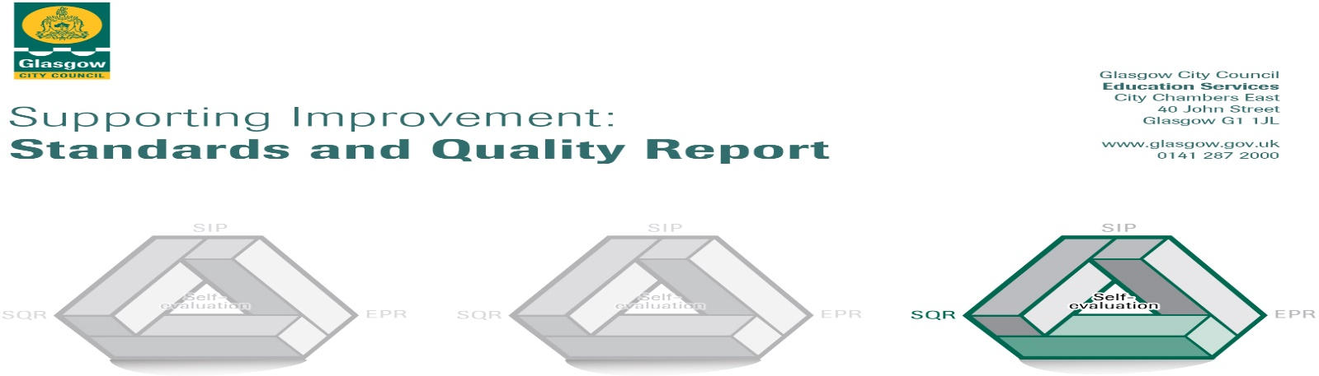
The summary report is provided for parents/careers and partners to outline our achievements this session and our priorities for next session. Throughout this session we have taken forward our priorities as detailed in our School Improvement Plan. Through our processes of self-evaluation, we have identified how we can improve outcomes for our children and young people.
Our achievements and improvements this year.
There have been many great achievements and success during this session, however, one the highlights of last session was to receive our UNICEF Silver Rights Respecting School Award. This award recognised the work the whole school community has made to recognise the rights of young people and to create an ethos where these are respected. Embedding our refreshed School Charter was key to this success.
We made considerable progress with our improvement priorities and we would like to highlight the following improvements/achievements. Last session we had a key focus on the following areas:
Learning, Teaching & Assessment
We continued to embed our new Learning and Teaching Policy which is bringing about a greater consistency to the classroom experience for all young people. All staff are members of Pedagogy Pods which met nine times last session to discuss how they can improve their classroom practice and better meet the needs of all young people. These had a focus on digital learning as we continued to embed the use of the iPad in classroom practice. They also looked at how we could improve feedback to young people who now have a growing understanding of where they are in their learning and what they need to do to improve. We continued to develop our approaches to pupil tracking so that we can ensure that all young people are making progress with their learning and to have appropriate interventions when this is not the case. To support this, we worked with primary colleagues on moderation to further develop our understanding of standards and to support transitions.
Improving wellbeing, equality & inclusion
Our new Promoting Positive Behaviour Policy was launched and this is leading to a greater consistency across the school. As part of this, we reviewed our Bullying and Equalities and Child Protection and Safeguarding Policies to ensure they were in line with changes to legislation. We recognise that some young people have barriers to attending school regularly and we reviewed our policies to increase engagement. To support this, we continue to embed a nurturing approach across the school and all staff completed All Behaviour is Communication Training (ABC) to support this. We also increased the number of nurture groups within the school. These help support the mental-well being of all young people and we now have a whole school strategy to support the mental wellbeing of young people and staff. Our Social Education Programme is key to this and we continue to review our provision in this area. This includes all young people understanding the wellbeing indicators and completing regular reviews to this which helps inform the interventions we can put in place to support young people.
Raising attainment and achievement
During last session we continued to embed our literacy and numeracy interventions to support young people who have gaps in their learning to support them to access the curriculum. These include our Read, Write, Ink and SEAL programmes (a numeracy intervention) as well as Reciprocal and Paired Reading. Our young people tell us that they benefit from these programmes and by careful tracking we can see the progress they are making.
We aim to raise the attainment and achievement of all young people and there are details of this further on.
Family Learning
Our Family Learning took place through a number of Fairs – Christmas, Easter and Summer – where families were able to come along and enjoy some free food and fun learning tasks together.
Curriculum
We are always striving to have the best experience for our young people and began a review of our Broad General Education (BGE) which is delivered in S1-3. A key focus of this was to look at how we can embed skills for life, learning and work into our everyday practice.
We have expanded the range of qualifications available to young people including Laboratory Skills, Criminology, Travel &Tourism as well as Business and IT. Working with partners we were able to offer a wide range of qualifications such as Barista, Health & Safety at Work, Personal Development Award and, by working with the DRC we were able to build a bespoke Hair and Beauty Couse which delivered a range of qualifications.
Transitions
We work very closely with our associated primary schools and with them have reviewed our transition programme to include more visits from secondary school staff to primary classrooms. We have also had a key focus on supporting young people with Additional Support Needs at the time of transition. This has included an Enhanced Transition programme with more visits to the secondary school and also an additional transition day for these young people.
We are in the very fortunate position to be in receipt of a substantial PEF Funding.
This funding has allowed us to develop strong partnerships with third sector organisations and have allowed us to recruit three Youth Workers through FARE. We now have a strong partnership with the Rangers Charity Foundation which means we have a Hub Officer who supports employability and positive destinations alongside our existing Developing the Young Workforce Co-ordinator.
Our funding has also allowed us to increase the Counselling service available to young people, which was invaluable to support the health and wellbeing of young people during lockdown. We now have provision 4 days per week.
It has also enabled us to have a Campus Police Officer on site which has resulted in a very strong partnership with Police Scotland. It also allows us to have a very active role in in the community as they lead twice weekly litter picks.
Through this funding we have increased the Librarian provision which means the library is available to young people everyday supporting their literacy development.
Wellbeing, equality and inclusion
There is an integrated model of Pupil Support within the school which is effective in targeting appropriate resources based on individual and group plans. Our Pupil Support Staff demonstrate a high level of commitment in their support of young people with Additional Support Needs through facilitating additional supports for target groups focused on enhanced nurture, Read, Write, Ink, ASC support, post-dyslexia assessment support and Seasons for growth; as well as providing in-class support.
Our Knightswood Inclusion and Intervention Team and Learning Community Joint Support Team meet regularly to engage the support of other agencies in meeting the needs of vulnerable young people and those in danger of missing out, while the school youth workers and counsellors provide support to individual and groups of pupils.
Progress in improving outcomes for children in attainment and achievement
At present the majority of the young people in S1-3 are broadening and deepening their educational experience through courses built around the Experiences and Outcomes at Level 3 within the Curriculum for Excellence framework.
Attainment by the end of S4 | Attainment by the end of S5 | Attainment by the end of S6
81% achieved five or more Level 3 Awards  79% achieved five or more Level 4 Awards  45% achieved five or more Level 5 Awards | 56% achieved 5 Level 5 awards or better  74% achieved one or more Level 6  42% achieved three or more Level 6  14% achieved five or more Level 6 | 62% achieved 3 or more Level 6  43% achieved 5 or more Level 6  21% achieved 1 or more Level 7
Although we are very pleased with the improvements in performance, this still remains a priority for the coming session. In addition to sitting National Qualifications our Dance and Musical Theatre students sit a number of performance exams.
We also worked with FARE and the DRC who delivered a range of qualifications such as Barista, Health & Safety at Work as well as industry standard beauty qualifications which are not reflected in the figures above.
Leaver Destinations
These figures reflect continuing improvement in positive destinations
37% of students went on to Higher Education 29% of students went on to Further Education
7% of students went on to Training 17% of students went on to employment.
1.3% Personal Skills Development 3.2% Unemployed not seeking
4.6% Unemployed seeking
Wider Achievements
We continue to offer a wide range of extra-curricular activities. Our Duke of Edinburgh programme is very well established and large numbers of our young people benefit greatly from this and young people gained Bronze and Silver Awards. There are many opportunities for leadership with in the school. Young people make positive contributions to the life of the school through committees and assistance with our Family Learning Programme, the ECO group and the Rights Respecting Schools Student Council as well as the LGBT group and our new formed Anti-racist group. Pupils are now gaining recognition for the work in these both through the Saltire Award and the Youth Achievement Award.
We also introduced our Senior Captaincy and Prefect Team which gave young people an opportunity to lead with in their school through a range of opportunities.
Following a break due to Covid, we were once again able to run our Creative and Aesthetic Evening showcasing our art, music and drama talent. Our musicians also had their first ever Summer Concert giving our ever-expanding orchestra and soloists an opportunity to show case their talents.
Our young people who attend the Dance School of Scotland dance and musical theatre course provide us with many opportunities throughout the session to attend performances in theatres across the city as well as here in school.
Our Annual Awards Ceremony is a fantastic event as the whole school community gathers to celebrate the amazing achievements of our young people. This was led by our young people and again was a fabulous celebration of the diverse skills and talents of our young people.

Here is what we plan to improve next year.
Grand Challenge To provide an inclusive education meeting the needs of all learners
Mission 1: Improve attendance of the 19% (S2-6 Aug – Mar figures) of young people with <75%
Mission 2: Fully embed our Promoting Positive Behaviour and Equality Policy in the life of the school
Grand Challenge All young people experience high quality learning, teaching & assessment
Mission 1: To fully embed our Learning & Teaching policy in all classrooms in our school providing a consistent experience for all young people
Mission 2: To develop curriculum to provide challenge
Grand Challenge Raising attainment and achievement for all learners
Mission 1: increase attainment in Literacy & Numeracy in the BGE and refine approaches to tracking attainment
Mission 2: Increase attainment in Senior Phase

How can you find out more information about our school?
Please contact us directly if you require further information or if you wish to comment on the report.
The contact e-mail address is: Headteacher@knightswood-sec.glasgow.sch.uk Our telephone number is: 0141 582 0160
Our school address is: 60 Knightswood Rd, G13 2XD Further information is available in: newsletters, the school website, and the school handbook

