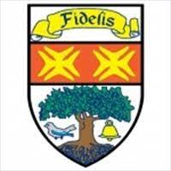

Knightswood

Secondary School

For help to claim EMA speak to your ***Pastoral Care Teacher***

What would you do with £30 a week?

**EDUCATION**

**MAINTENANCE**

**ALLOWANCE**

If you are aged 16-19 and have stayed on at school, you may be able to claim Education Maintenance Allowance (EMA).

This is worth £30 per week.

To claim you must attend school for at least 21 hours per week.

