Dear Parents and Carers,
Here we are nearly at the end of 2023 and there is a lot planned before the final bell of the year which I thought you would like to know.
This letter also includes our first “Keeping KSS Young People Safe” bulletin with information about how we aim to do this here in Knightswood Secondary School as well as information on recent assembly inputs that all S1-3 have had during recent assemblies.
Our S4-6 young people have started their prelims and we have been impressed by their preparations for these. This is a change of timing for us and we will look for feedback from young people, staff and parents / carers in the new year.
We have a number of events planned also over the next two weeks.
12th December 2023 – S1 Pantomime Trip
13th December 2023 – Fuel Zone Christmas Lunch
18th December 2023 – S2 Cinema Trip
18th December 2023 – Christmas Concert 6.00pm – 7.00pm in the Drama Studio
19th December 2023 – S1-2 Ceilidh P6&7
20th December 2023 – Happiness Event P6&7
20th December 2023 – Christmas Fair 3.45pm – 5.00pm
22nd December 2023–School closes at 2.30pm. We re-open on Monday, 8th January 2024 at 8.45am
Extra-curricular Clubs
We still have lots of extra-curricular clubs on offer. There are details at the end – please encourage your young person to take part in these. Lots to get involved with!
Parents evenings Session 2023 – 24
Our recent S1 Parents’ / Carers’ Evening was very well attended and it was great to meet so many of you at this. The dates of our next evenings are below.
Term | S1 | S2 | S3 | S4 | S5-6
Jan – Mar | Interim report issued | Full report issued  Parent / Carer Evening 28th February 4.00pm – 6.30pm |  | Interim Report issued  Parent / Carer Evening 8th February 2024 4.00pm – 6.30pm | Interim Report issued  Parent / Carer Evening 30th January 2024 4.00pm – 6.30pm
Apr - Jun | Full report issued |  | Full report issued  S3 Exams

SQA Exams
SQA Exams are scheduled to start on Monday, 22nd April and finish on Wednesday, 29th May 2024. You will find the SQA timetable here 2024 Exam timetable revision 4 031023.indd (sqa.org.uk). It should be noted that there are exams scheduled on the May holidays.
Supported Study
Our programme of Supported Study is currently underway and started in September. This will resume following the Christmas Break. Details will be emailed directly to young people via Glow and shared with Parent / Carers via Groupcall. Please encourage any young person in S4-6 to attend these sessions.
Behaviour in the community
Almost all of our young people behave extremely well and are ambassadors for our school in the local community. We regularly get emails and are stopped by local residents when we are the community at interval and lunchtime complimenting them on their behaviour. However, we do occasionally receive complaints about the behaviour of a small minority of our young people at lunchtime and at the end of the school day. These have included littering as well as throwing objects at vehicles and disrespectful behaviour on public transport. We continually re-enforcing the responsibilities of our young people when they are out in the community through assemblies and PSE lessons.
Our Campus Police Officer leads our S2-3 young people on twice weekly litter picks ensuring that we are playing our part in keeping our community tidy and the local residents do appreciate their efforts. There is more information from our Campus Officer at the end of this letter.

Pastoral Care Staff
Your young person sees their Pastoral Care Teacher twice a week in Personal and Social Education and they know your young person really well. If you have any questions then their Pastoral Care Teacher is ideally placed to answer these and should always be your first point of contact with the school.
Arran – Mrs. McLelland / Ms DiRollo Bute – Mr. Deveny Harris – Mrs. Schimmel
Islay – Mrs. Whelehan Skye – Mr. Shields Tiree – Mrs. Gray
Parent / Carer Council
Thank you to the Parent / Carers that can along to our second meeting. We agreed dates for the session and we are looking for new members to join our Parent / Carer Council. This is open to all parents / carers who have young people in Knightswood Secondary School.
Date | Theme
25th January 2024 5.45pm – 6.45pm | The role of Pastoral Care
18th March 2024 5.45pm – 6.45pm | Supporting young people with Additional Support Needs
14th May 2024 5.45pm – 6.45pm | School Improvement Plan for next session

What is the role of the Parent Council?
The Parent Council helps to create an environment where all parents know that their views matter, and where they feel confident and comfortable putting them forward. They work on behalf of all parents to discuss educational matters that are of importance to all. They do not get involved in individual circumstances relating to children or staff in the school.

Thank you again for your continued support and I look forward to continuing to work in partnership with you in 2024.
Maura McNeil Head Teacher

Meet our Campus Police Officer
I am Police Constable Evie Coultas. I have been working as Campus Police Officer within Knightswood Secondary School for over a year. I thought it would be useful to introduce myself and let you know a bit more about what my role is within the school.
I often get a response of shock when I inform people I am a police officer within a school. I believe there is a presumption that the role of Campus Police Officer is to tackle unruly behaviour. However this is not the case.
This role enables Police Scotland to work in close partnership with Knightswood Secondary School; delivering a service to both the school and its community. This unique position, being a police officer and working within this school, allows me to: enhance the learning environment by delivering safety and educational inputs; assist pupils at risk or who have challenging behaviour; create a safe environment for pupils and staff; advise and coordinate any concerns which are raised by the community to the school. I hope all of this will bring a positive change to the relationship the young people have with the police and help them to develop respect for themselves, their fellow pupils and their community.
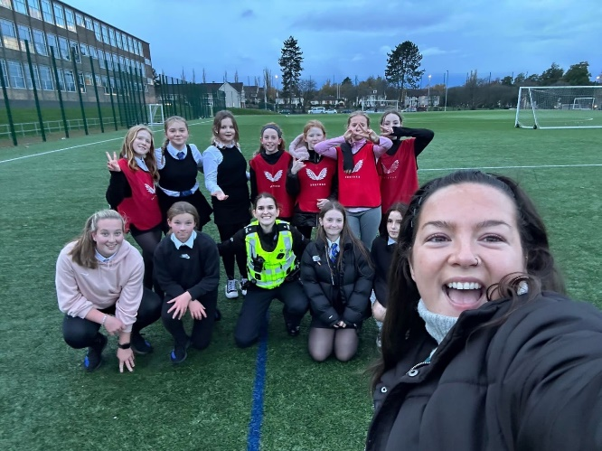
I look forward to continuing in this role as the Campus Police Officer at Knightswood Secondary School; working with staff and parents to encourage the positive choices of our young people.

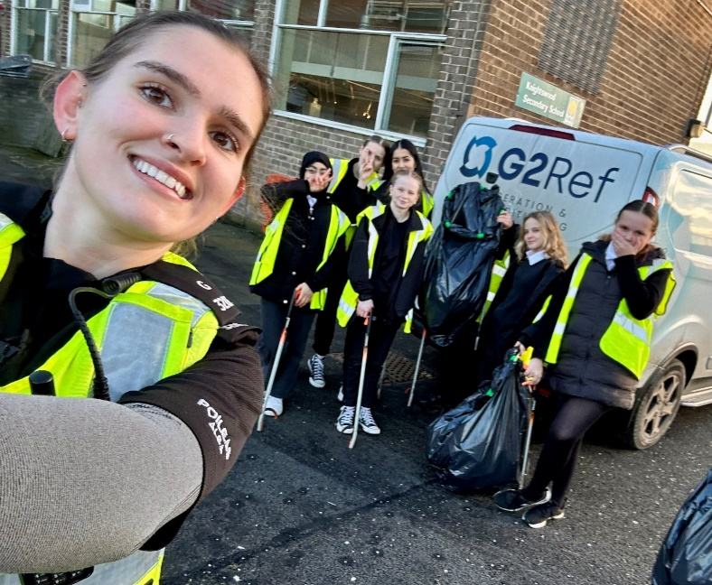
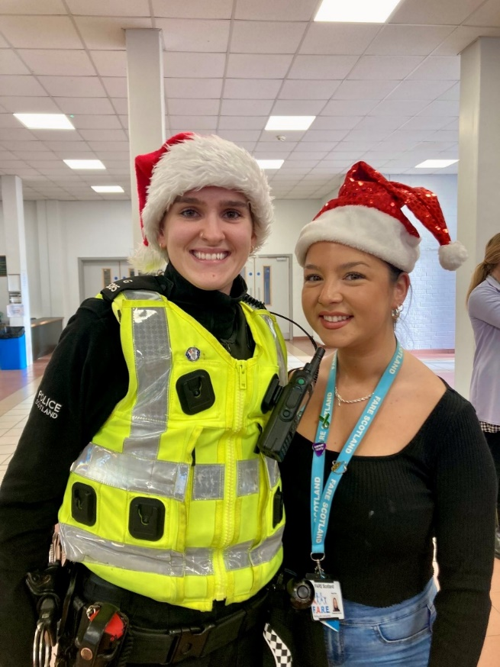
Extra-Curricular Clubs
MONDAY | TUESDAY | WEDNESDAY | THURSDAY | FRIDAY
LUNCH | LUNCH | LUNCH | LUNCH | LUNCH
S1-3  BGE DANCE  Every Monday 1.15-1.45PM  Location: PE Gym 3  S1-6  Monthly Newsletter Mrs Frizzell  Location: English Base  S1-6  EAL Buddy Club  Mrs Morgan  Location: F20  S1-S6  School Orchestra  Music Department | S1-6 Set and Costume Design Ms Gallagher  Location:S11  S1-6 Coding Club Mrs Graham  Location: S01  S1-6 Chess Club Senior Pupil  Every Tuesday and Thursday Lunchtime  Location: Library | S1-6 Debate Club Ms Teasdale/Mr Airdrie  Location: G06  S1-6 Well-Being Drop In  Miss Di Rollo  Location:F10  S1 Craft Club  Location: G12 | S1-6  Chess Club  Senior Pupil  Every Tuesday and Thursday Lunchtime  Location: Library  S1-S6  String Assemble  Music Department | S1-6 Running Club  Every Friday 7.30am-8.15am  Location: PE Base
MONDAY | TUESDAY | WEDNESDAY | THURSDAY | FRIDAY
AFTER-  SCHOOL | AFTER-  SCHOOL | AFTER-  SCHOOL | AFTER-  SCHOOL | AFTER-  SCHOOL
S1-6  Garden and Painting Club Ms Gallagher  Location:S11 | S1-3  Drama Club Mr Airdrie  Every Tuesday 3.30-4.30pm  Location: Drama Studio | S1-6  Netball  Every Wednesday 3.30-4.30PM  Location: PE Gym Hall  S1-6 Set and Costume Design  Ms Gallagher  Location:S11 | S1-6 FAREBEARS  Fitness  Location: Fitness Suite  S1-6 FAREBEARS  Football  Location: PE ASTRO  S1-6 FAREBEARS Badminton  Location: PE Gym Hall  S1-6 Film Club Mr Airdrie  Location: F23 | Boxing Club  Location: PE Dept

