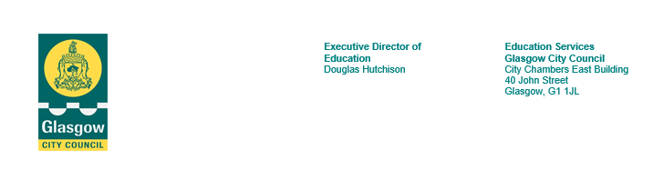

November 2023

Prelim Examinations 2023

Dear Parent Guardian,

Study leave for all S4,5&6 pupils will begin on Monday 11th December and will run until Thursday 21st December 2023 (inclusive.)

Pupils who are studying National 3 and 4 courses will have to attend at the times specified in the timetable that will be issued in due course and placed on TEAMS and the school website.

There will also be a timetable of master class support that all pupils can access before their exams with subject specialists, please make use of this valuable opportunity as it will set you up for your exam the next day. Again this will be published on TEAMS and the school website once complete.

There will be a study room timetable published outside of Mr Hood’s office for pupils who would prefer to come into school to study.

Can I remind you that pupils should be in full school uniform when in school for exams or study sessions.

I would like to take this opportunity to wish our senior pupils the very best of luck in their upcoming prelim examinations.

Regards

Mr John Hood

Depute Head Teacher