Knightswood Secondary School

We know that things are very different just now but this
booklet contains some information for when school gets
back to normal.

Please read this short booklet and then put any questions
you have on our P7 Transition Survey.

Our timetable:
Our school day starts at 8.45 am every day. You don’t need to know when every lesson starts. Your teachers and our S6 buddies will help with the timings and how to get to your next lesson.

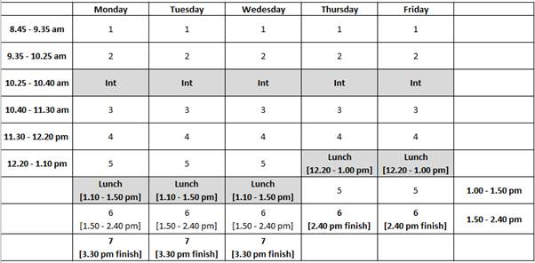

At interval and lunchtime you can buy a wide range of snacks and meals in our Fuel Zone canteen. You will be given a Q card and can put money on it online so you don’t need to bring cash to school.

You can also bring a packed lunch and we have lots of sitting space in our Fuel Zone. We also have a playground set aside only for S1s.

Honesty, Ambition, Responsibility, Respect, Inclusion

“A place of excellence and an excellent place to be"

The teachers that will help you:

When you start secondary school you will find that you have more teachers than you did in Primary. That means there will be more people to help you! There are also specific teachers whose job it is to support you when you are at Knightswood Secondary.

Pastoral Care teacher – this is the person you can go to for advice and support. They will also teach you two periods of Personal Social Education each week. You will have the same pastoral care teacher throughout your time at KSS. If you have any brothers or sisters here, you will have the same Pastoral Care teacher as them. You can ‘meet’ them in one of our video greetings this term.

Year Group Head – your Year Group Head supports pupils from S1-3 and will support you along with your Pastoral Care teacher. They will also do a video welcome this term.

Support for Learning department – the Support for Learning department are there to help your learning. They are experts in helping with literacy and numeracy and run various groups to help S1s settle into school.

Subjects you will study in S1:

English, Maths, Science, Social Studies, French, Physical Education, Art, Drama, Music, Information Technology, Religious Studies and Personal & Social Education,.

Our specialist facilities include 12 science labs, 9 computer suites, 3 technical workshops, and 4 gym halls.

Other forms of learning you can do:
We also offer a wide range of extra-curricular clubs such as football and other sports teams, Science & STEM club, library and reading ambassadors, Cooking club,

School tablets:
In October, every KSS pupil will receive a tablet computer for their school work. We are very excited about how tablets will help your learning. You will need to remember to charge and bring it to school every day.

Homework:
Different subjects give different amounts of homework but you should expect to get some homework each day. It is important to start your homework on the day you get it so you can ask for help if there is anything you don’t understand.

Doing homework helps to reinforce your learning and gets you in good working habits for the rest of your school career.

School dress code:
- White shirt
- School tie
- Plain black V-neck jumper
- Black skirt / trousers
- Black school blazer or plain black jacket

You can buy a tie and blazer from the school and other parts of our dress code can be bought from most supermarkets.

You will also need to bring sports kit on the days that you have PE. This should be a plain blue T-shirt, black shorts, socks and trainers. You can wear tracksuit bottoms in colder weather.

Equipment for classes:
Being prepared is very important and you should aim to bring a school bag and the following equipment every day.



Good learning routines:

One of the most important things that you can bring to school is a good attitude to learning.

Our ‘Back to Basics’ routines are important for helping everyone to get the best out of their time at secondary school. We will talk more about these when you start with us.

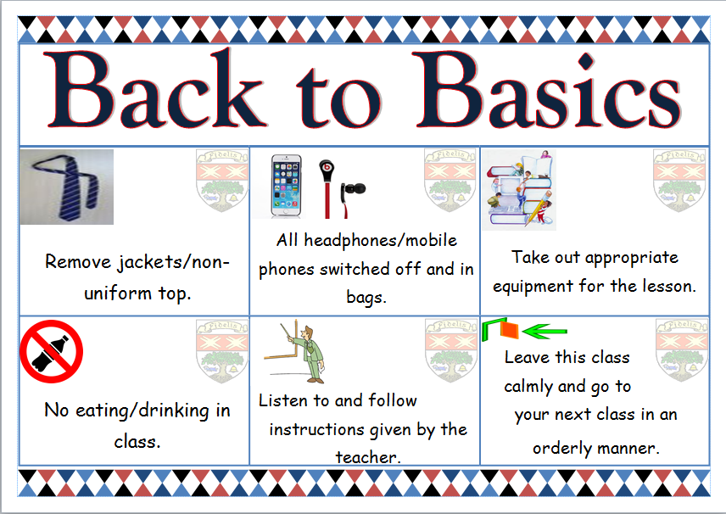

Attendance – coming into school every day you possibly can

Time-keeping – making sure you are at lessons on time

Morning intervals and lunch – staying in the school ground

Telling teachers if you are worried about anything

Working well with your teachers in every class

Working well with other pupils – be kind and help others

Remaining calm between lessons and keep left in the corridors

Represent our school well when coming and going from school

Have a growth mindset – you will get better at anything if you accept advice and are prepared to work hard to improve.

Honesty, Ambition, Responsibility, Respect, Inclusion

“A place of excellence and an excellent place to be"

