**S1 ICT – SELF ISOLATION TASKS**

All work for S1 classes can be found in Teams. Teachers will post each week to let pupils know what work they should be completing.

**Lesson PowerPoints**

These can be found in the files section of Teams in Class Materials. Select the topic the class are working on and open the relevant PowerPoint.

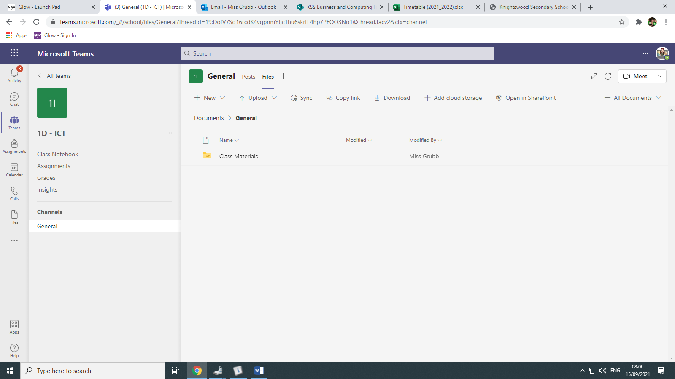

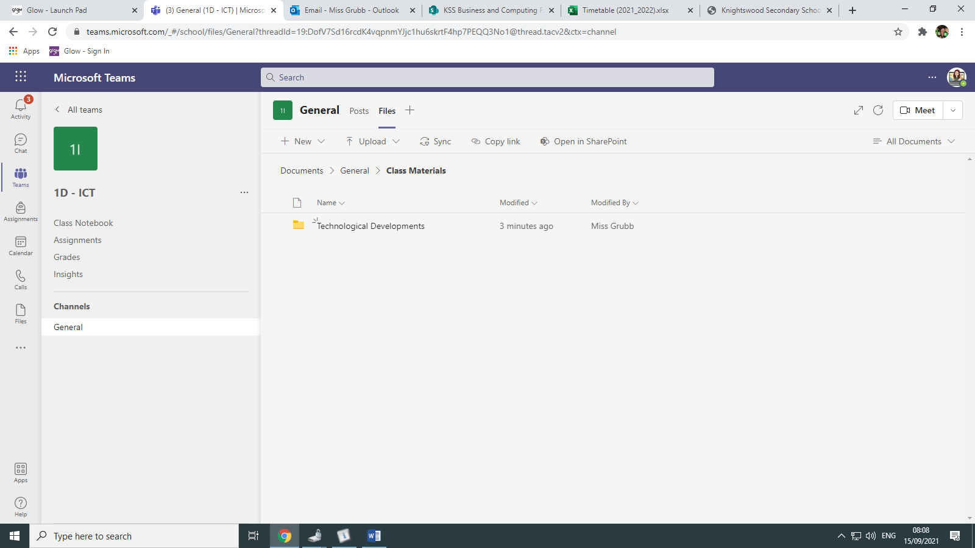

**Lesson Tasks**

These can be found in Class Notebook and link in with the PowerPoints for the lesson. Pupils should remember to click on their **own names** in Class Notebook to complete tasks.

