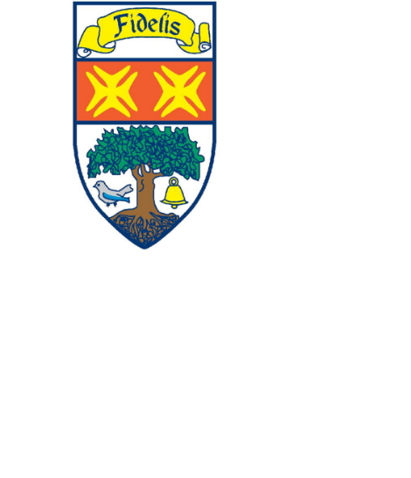KNIGHTSWOOD SECONDARY SCHOOL



Incorporating the Dance School of Scotland

**Dear Parent/Carer,**

At Knightswood Secondary School, we view school uniform as an important way of ensuring equity. School uniform not only helps to promote a sense of school identity; it also encourages a greater understanding of the importance of appropriate attire as our young people progress on to the world of work.

We would appreciate your support in ensuring that your child adheres to the Knightswood Secondary School’s Uniform Policy.

**KSS school uniform:**

* White shirt
* School tie
* Black trousers (not tracksuit trousers or gym leggings)
* Black skirt
* Plain Black jumper (no brands or hooded tops)
* Appropriate school footwear

**School Ties:**

These are available to purchase at:

https://app.parentpay.com/ParentPayShop/Uniform/Default.aspx?shopid=10914.

The cost of the school tie is £5.00.

Should you require a clothing grant, please access the appropriate forms from the following link: [Clothing Grants and Free School Meals - Glasgow City Council](https://www.glasgow.gov.uk/index.aspx?articleid=17885). The website also outlines who is eligible for: clothing grants and free school meals .