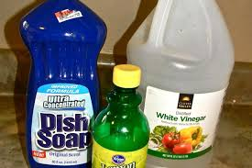S1

Acids and Alkalis Differentiated

Knightswood Secondary School Science

Name ____________________ CLASS ___________

Teacher____________________________

1. State that the pH scale is used to measure if a substance is acidic, alkaline or neutral.

Success criteria

1. Describe how to measure the pH of a substance using universal indicator or pH paper.
2. State that acids have a pH less than 7 and that alkalis have a pH above 7.
3. State that neutral substances, like water have a pH of 7.
4. State that acidic substances turn pH paper or universal indicator red/orange.
5. State that alkaline substances turn pH paper or universal indicator blue/purple.
6. State that neutral substances turn pH paper or universal indicator green.
7. Explain why the pH of an acid increases when it is diluted with water.
8. Explain why the pH of an alkali decreases when it is diluted with water.
9. Describe how to make an indicator for acid and alkalis using

vegetables.

1. Give examples of some common household acids, such as lemon juice

and vinegar and some common household alkalis, such as baking soda,

bleach and toothpaste.

1. Explain that by adding an alkali to an acid, the acid is neutralized.
2. Explain that by adding an acid to an alkali, the alkali is neutralized.
3. Give examples of everyday Neutralisation, for example: a bee sting is

acidic and can be neutralized by adding baking soda which is an alkali.

1. Give examples of everyday Neutralisation, for example: a wasp sting is

alkaline and can be neutralized by adding vinegar which is an acid.

1. Describe that a neutral solution can be evaporated to leave a salt at the

end

1. State that acid rain is produced from cars, factories and power stations.
2. Design and carry out an investigation to find out what antacid tablet is

most effective at neutralising stomach acid (hydrochloric acid)

**In the Science Department we will check your progress in a number of ways:**

1. Weekly Homework
2. End of Unit Class Tests
3. Demonstrating your learning to your teacher under the

following headings:

* + **Say**
  + **Make**
  + **Write**
  + **Do**



1. You could record yourself talking about something you have learned in your topic and let your teacher hear it.
2. You could give a presentation to your class.
3. You could discuss your topic with a small group of friends.
4. You could tell a parent or guardian or someone else at home about your learning.

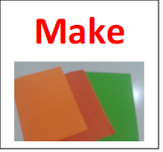

1. You could make a poster.
2. You could make a model.
3. You could make a presentation.
4. You could make your own revision worksheet.

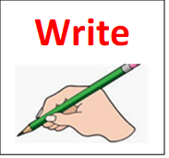

1. You could answer some questions about your topic.
2. You could write a story about your topic.
3. You could complete a worksheet about your topic.
4. You could write a paragraph about your topic.

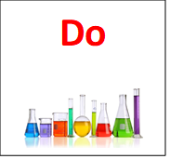

1. You could carry out an experiment.
2. You could carry out an investigation.
3. You could teach someone else in the class what you have learned.
4. You could do an online quiz or a checktest to check your learning.

**Starter Activities**

|  |  |
| --- | --- |
| **Lesson 1** | **Lesson 7** |
| **Lesson 2** | **Lesson 8** |
| **Lesson 3** | **Lesson 9** |
| **Lesson 4** | **Lesson 10** |
| **Lesson 4** | **Lesson 11** |
| **Lesson 5** | **Lesson 12** |
| **Lesson 6** |

**Acids and Alkalis Lesson 1**

**Learning Intention**: Remembering and Understanding

**Context** : To find out about the pH scale and the pH range

of acids, alkalis and neutral solutions

Many substances are found in our homes and schools. We are going to learn how to tell apart.

**Laboratory Acids**

There are three common acids which we use in chemical laboratories.

**Hydrochloric acid, Sulfuric acid and Nitric acid.**

**Laboratory Alkalis**

There are three common alkalis which we use in chemical laboratories.

**Sodium hydroxide; Limewater (calcium hydroxide) and Potassium hydroxide**

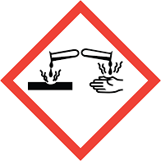

Acids and alkalis are harmful and corrosive. Acid have a sour taste w and alkali have bitter and slippery.

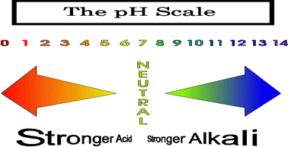

The pH scale is a number line that measures how acid, alkali or neutral a substance is.

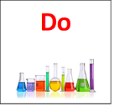**Acids and alkalis Activities Lesson 1**

Experiment: **Teacher Demo**

Collect a dimple tray; pipette; 0.1 molar hydrochloric acid; 0.1 molar sodium hydroxide; a pH scale and universal indicator.

1. Add a few drops of acid/alkali to the dimple tray.
2. Add a few drops of universal indicator to the acid/alkali and use the pH scale to work out the colour and pH number.
3. Repeat using water.

Complete the table of your results below.

|  |  |  |
| --- | --- | --- |
| Substance | Colour with Universal Indicator | Number on the pH scale |
| hydrochloric acid |  |  |
| sodium hydroxide |  |  |
| water |  |  |

2. Colour the pH scale using the colours in the box (complete at home if you do not

have the colours in class)

|  |  |  |  |  |  |  |  |  |  |  |  |  |  |  |
| --- | --- | --- | --- | --- | --- | --- | --- | --- | --- | --- | --- | --- | --- | --- |
| **0** | **1** | **2** | **3** | **4** | **5** | **6** | **7** | **8** | **9** | **10** | **11** | **12** | **13** | **14** |
| **red** | **red** | **red** | **pink** | **orange** | **orange** | **yellow** | **green** | **turquoise** | Light blue | Light blue | **blue** | **blue** | **purple** | **purple** |

3. Acids have a pH range of _______ to _________.Alkalis have a pH range of

________ to ______. Neutral substances have a pH of _________.

4. Universal indicator goes _________ or ___________ in acid, green in



_____________and ____________ or ____________ in alkali.

Extension task Now attempt the check test on **page 34**

**Success criteria covered** in this lesson were. **1 to 7**

**Dilution of Acids and Alkalis Lesson 2**

Learning Intention: Solving a problem

Context: To find out what happens to the pH of an acid or an alkali when they are diluted with water

When water is added to orange juice the orange juice becomes lighter in colour. This is because the orange juice is being diluted. The more water you add the lighter the orange juice becomes.

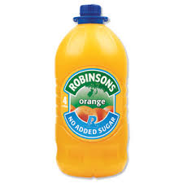

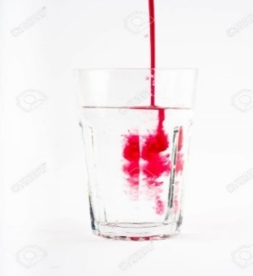

In the lab acids and alkalis can also be diluted.

In real life the acid in a car battery is sulfuric acid. If it spills, it must be diluted before it can be removed safely

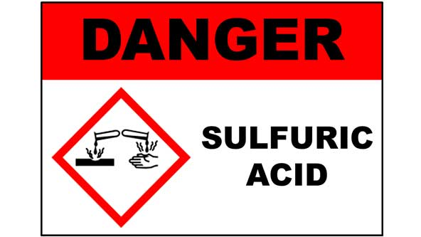

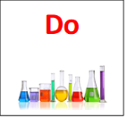**Dilution of Acids and Alkalis Activity Lesson 2**

Experiment for diluting acids

You will need a small beaker, a 10ml syringe, 6 test tubes, a dropping pipette, a bottle of universal indicator

1. Pour some acid into a beaker and measure 10cm3 with a syringe.
2. Add the acid to a test tube.
3. Use a pipette to take 1cm3 of acid from the test tube and add to the next test tube.
4. Measure 9cm3 of water in the syringe and add to the 1cm3 of acid.
5. Repeat steps 3 and 4 another 4 times.
6. Add universal indicator to all test tubes and record the pH.

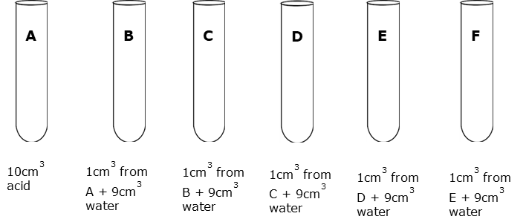

Write your results in the table below

|  |  |
| --- | --- |
| Test tube letter | Colour of universal indicator |
| A |  |
| B |  |
| C |  |
| D |  |
| E |  |
| F |  |

2. If time permits repeat the experiment using an alkali and record your

results here

|  |  |
| --- | --- |
| Test tube letter | Colour of universal indicator |
| A |  |
| B |  |
| C |  |
| D |  |
| E |  |
| F |  |

3. Complete the following sentences



When an acid is diluted the pH _____________ to 7

When an alkali is diluted the pH _____________ to 7

**Success criteria covered** in this lesson were **8** and **9.**

**Making Indicators Lesson 3**

Learning intention: Applying

Context: To find out if we can make an indicator using plants.

Indicators can be used to test the pH of liquids found in the laboratory, but they can also be used to find the pH of household substances.

There are many garden plants that can be used as pH indicators. Most plants contain pH-sensitive dyes which makes them perfect for testing acid and alkalis. Many of these natural pH indicators show a range of colour in acid or alkaline substances

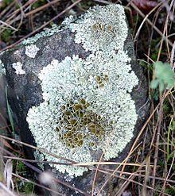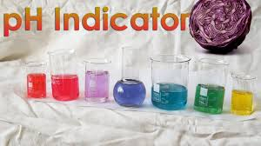

Litmus paper is another type of pH indicator made by treating paper with natural dyes from lichens.

Litmus paper is either red or blue.

Red litmus paper turns blue when the pH is alkaline, while blue paper turns red when the pH is acidic.

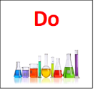**Making Indicators activity Lesson 3**

1, Experiment to make your own indicator from plants

What you will need in the classroom

Red cabbage, dropping pipette, 3 test tubes, vinegar, and 0.1 molar ammonia solution and water

1. Boil the kettle

2. Cut a bit of red cabbage into pieces and place them in a beaker of hot water

3. Filter the mixture to collect the purple solution. (this will be your indicator)

4. Test different chemicals with your cabbage indicator

Complete the table in your to record your results.

|  |  |  |  |
| --- | --- | --- | --- |
| Name of indicator | Colour in hydrochloric acid | Colour in water | Colour in sodium hydroxide |
| Red Cabbage |  |  |  |
| UI |  |  |  |
|  |  |  |  |

2. Extension task -now attempt the check test 2 on **page 35**

**Success criteria covered** in this lesson was **10**



**You could also make red cabbage indicator at home (optional)**

**Test the different substances found in your kitchen and bathroom with your indicator.**

|  |  |  |
| --- | --- | --- |
| Name of Substance | Colour with Cabbage Indicator | Acid / alkali/ neutral |
| bleach |  |  |
| baking powder |  |  |
| vinegar |  |  |
| water |  |  |
| salty water |  |  |

**Testing everyday Substances** **Lesson 4**

Learning intention: Applying and understanding

Context to test everyday substances

Measuring pH is a skill used to find out if a solution is an acid, alkali or

neutral. You can use pH indicator, pH paper or a pH meter to measure the pH of any substance you find in your home.

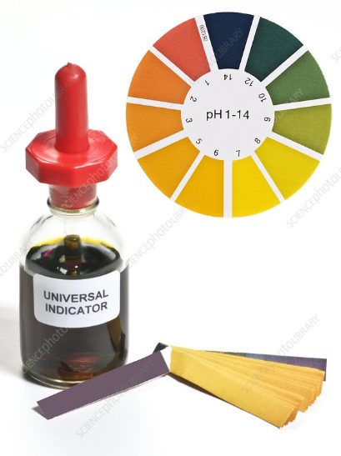 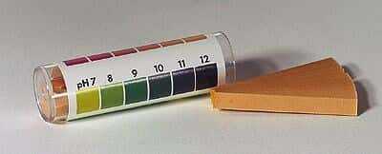

Universal indicator can be used to test the pH of everyday substances to get the pH number, you use a pH chart and match the colour to a number.

The pH scale below shows examples of everyday substances and their pH value

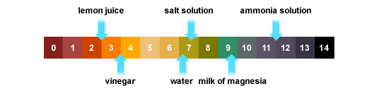

The substance must be soluble in water to measure its pH value.

**Testing Substances Activity Lesson 4**

1. Experiment instructions

What you need

Dimple tray, dropping pipette, vinegar, bleach, oven cleaner, lemon juice,

baking powder, soap, toothpaste, salt, sugar

1. Add a small drop of your everyday substance to a dimple
2. Add 3 small drops of universal indicator to your sample
3. Record your result in a table like the one shown below
4. Repeat for all the other substances.
5. **You will need** to dissolve these in water before you test their pH

Complete the result table below

|  |  |  |  |  |
| --- | --- | --- | --- | --- |
| **Substance** | **Colour of UI** | **Colour of pH paper** | **pH number** | **Acidic, Alkaline or neutral?** |
|  |  |  |  |  |
|  |  |  |  |  |
|  |  |  |  |  |
|  |  |  |  |  |
|  |  |  |  |  |
|  |  |  |  |  |

2. Fill in the blanks (**use the pH scale on page 6 to help you with your**

**answers).**

Two acids are_____________ and ________________

Two neutral substances are ______________ and ______________

Two alkalis are ________________ and _______________

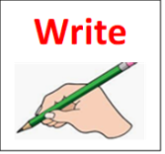

It is impossible to test the pH of sand because it is in______________

**Success criteria covered** in this lesson was **11**

**Extension task-**  Complete the DYW task for the enthusiast on **page 39**

**Neutralisation** **Lesson 5**

Learning intention: Solving a problem

Context To find out what happens to the pH of an acid when we add an alkali to it

To find out what is produced when an acid reacts with an alkali

Acids have a low pH ranging from 0 to 6. If you add enough of an alkali to an acid the pH will rise to 7.

Alkalis on the other hand have a high pH from 8 to 14 at the other end of the pH scale. This means you can also neutralise an alkali by adding an acid to it. The pH of the alkali will fall to 7.

Take the example of hydrochloric acid reacting with sodium hydroxide. In this reaction the acid will cancel out the alkali. We can show thiis reaction with the help of an indicator like Universal indicator

Universal indicator goes red in acid and blue or purple in alkali. If the reaction is successful, then there should be a green solution at the end.

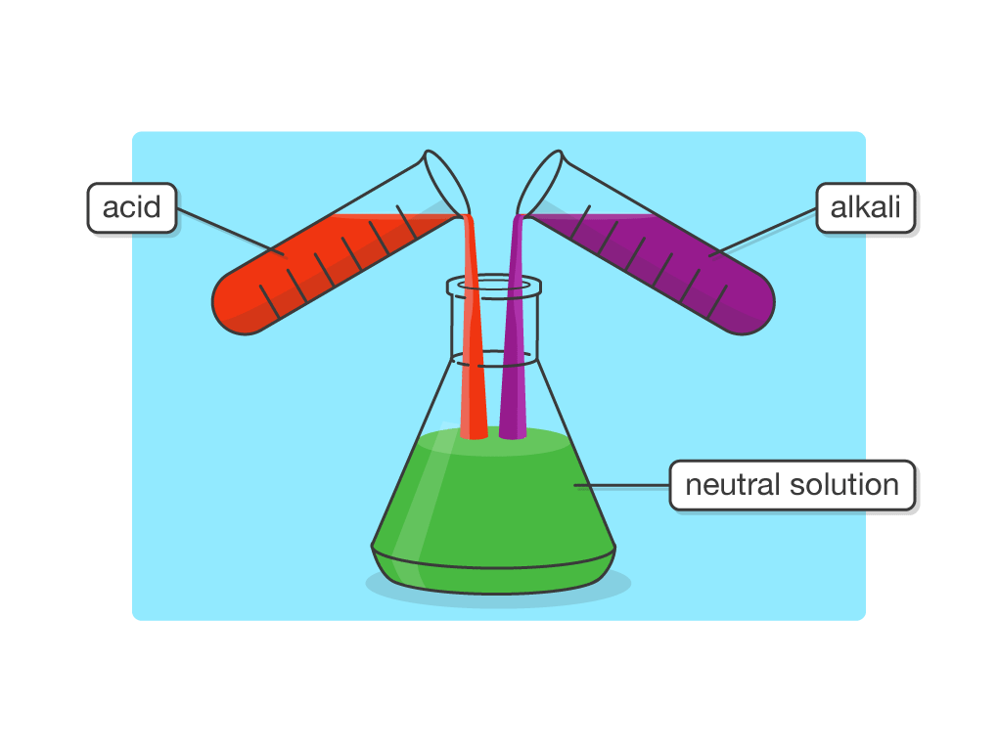  
This reaction is called **neutralisation** and it is very useful especially in everyday life.

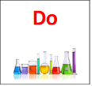**Neutralisation Activities Lesson 5**

1. Neutralisation Experiment

What you need

Two 10 ml syringes, 0.1 molar hydrochloric acid, 0.1 molar sodium hydroxide, universal indicator, conical flask

1. Using the acid syringe add 10cm3 of hydrochloric acid to a conical flask.

2. Add 2 or 3 drops of universal indicator to the conical flask.

3. Fill the alkali syringe with 10cm3 of the alkali, sodium hydroxide.

4. Add 1cm3 of alkali to the acid with gentle swirling.

5. Repeat step 4 until you have added 9cm3 all of alkali.

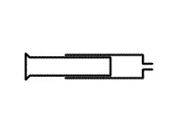6. Add alkali 1 drop at a time, with gentle swirling and observe what happens to the colour of the solution.

10cm3 of alkali added 1cm3 at a time

10cm3 of acid and universal indicator

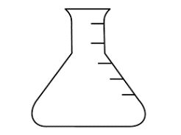

Repeat the above experiment but neutralise 10cm3 of the alkali with 1cm3 volumes of the acid. Your teacher may demonstrate this experiment using specialist equipment

Complete the following sentences

1. It took ________ml for the acid to go from red to green

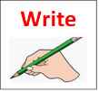2. It took________ ml of acid for the alkali to go from purple to

When an acid is neutralised the pH de___________ to 7

When an alkali is neutralised the pH in___________ to 7

**Success criteria covered** in this lesson were **12** and **13**

**Extension task-**  Complete check test 3 on **page 36**

**Everyday Neutralisation Lesson 6 +7**

**Learning intention:** Demonstrating my understanding

**Context:** To find out about neutralisation in everyday life

When an acid reacts with an alkali a neutralisation reaction takes place. In everyday life there are many useful neutralisation reactions

Examples of everyday neutralisation include treatment of indigestion,

insect stings tooth decay and farmers reducing soil acidity by adding a

chemical called lime to their fields.

Below is an example of different sources of acid in everyday life

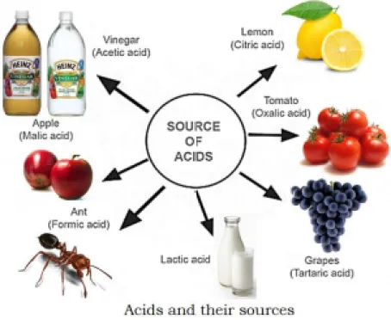

To get rid of problematic acids you can simply carry out a neutralisation reaction using an alkali. The process can be carried out to get rid of problematic alkalis

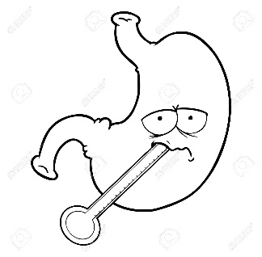 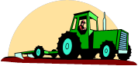 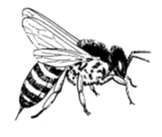

**Neutralisation in everyday life Activity Lesson 6 + 7**

In these next couple of lessons, you are going to demonstrate your understanding of neutralisation reactions in everyday life

The table gives some examples of different problems in everyday life caused by too much acid or alkali

|  |  |
| --- | --- |
| Problem | Acid or alkali |
| tooth decay | acid |
| Bee sting | acid |
| Upset stomach | acid |
| Wasp sting | alkali |

Use the information in the table and any other information you have learnt so far in this topic to create a poster about neutralisation in everyday life.

In your poster you should include the following;

1. State the problem with the acid or alkali

For example; tooth decay is caused by too much acid in your mouth

2. State how the problem can be resolved

Brushing your teeth with an alkaline toothpaste can get rid of the acid

**See page 33 for ideas for your poster**

**Extension** -now complete the check test 4 exercise on neutralisation on **page 38**

**The Success criteria covered** in these lessons were **14** and **15**

**Products of Neutralisation Lesson 8**

**Learning Intention:** Solving a problem

**Context:** To find out what is made when a neutral solution is

evaporated

When an acid neutralises an alkali, a neutral solution is produced.

**Acid + alkali -------> neutral solution**

There is another product in a neutralisation reaction. We need to find a way to separate and identify the other product in the neutral solution. The unknown product has dissolved in the water. The word we used for this is soluble. A soluble substance can dissolve in a liquid like water.

A process known as **Evaporation** is used to separate a soluble substance that has dissolved in water to form a solution.

The apparatus below can be used to carry out the evaporation of a neutral solution.

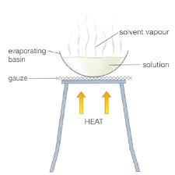

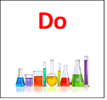**Products of Neutralisation Activity Lesson 8**

1. Evaporating Experiment

What you will need

Bunsen burner, tripod, evaporating dish (or small beaker), neutral solution

1. Collect some neutral solution from your teacher in a small beaker
2. Pour it into an evaporating dish or small beaker
3. Evaporate half the water away on a low blue flame
4. Allow to cool overnight
5. Check to see what happens in the next lesson

2. Fill in the blanks

1. The _________ flame was used to evaporate the water away
2. We used a low flame to stop _____________________________.
3. There was a ___________ solid left behind.

3. Use the word bank fill in the blanks

water solution salt acid

When an ___________ neutralises an alkali, a neutral ____________ is

made. When the ____________was evaporated there was a solid left

behind. We call this a __________

Word equation for a neutralisation reaction is

**Acid + Alkali water + salt**

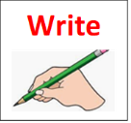

**The Success Criteria covered** in this lesson was **16.**

**Extension task-** - Complete For the Enthusiast 2 **page 40**

**Acid Rain Project Lesson 9+10**

**Learning Intention:** Researching

Context: To find out what cause’s acid rain and its impact on society

Sometimes the smoke from factories, power stations and cars can dissolve in the clouds making rainwater acidic. When the rain falls it can turn rivers oceans and farmland acidic. It can also cause the erosion of buildings and weathering of rock

The picture below gives an illustration of acid rain

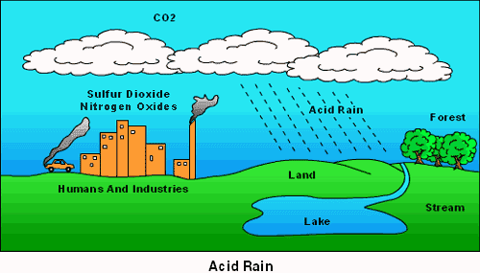

**Acid Rain Activities Lesson 9**

Experiment

In groups collect two medium size beakers, a wash bottle, cotton wool, 3 wooden splints, measuring cylinder, universal indicator, Bunsen burner

1. Put 20 ml of water into one beaker

2. Add some universal indicator to the water

3. Place the cotton wool into the second beaker

4. Light the splints then put them out and collect the gas in the **second** beaker with the cotton wool.

5. Place a mat over the beaker to stop the gas escaping

6. Lift off the mat slightly and use the wash bottle to soak the cotton wool

7. Once all the gas has been collected squeeze out the cotton wool over the first beaker.

8. Discuss what happened in your groups.

**Questions to think about**

What does the water in the first beaker represent?

What does the cotton wool represent?

What do you think the smoke from the wooden splint represents?

What happened to the water in the first beaker?

Did you expect this result?

2. Watch the video clip and answer the following questions.

a) What is Acid rain?____________________________________________________

b) Where does it come from?___________________________________________

c) Why is it so bad?_____________________________________________

3. Complete the diagram below by filling in the blanks

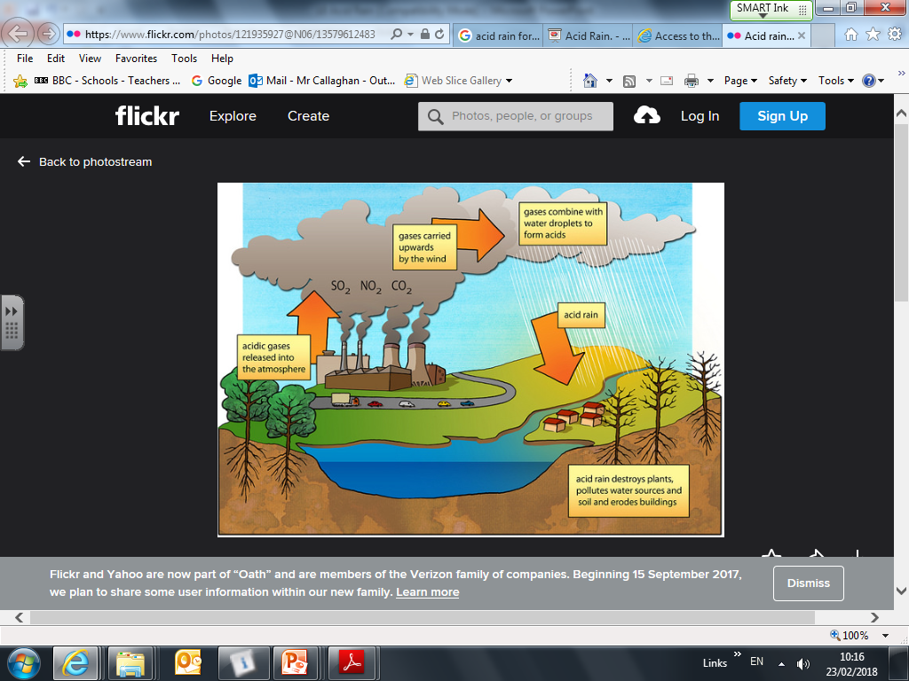



**Acid rain Activities Lesson 10**

1. Look at the 4 cartoons below.

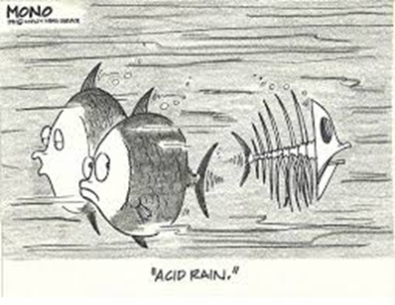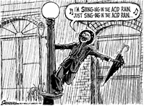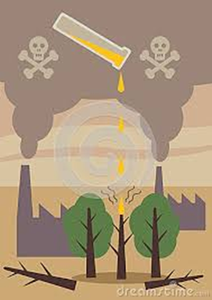

What message are they trying to give about acid rain?

________________________________________________________

Do they give you any clues about the effects of acid rain? yes/no

The most powerful cartoon is ___________________

Reason ____________________________________________________

2 Watch the video clip on the effect of acid rain on rivers

What did you learn?

______________________________________________________

_______________________________________________________

**Acid Rain Research Project**

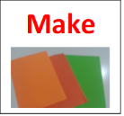

You are going to carry out research into the effect of Acid rain.

Pick any two effects from the diagram below and try to answer the

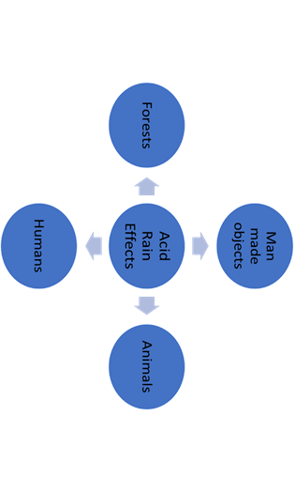 following questions

1. How does acid rain affect....................?
2. What can be done to protect your chosen structures?

Use these websites to help with your research

<https://www.nationalgeographic.co.uk/2019/03/acid-rain-explained>

<https://sciencing.com/negative-health-effects-acid-rain-humans-24007.html>

<https://www.livescience.com/63065-acid-rain.html> (causes and effects/solutions)

You can present your findings in a power point or as a poster or Power point

**Success criteria covered** in this lesson was **17**

**Acid Rain Research Project Part 2**

**Instructions to complete research task**

1. Spend half a period to complete your presentation (you can choose to do a power point or a poster).
2. Send your PowerPoint to your teacher or hand in your poster.

(If you need extra time you can complete this as a homework task)

**On your return class**

1. Watch the video clip on the job of an Environmental Scientist
2. Discuss with a partner why Environmental Scientists play such an important role
3. Watch the second video clip from students at Manchester University.

Would this career be of any interest?

For more information visit the following website

<https://www.myworldofwork.co.uk/my-career-options/job-profiles/food-scientist-or-food-technologist>

**Success criteria covered** in this lesson was **17**

**Stomach Investigation Lesson 11+12**

**Learning intention** : Investigating a problem

**Context:** To plan and carry out an investigation into the

effectiveness of different stomach powder

One common health problem caused by excess acid in the stomach is acid indigestion.

The acid in our stomach helps to break down food. Sometimes too much acid is produced which causes the problem of indigestion or heart burn.

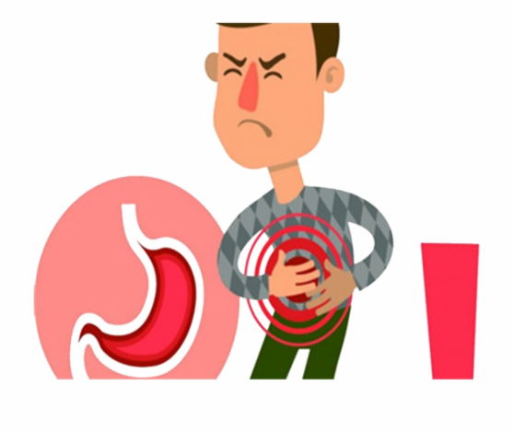This a burning sensation in the gullet when bits of undigested foods and acid goes up from the stomach

The acid in the stomach is hydrochloric acid which you have already met in the science lab.

Often the remedy for this painful condition is to take an antacid. These are cheap and readily available medicines.

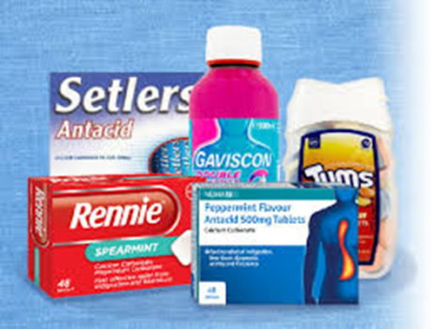

This is another example of neutralisation in everyday life.

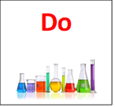**Stomach Powder Investigation Activities Lesson 11 + 12**

1. In groups plan out how you will carry out an investigation to compare stomach

powders or antacids

Complete the following sentences to help with the planning of the investigation

a). I will use __________ stomach powders.

b). I will use ________ml of hydrochloric acid each time

c). I will use ______ drops of indicator each time.

d). I will measure __________________________

e). I will do the experiment _____________

f). I am trying to find out which _________________

2. Get your teacher to check your plan

You **must** ensure that you have considered how to do your experiment safely.

3. Carry out your investigation

Here is a list of chemical and apparatus you may need for your

experiment

different antacids

0.1Molar hydrochloric acid

indicator

small beakers

stop clock

measuring cylinder

4. Record the finding from your investigation

**Extension task-**now Skills test 1 **page 42 (optional)**

Complete the full investigation write up in the next lesson

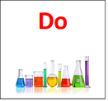**Stomach Powder Investigation Activities Lesson 11 + 12**

1. Watch the video clip on writing a Scientific Report

You can take notes while you watch

Use the following format to complete your stomach powder investigation report

Aim: This is what you are trying to find out

Hypothesis- This is your prediction of what you think is going to happen

Method: Use the steps from your plan to give a brief description of what

you did (Sometimes drawing a diagram helps)

Results: Record your results in a table

Think about what you measured

Think about how you carried out your measurement

Conclusion: This is what you found out

Evaluation: This is how you suggest improvements to your experiment

Complete your Scientific Report for this investigation

**Title:** Use the title from the top of the page

_________________________________________________________

**Aim:** To find out which antacid _______________________________

**Hypothesis:** I think that antacid will___________________________

________________________________________________________

**Procedure (method):**

You can also include how you worked safely during the investigation

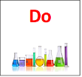

**Results:**

|  |  |
| --- | --- |
| **Name of tablet** |  |
|  |  |
|  |  |

**Conclusion:** I found out that...........

**Evolution:**

To improve this experiment____________________________

Circle one of the statements below to complete your evaluation

1. I would have repeated the experiment more times to make it more

reliable

2. I would have weighed the tablets

3. I would have used 0.5ml of indicator for each experiment.

4. I could have used more antacid tablets

**Extension task -** now try Skills test 2 on **page 43**

**Success criteria covered** in this lesson was **18**

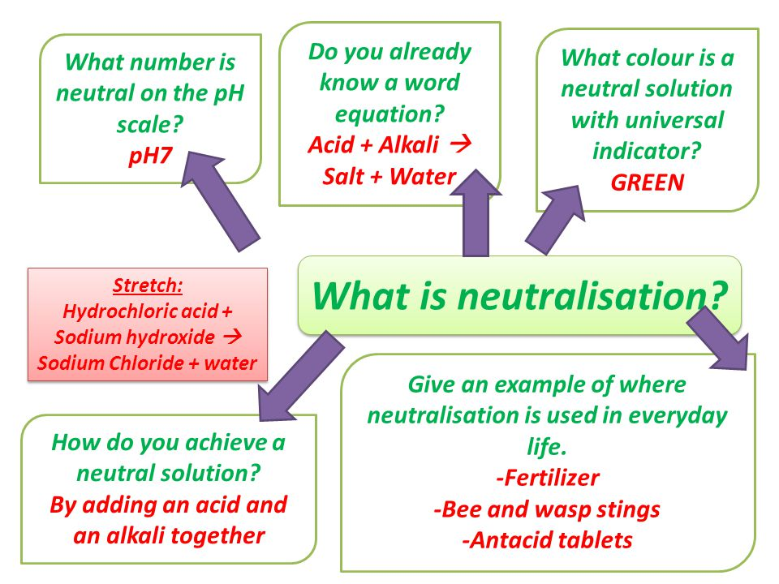

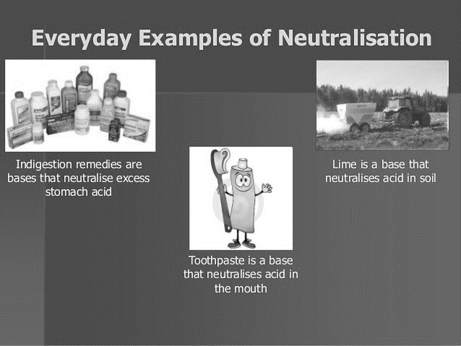

**Check Test 1**

**1.** The pH of three liquids were measured

|  |  |
| --- | --- |
| **LIQUID** | **pH** |
| A | 10 |
| B | 3 |
| C | 7 |

1. Which liquid is an acid _________?
2. Which liquid is neutral __________
3. Which liquid is an alkali__________?

**2.** Niamh took some sugar and dissolved it in water. She found that the sugar is

neutral. The pH of the sugar would have been __________

**3.** Siobhan measured the pH of three liquids, coca cola, fresh orange, and carbonated

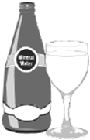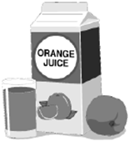 water. Her results were as following



Carbonated water

pH = 5.1

Coca cola

pH = 3.6

Orange Juice

pH = 4.5

1. Which is the most acidic solution? _____________
2. Which is the least acidic solution?_____________
3. Which drink has a pH closer to that of water?____________
4. Acids have a bitter taste. Explain why coca cola tastes sweet.

________________________________________________

**Check Test 2 Literacy**

Read the following passage on plants as indicators and answer the questions.

How acid or how alkaline a soil is affects what plants grow and how they grow. Hydrangeas are a good example of this. They have blue flowers when they are grown in acid soil and pink when the soil is alkaline. The acidity of the soil can be measured using the pH scale. Crops usually grow best when the pH is close to 7.

Farmers and gardeners control soil pH to improve how fertile the soil is. This means that they can grow better crops. The natural world has given us lots of plants that can be used to test the pH levels of a solution. The table below gives you examples of plants that can be used as indictors.

|  |  |  |
| --- | --- | --- |
| **Name of plant** | **Colour in acid alkali** | **Colour in alkali** |
| beets |  | Red to purple |
| blackberries | Red | Blue to violet |
| blueberries | Red |  |
| cherries | red | Blue to purple |
| Geranium petals | Orangey-red | blue |
| Red grapes | Deep red | violet |
| Horse chestnut leaf | Fluorescent blue |  |
| onion | Pale red | green |
| Morning glories | Purplish- red | blue |
| petunia | Reddish-purple | violet |
| Poison primrose | red | purple |
| Rose petals |  | blue |
| turmeric |  | Changes from yellow to red |

1. Crops grow best at pH ____________

2. To get pink flowers from hydrangea you should add _______________________to the soil

3. Two plants that can be used to test an alkaline solution are _________ and __________ .

4. Geranium petals go _____________________ acid solution

5. A plant-based indicator that can test for an acid or an alkali is __________________

**Check Test 3**

1. Many different household substances are acidic or alkaline.

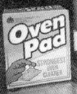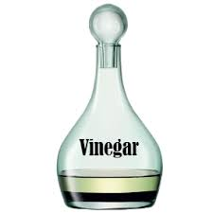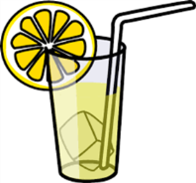

Oven cleaner

Vinegar

Lemonade

Dishwashing powder

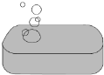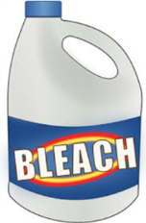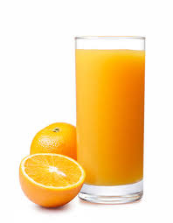

Soap

Bleach

Coke

Orange juice

Complete the table to show which of the following substances are acidic and which are alkaline

|  |  |
| --- | --- |
| Acid | Alkali |
|  |  |
|  |  |
|  |  |
|  |  |
|  |  |

2. Here are six statements

**A** It has a pH value greater than 7

**B** It has a pH value less than 7

**C** It has a pH value equal to 7

**D** Its pH will stay the same when diluted

**E** Its pH will rise when diluted

**F** Its pH value will fall when it is diluted

1. Which two statements are true for a neutral substance? ______and _____
2. Which two statements are true for an alkaline substance? ______and ______
3. Which statement is true for an acidic substance_____________?
4. Which statement is true for water? _____________

**Check Test 4**

1. Liam was stung by a wasp. Wasp stings are alkaline.

Liam has a bottle of vinegar and some baking soda.

Which of the two should he used to treat the bite. Explain your answer.

2. During manned space flights the amount of carbon dioxide in the air in the spacecraft increases. To remove the carbon dioxide the air is passed through filters which contain lithium hydroxide which has a pH of 14. The lithium hydroxide neutralises the carbon dioxide gas.

a) What type of substance is lithium hydroxide

b) Is carbon dioxide acidic or alkaline? Explain your answer.

3. Our stomachs contain acid. If we have too much to eat, we can suffer from acid indigestion. Indigestion tablets and liquids contain substances that can neutralise the excess acid and stop the indigestion.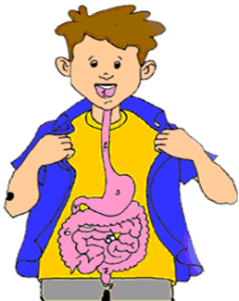

1. Explain the meaning of the two underlined words.
2. What type of substance do you think is present in the indigestion remedy?
3. Suggest a likely pH for the liquid in our stomachs.
4. What happens to the pH of the liquid in our stomachs when we take the indigestion tablet?

**For the Enthusiast 1 -DYW**

1. Pick one of the following tasks and try to answer the questions about Food Scientists.

**Task 1 Find out about food Scientists**

<https://www.myworldofwork.co.uk/my-career-options/job-profiles/food-scientist-or-food-technologist>

Use the website above to help with the task

1.What does a food scientist do?

2.What Science do food scientists need?

3. How much does a food scientist earn

4. What qualifications would a food scientist need?

5. What are the job prospects for food science?

**Task 2 Famous Food Scientist**

Find out about famous food Scientists from the past Use the website to help

<https://www.txcte.org/sites/default/files/resources/documents/Famous-Food-Scientists-Research-Key.pdf>

Pick any one and create a summary poster or power point​

Include the following:

1. when they were born
2. where they lived​
3. what they discovered

For both task you could present your findings to your class.

**Additional website**

How food scientist carry out test to make sure that our food is safe​

<https://nationalcareers.service.gov.uk/job->[profiles/food-scientist](https://nationalcareers.service.gov.uk/job-profiles/food-scientist)​

Job description of a food scientist​

<https://targetjobs.co.uk/careers-advice/job->[descriptions/279551-food-scientist-job-description](https://targetjobs.co.uk/careers-advice/job-descriptions/279551-food-scientist-job-description)​

**For the Enthusiast 2**

1. In Greece there are ancient buildings called the Acropolis which were built over 2500 years ago. Over the last 100 years these buildings have started to erode.

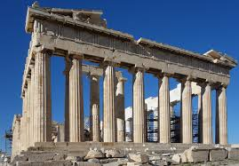

Explain why the buildings have started to wear away so badly.

1. When lakes and oceans become acidic due to acid rain fall marine life can be badly affected. Fish can die and habitats like coral reef can be damaged. Lime can be added to reduce the effects of acidic rivers and oceans.
   1. What gas causes acid rain?
   2. What type of substance must lime be?

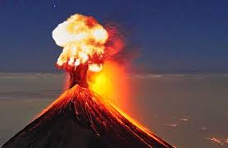3. When volcanoes erupt, they can release thousands of tonnes of acidic gases into the atmosphere along with hot ash and molten lava.

* 1. Name two gases that are acidic.
  2. What do you think the pH of a river is? after a nearby volcano erupts.

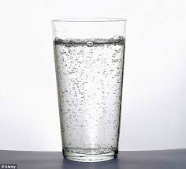

4. Why can carbonated water increase the rate of erosion of your teeth?

5. Acid rain that falls in Scandinavian countries can damage the growing Christmas trees. To combat the problem the farmers, add limestone to the land. This helps neutralise the acidic soil. The Christmas trees then start to grow well again.

1. What type of substance is limestone?
2. What other type of substance could neutralise the acidic soil?

**Going Further Acids Skills Check 1**

1. The pH of various liquids was measured. Detergent has a pH of 11.4, alcohol had a pH of 7 and tap water had a pH of 6.6. It was found that tea had a pH of 5.8, sour milk a pH of 4.7 and oven cleaner pH 14.0.Use this information to complete the table of results.

|  |  |
| --- | --- |
| Liquids | pH |
|  |  |
|  |  |
|  |  |
|  |  |

1. The table below shows the amount on sulphur dioxide gas emitted from the European Union in 2002.

|  |  |
| --- | --- |
| **Source of sulphur dioxide** | **Sulphur dioxide emitted (millions of tonnes)** |
| Homes | 4.0 |
| Heavy Industry | 8.0 |
| Refineries | 10.0 |
| Power stations | 19.0 |

Present this information in a bar graph. **Ask your teacher for some graph paper**

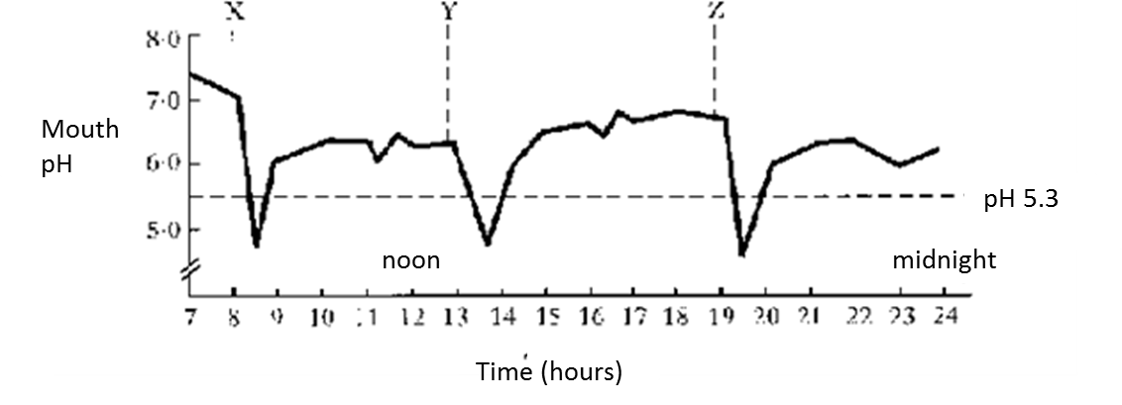**3.** Kirsty eats three meals a day. The graph shows how her mouth’s pH changes during the day. X, Y, and Z are mealtimes. Tooth decay occurs if the pH of the mouth falls below 5.5.

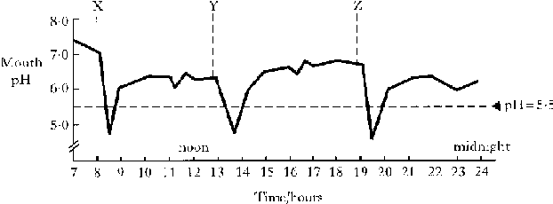

1. What happens to the pH of the mouth after meals?
2. Why are most toothpaste alkaline?

**Going Further Acids Skills Test 2**

1. As the pH number of an acid increases, its concentration decreases.

Lisa did an experiment to find out how the concentration of an acid affects the time it takes to dissolve a piece of marble.

Here are her results

|  |  |  |  |  |  |
| --- | --- | --- | --- | --- | --- |
| pH number of acids | 1 | 2 | 3 | 4 | 5 |
| Time to dissolve marble (minutes) | 2 | 4 | 10 | 14 | 22 |

1. Draw a line graph of her results. **Ask your teacher for graph paper**

b) What conclusion can you draw from her results?

c) How long would it take for a piece of marble to dissolve if the pH of the acid was

4.5?

1. Lauren added an indigestion tablet to an acid. The tablet reacted with the acid and carbon dioxide gas was released. She measured how much carbon dioxide was given off. Her results are shown in the table below.

|  |  |  |  |  |  |  |
| --- | --- | --- | --- | --- | --- | --- |
| Volume of gas (cm3) | 0 | 50 | 90 | 110 | 120 | 120 |
| Time (s) | 0 | 50 | 100 | 150 | 200 | 250 |

1. Plot a line graph of her results. **Ask your teacher for graph paper**
2. How long did it take to produce 80cm3 of gas?
3. What volume of gas was produced after 70 second?
4. What was the final volume of gas produced?
5. What volume of gas would be produced if Lauren had only added half an indigestion tablet?

**Extension Task Acid and life lesson 13**

**Learning intestion Applying**

Context : Investigating tooth decay

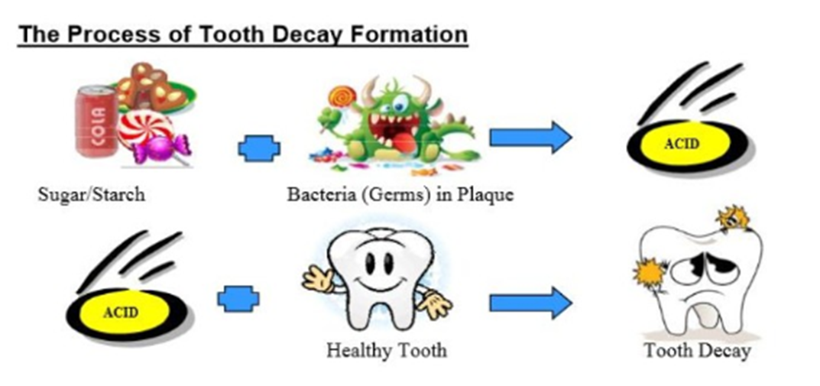Acids can influence the earth’s materials. Our teeth can be affected by too much acid which cause tooth decay. Tooth decay is the biggest disease effecting young people in Britain.

Chemically teeth are very similar to eggshells

[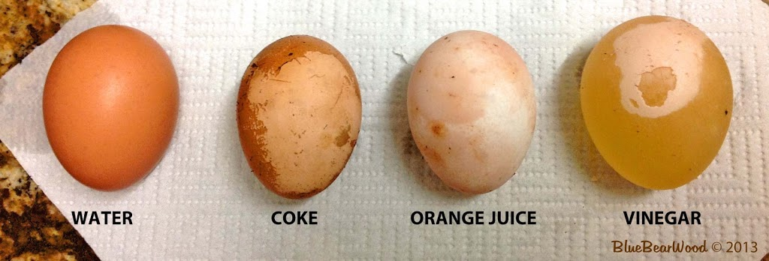](https://www.bluebearwood.co.uk/wp-content/uploads/2013/05/24-HRS.jpg)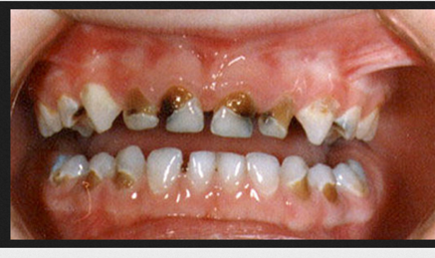

Your teacher may set up an experiment to show different conditions affect eggshell.

**Acid and life Activities lesson 13**

Here are some questions for you to think about. There is no need to

share your answers.

1. How many times a day do you brush your teeth?

2. Are fizzy drinks bad for your teeth?

3. Are sugary, fizzy drinks worse?

4. How many fillings do you have?

5. Have you had any teeth taken out?

6. How can you prevent tooth decay?

Your teacher will place 4 eggs in 4 different beakers containing the following

1 vinegar 2. water 3. orange juice 4. coke

To make this a fair experiment the liquids in each beaker were kept at the same volume

3. Check over the course of a week what happens to the egg

shell

|  |  |  |  |  |
| --- | --- | --- | --- | --- |
| conditions | water | vinegar | coke | Orange juice |
| What happened to the eggshell |  |  |  |  |

4. Write a report of **about 80 to 100** words on the effects of acid on

earth’s material. You can choose from any of the following questions:

1. Why are fizzy drinks so bad for our teeth

2. In what food are acids naturally occurring

3. Why is vinegar added to certain foods

4. Why do so many cleaning products come with the following warning label

5. Why is battery acid in cars so dangerous



**This is an optional lesson**

**Chosen Topic**_________________________________________