Knightswood
Secondary School
ELECTRICITY L1 to L3
Workbook V4

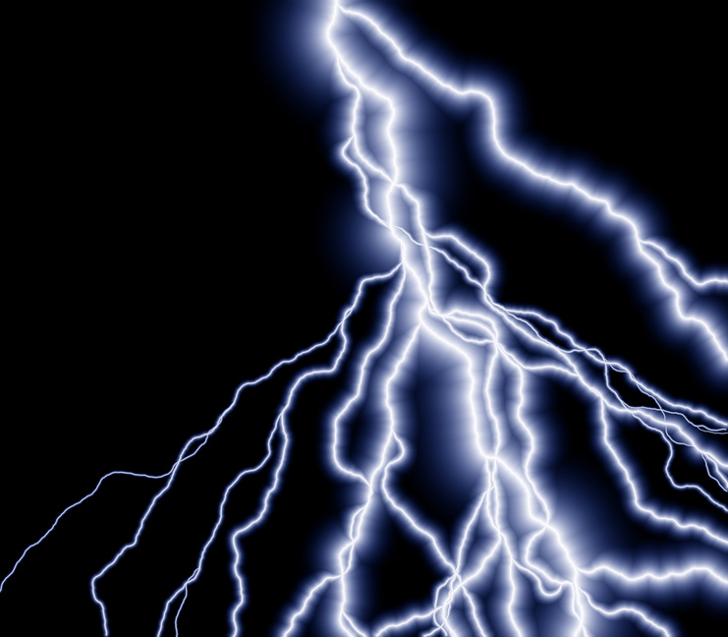

NAME: CLASS:

Teacher

1 – Introducing Electricity

Starter
Wite down the 5 electrical appliances in your home that you think are most important. Write them in order of importance, with the most important at the top.

1
2
3
4
5

Electrical Appliances

Electrical appliances are machines …………..

Appliances that use the Most Electricity

Write down what you think uses the most electricity in your home? List your top 3 appliances.

1 ..

2 ..

3 ..

Electricity
- Electricity is a type of ..
- Electricity ….
Why is Electricity is important?

Electricity is very important to us for lots of things like staying warm, cooking, lighting and entertainment. This is why understanding how to use it and how to stay safe is important.

Experiment 1 – Building a Torch

Aim

The aim of this experiment is to build an electrical circuit that is found in a torch.

Step 1 - Connect a battery, and a bulb together. Make sure the bulb lights up

Step 2 - In the box below, draw a picture of the circuit you made. The circuit must include the battery, bulb and connecting wires.

Drawing: What your circuit actually looks like

Step 3 - Now try to connect the switch to allow you to switch the bulb on and off.

Step 4 - Fill in the blanks

Drawing a picture of a circuit can become complicated and hard to understand.

Scientist use .............................. to represent each........................... in a circuit.

A diagram can be drawn to show how all of the components are connected.

This is called a ................................... ............................. .

Electrical Component and their Symbols

Step 5 Complete the table below.

Component name | Component symbol | Description  What does the component do?
Cell
(battery) |  |  | 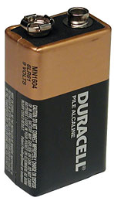
Bulb |  |  | 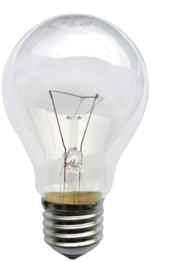
Wire |  |  | 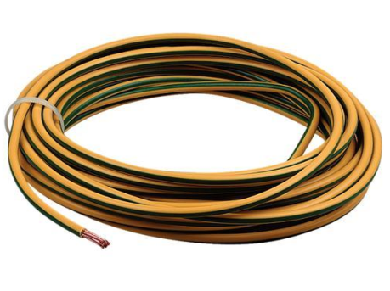
Switch |  |  | 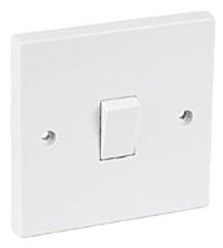
Motor |  |  | 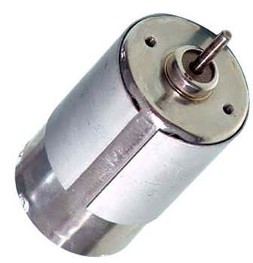
Buzzer |  |  | 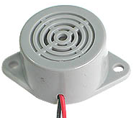
Resistor
Ammeter
Voltmeter

Step 6 Activity - Circuit Diagram of a Torch

Using the symbols above go back to Experiment 1 and draw a CIRCUIT DIAGRAM for the circuit you built IN THE BOX BELOW.

I can…. | RED | AMBER | GREEN
Explain why electricity is important to our lives.
Build an electrical circuit that allows a bulb to light.
Explain what an electrical component is.
Draw the circuit symbols for a cell, bulb, wire, switch, motor and buzzer.

Plenary

Lesson 2 - Measuring Current

Starter
Using your knowledge from the last lesson, draw the circuit symbol for:
- a bulb

- a switch

- a cell

Experiment 2 – Measure Current

Aim
The aim of this experiment is to find out how to measure current.

Step 1 - Make a circuit, without the ammeter, that will allow the bulb to light. (Use a Battery and one bulb)

Step 2 - Using a Multimeter as an AMMETER

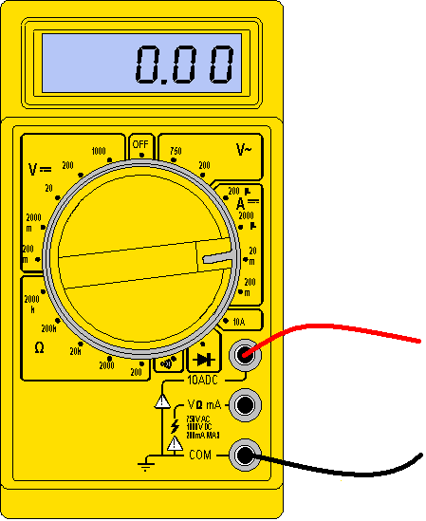 | Connecting the multimeter as an AMMETER  1 Connect the BLACK lead into the COM  2 Connect the RED lead into the 5A or 10A  3 Turn the Dial till it reads either 5A or 10A  The Multimeter is now ready to use as an Ammeter

Step 3: Try to connect the ammeter into your circuit to allow you to measure the current. Make sure that the bulb is still lit when the ammeter is in your circuit.

Step 4 - Complete the following passage:

- The current flowing in my circuit was ……. Amperes

We can measure lots of different things to do with electricity.
2 Current is how much electricity is ………………………… .
3 We use an ………………………… to measure current.

Symbol for an Ammeter

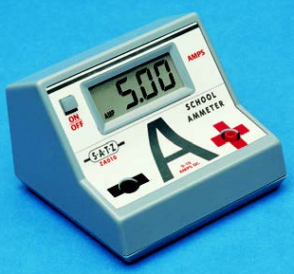 | 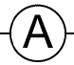

Step 5 Draw a circuit diagram of the circuit you made to measure current.

Circuit Diagram

Step 6 Fill in the missing words

1 To measure current we use an ………………………….
The way that we set this up is very important.
2 An ………………………… must always be set up as part of the circuit, allowing ………………………… to flow through it.
3 We say that the ………………………… is connected in ………………………… .

Units

When we take measurements we must always include units. For example, the units of temperature are degrees Celsius (ºC). The units of length are metres (m).

Units of Current

Step 7 fill in the missing words

What units do we use to measure electrical current? ………………………

What is the symbol for the units of electrical current? …….......

Step 8 Plenary – Tick Green for ‘ I fully understand’. Amber for ‘ I need to revise’, Red for ‘I don’t understand’

I can… | RED | AMBER | GREEN
Explain what is meant by electric current.
Set up an ammeter to measure the current in a circuit with a battery and a bulb.
Draw a circuit diagram for a circuit containing a battery, a bulb and an ammeter.
State the units in which electrical current is measured

Lesson 3 – Bulbs and Current

Starter

1

2

Experiment 3 – Bulbs and Current

Aim
The aim of this experiment is to find out how adding more bulbs into a series circuit affects the current flowing through a circuit.

Step 1 Draw the circuit diagram shown on the Board, in the BOX BELOW (one bulb, Ammeter and Battery).

Step 2 Connect the circuit.
Step 3 Measure the current with one bulb and record the value in the table.
Number of bulbs | Current (A)
1
2
3

Results

Step 3. Measure the current with one bulb and record it in the table in your workbook.

Step 4:
Add one more bulb to the circuit and measure the current.
Record the current in the table in your workbook.

Step 5: If you have one add a third bulb to the circuit and measure the current. Record the current in the table in your workbook.

Step 6: Complete the following passage:

We can see from our results that if we add more bulbs to a circuit, the current ……………………………. This also means that when we add more bulbs to a series circuit, each bulbs gets …………………….

Step 7: Write down what you did to show how changing the number of bulbs in a circuit changed the current. This is called INSTRUCTIONS

Instructions

Step 8: Plenary – Tick Green for fully understand, Amber for, neet to revise .Red Not sure at all.

I can… | RED | AMBER | GREEN
I can design a circuit to investigate the effect that adding bulbs to a circuit has on current.
I can carry out an experiment to investigate the effect that adding bulbs to a circuit has on current.
I can describe the effect that adding bulbs to a circuit has on current.

Knightswood
Secondary School
ELECTRICITY L4 to L6
Workbook V4

NAME: CLASS:

Teacher

Lesson 4 – Cells (Batteries) and Current

Starter
Answer ….

Experiment 4 – Cells and Current

Aim

The aim of this experiment is to find out how adding more batteries affects the current flowing through a circuit.

Step 1 Draw the circuit diagram shown on the Board in the box below. (one battery, two bulbs and on ammeter).
Step 2 Connect the circuit
Step 3 Measure current with one battery and record the reading it in your workbook.

Number of batteries | Current (A)
1
2
3

Step 4 Connect a second battery into your circuit (in series) and record the value of current in the table above.

Step 5 If you have a third battery connect it into your circuit (in series) and record the value of current in the table above.

Step 6 Complete the following passage:

We can see from our results that if we add more batteries to a circuit the current …..

Instructions

Step 7 Write down what you did to show how changing the number of batteries in a circuit changed the current.

Step 8 Plenary – Tick Green for I fully understand, Amber for, I neet to revise .Red I am not sure at all.

I can… | RED | AMBER | GREEN
I can design a circuit to investigate the effect that adding batteries to a circuit has on current.
I can carry out an experiment to investigate the effect that adding batteries to a circuit has on current.
I can describe the effect that adding batteries to a circuit has on current.

Lesson 5 – Current in Series Circuits

Starter
As more batteries are added to a circuit, the in the circuit ………………………..

Series Circuits
In a series circuit, all of the components are in one big loop.



This is a series circuit made up of a battery, bulb and switch.

Current in a Series Circuit.

Aim
The aim of this experiment is to
1 Measure the current at different points in a series circuit
2 Think of a rule describing current in series circuits.
3 Determine what happened in a series circuit when one component breaks or is removed.

Step 1 Draw Diagram 1 shown on the board in the box below. 2 batteries, 2 bulbs, 1 ammeter.
Step 2 Build the circuit
Step 3 Record the current in the table below

Step 4 Draw Diagram 2 shown on the board in the box below.
Step 5 Build the circuit
Step 6 Record the current in the table below

Step 7 Draw Diagram 3 shown on the board in the box below.
Step 8 Build the circuit
Step 9 Record the current in the table below

Ammeter | Current (A)
1
2
3

Step 10 Complete the following passage to make a rule for current around a series circuit:

We can see from our results that, the current in a series circuit is…

We have seen that the current in a series circuit is the same at every point in the circuit.

A
1
A
4
A
2
A
3
4 A
4 A
4 A
4 A

Step 11 Copy the following into your workbook
Relationship (Series Circuit)

A1(supply) = A2 = A3 = A4

Step 12 Coppy the following into your workbook

Rule
In a Series Circuit the current is the ….

What happened in a Series Circuit if a bulb (component) breaks?
Step 13 Carefully unscrew one of the bulbs.
What do you notice?

…………………………………………………………………………………………………………………………………

Step 14 Screw the bulb back in and unscrew the other one.
What do you notice?

…………………………………………………………………………………………………………………………………………

Step 15: Complete the following passage

If one component in a series circuit stops working the other components will …………………………………………………………….

Do you think that a series circuit would be a good way to set up bulbs or other appliances in your house?
My series circuit:

Step 16 Plenary – Tick Green for I fully understand, Amber for, I neet to revise .Red I am not sure at all.

 | RED | AMBER | GREEN
I can build a series circuit and measure current at various points in the circuit.
I learned from my experiment that the CURRENT AT ANY POINT IN A SERIES CIRCUIT IS THE SAME.
I derived the equation for Current in a Series circuit A1 = A2 = A3 ……

Lesson 6 – Introduction to a Parallel Circuit

Starter

Write down two things you know about a Series circuit
1

2

Parallel Circuits

In a parallel circuit, the components are arranged in branches.

Experiment 6 – Components in Branches

Aim

The aim of this experiment is to find out what happens if we switch off one component in a parallel circuit.

Step 1 Draw the Circuit diagram shown on the board in the box below.

Step 2 Build the circuit

Step 3:
Carefully unscrew one of the bulbs from its holder! (This is just like one of the bulbs developing a fault and ‘blowing’) .
What happens to the brightness of the other bulbs?

………………………………………………………………………………..……………………………………………………………

Step 4: Screw the first bulb back in. Unscrew a second bulb, what happens to the brightness of the first bulb

………………………………………………………………………………..…………………………………………………………………
Step 5: Screw the bulb back in

Step 6 Add a switch into one branch of the circuit

Step 7 – Turn the switch off. What happens to the bulb in that branch.

……………………………………………………

Step 8 Copy the circuit shown on the board into your workbook (2 bulbs and 1 switch)

Step 9 - Add a switch into the second branch. Turn the switch off, what happens to the bulb in that branch.

…………………………………………………………………

Step 10 Complete the note in the box below: Three advantages that a parallel circuit has over a series circuit are:

1. When more bulbs are added in parallel the brightness of each bulb…..
2. Each bulb can be…..
3. When one bulb blows, all of the other bulbs…..

Step 11 Plenary – Tick Green for I fully understand, Amber for, I neet to revise .Red I am not sure at all.

I can… | RED | AMBER | GREEN
I can describe (draw) a parallel circuit.
I can build a parallel circuit containing 2 bulbs and 2 batteries.
I can explain the advantages of a parallel circuit over series circuit.

Knightswood
Secondary School
ELECTRICITY L7 to L9
Workbook V4

NAME: CLASS:

Teacher

Lesson 7 – Current in Parallel Circuits

Starter

- Describe how components are connected in a parallel circuit.

- If we unscrew one bulb in a parallel circuit, what will happen?

We have already seen three advantages of a parallel circuit over a series circuit. Now we will look at what happens to the current around a parallel circuit.

Experiment 7 – Measuring Current in a Parallel Circuit
Aim

The aim of this experiment is to
1 Measure the current at different points in a parallel circuit
2 Think of a rule describing current in parallel circuits.

Step 1 Draw a diagram shown on the board in the box below.
Step 2 Build the circuit.
Current supplied from the Battery (Supply) – A1

Step 3: Use the ammeter to measure current at A1
Step 4: Record your results in the table. Now move the ammeter to measure the current in the first branch.
Step 5 Draw the Circuit diagram shown on the board in the box below.
Step 6 Build the new circuit. Use and ammeter to measure the current at A2. Record the results in your table.

Circuit Diagram – ammeter in second Branch (A2)

Step 7 Draw the Circuit diagram shown on the board in the box below.
Step 8 Build the new circuit. Use and ammeter to measure the current at A2. Record the results in your table.

Circuit Diagram – ammeter in second Branch (A3)

Table of Results
Ammeter | Current (A)
A1
A2
A3
A4

Step 9: Look at the table of results what did you notice. Write down your findings

The current in each branch of a ………….

Step 10: Copy the relationship into your workbook
Relationship
A = A + A + A

Rule
In a Parallel Circuit the sum of the current in each branch adds up to current supplied from the Battery (power Supply).

Step 11 Plenary – Tick Green for I fully understand, Amber for, I neet to revise .Red I am not sure at all.

… | RED | AMBER | GREEN
I can build a parallel circuit and measure current in each branch and at different points around the circuit.
I learned from my experiment that the sum of the currents in each branch equals the current supplied from the battery.
I derived the equation for Current in a Parallel circuit A1 = A2 + A3+ A4 ……
I can solve problems relating to current in a parallel circuit.
Consolidation.

In each of the following examples, complete the table, by filling in the ammeter readings that are missing.
1
2
3

A
1
2
A
3
A
A
1
2
A
3
A
A
1
2
A
3
A
Ammeter | Current (A)
A₁ | ………
A₂ | 3
A₃ | 2

Ammeter | Current (A)
A₁ | 0.7
A₂ | 0.2
A₃ | ………
Ammeter | Current (A)
A₁ | 24
A₂ | 12
A₃ | ………

4
5

A
1
A
4
A
2
A
3
A
1
3
A
2
A
4
A
5
A

Ammeter | Current (A)
A₁ | ………
A₂ | 1.5
A₃ | ………
A₄ | ………
Ammeter | Current (A)
A₁ | ………
A₂ | ………
A₃ | 4
A₄ | 5
A₅ | 6

Lesson 8 – Measuring Voltage (Using A Series Circuit)

Starter (6 mins) – Watch the following video and fill in the blank words in part A and B
Paddle wheel current and voltage
https://www.youtube.com/watch?v=WvcwCttJjtI

Part A Voltage

We can measure lots of different things to do with electricity.
Voltage is how much ………………………… the electricity has .
We use a ………………………… to measure voltage.

Part B Voltage

The voltage is like the …………………………………………………………………………………………………

……………………………………………………………………………………………………………………………..

The symbol for a voltmeter is

 | 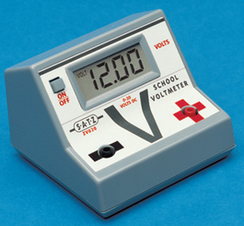

Aim
1 The aim of this experiment are to find out how to measure voltage. In this instance using series circuit.
2 Think of a rule describing voltage in series circuits

Step 1 Using a Multimeter as a Voltmeter.

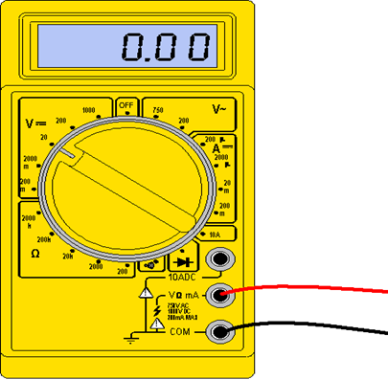 | Connecting the multimeter  1 Connect the BLACK lead into the COM  2 Connect the RED lead into the Terminal marked V  3 Turn the Dial till it reads 10V  The Multimeter is now ready to use as an Voltmeter

Step 2 Copy the circuit diagram into your workbook
Step 3 Build the SERIES circuit shown on the Board (2 Batteries and 2 bulbs).

Series circuit with 2 Batteries and 2 bulbs. – Vbat.

Step 4 Connect the voltmeter ACROSS the battery. Record your results in the table.

Step 5 Connect the voltmeter ACROSS each of the bulbs. Record the result in the table below.

TABLE OF RESULTS
component | Voltage (v)
V _{Battery}
V_{1 (bulb 1)}
V_{2 (bulb 2)}

Circuit Diagram with all voltmeters shown

Step 6 – look at the table can you come up with a conclusion

Conclusion

We can see ……………………………………………………………………………………………………………………………
………………………………………………………………………………………………………………………………………………
………………………………………………………………………………………………………………………………………………

Step 7 – Complete the following Relationship

Relationship

V supply =

Rule
In a Series Circuit the Supply Voltage equals the sum of the voltages across each component.

Step 7 Complete the passage.

To measure voltage we use an …………………………. The way that we set this up is very important.
A ………………………… does not let electricity flow though it. It must always be connected in ………………………… with the component we are measuring the voltage over.

Step 8 – Fill in the blanks

When we take measurements we must always include units. We have already seen that we measure electrical current in Amps (A).

What units do we use to measure voltage? ………………………

What is the symbol for the units of voltage? …….......

Step 9 Plenary – Tick Green for I fully understand, Amber for, I neet to revise .Red I am not sure at all.

 | RED | AMBER | GREEN
I can explain what is meant by voltage.
I can find the voltage across each component in a series circuit
I know the relationship between Voltage in a Series circuit
I know a rule describes voltage in a series circuit

8 – Voltage in Series Circuits

In each of the following examples, complete the table, by filling in the voltmeter readings that are missing.
1
2
3
V
1
V
2
V
S
V
1
V
2
V
S
V
1
V
2
V
S

Voltmeter | Voltage (V)
V_{s} | ………
V₁ | 5
V₂ | 2

Voltmeter | Voltage (V)
V_{s} | 1.2
V₁ | 0.7
V₂ | ………
Voltmeter | Voltage (V)
V_{s} | 80
V₁ | ………
V₂ | 50

When two identical components, for example bulbs, are in series the voltage from the supply splits between them equally. Complete the tables below.
4
5
6

V
1
V
2
V
S
V
1
V
2
V
S
V
1
V
2
V
S
Identical bulbs
Identical bulbs
Identical bulbs
Voltmeter | Voltage (V)
V_{s} | ………
V₁ | 5
V₂ | ………

Voltmeter | Voltage (V)
V_{s} | 1.2
V₁ | ………
V₂ | ………
Voltmeter | Voltage (V)
V_{s} | ………
V₁ | ………
V₂ | 6

Lesson 9- Voltage in Parallel Circuits

Starter
In a few sentences, describe the differences between series and parallel circuits
……………………………………………………………………………………………………………………
…………………………………………………………………………………………………………………………..

In a parallel circuit, the components are arranged in branches.

Experiment 9 Voltage in a parallel Cicuit

Aim
The aim of this experiment is to
- measure the voltage at different points in a parallel circuit and
- think of a rule describing voltage in parallel circuits.

Step 1 Draw the circuit shown on the Board in the Box below (2 batteies and 2 bulbs)
Step 2 Build the circuit

Step 3 Use a voltmeter to measure the voltage ACROSS the battery.
Step 4 Record the voltage Vs

Component | Voltage (V)
Supply Voltage (Vs)
Bulb 1 (V1)
Bulb 2 (V2)

Step 5 - Build the circuit shown on the board

Step 6: Measure V1 the voltage acorss the bulb in branch 1

Step 7: Record V1 in the table

Step 8 - Build the circuit shown on the board

Step 9: Measure V2 the voltage acorss the bulb in branch 2

Step 10: Record V2 in the table

Step 11 Complete the following passage to make a rule for voltage around a parallel circuit:

Results
The voltage across all of the components in a parallel circuit……………………………………
…………………………………………………………………………………………………………………………………………………..

Conclusion

Relationship
Vsupply (V1) =

Rule
In a parallel circuit, the voltage across each branch is the same as the supply voltage

Step 12 Plenary – Tick Green for I fully understand, Amber for, I neet to revise .Red I am not sure at all.

 | RED | AMBER | GREEN
I can build a parallel circuit
I can design an experiment to investigate the voltage across each component in a parallel.
I know the Relationship of Voltage in a parallel circuit.
I know the Rule of Voltage in a parallel circuit.
I can solve problems, finding the voltage at different points in a parallel circuit.

Knightswood
Secondary School
ELECTRICITY L10 to L12
Workbook V4

NAME: CLASS:

Teacher

Lesson 10 – Building a Fruit / vegetable Cell

Starter Task

List six things in your home that needs a battery (electrical cell)

1
2
3
4
5
6

Electro-Chemical Cells

What we call a battery is really called a cell or a number of cells.

There are chemicals inside the cell that can create ………………………………………
………………………………………………………………………………………………………………………………….

Experiment 10 Building a Cell

Aim
To build a cell using FRUIT / VEGETABLES and Common material

Step 2 copy the diagram shown on the board

Step 3 Build the Cell

Step 4 – Write down the type of material used for each pin (should not be the same)

……………………………………………………………………

……………………………………………………………………

Step 5 Measure the voltage produced with the Voltmeter. Record the result in the table below.

Name of Fruit | Voltage (V)
Lemon

Step 6 Other students will be using different fruits/veg. Get the results from other students and complete the table.

Step 7 Which Fruit/Veg produced the highest voltage.

…………………………………………………………………………….

Step 7 CONCLUSION. What can you conclude from your results

………………………………………………………………………………………………………………………………………….

……………………………………………………………………………………………………………………………………………

Step 8 A Fair Test - to keep the test fair

………………………………………………………………………………………………..

……………………………………………………………………………………………………

…………………………………………………………………………………………………..

Step 9 Plenary – Tick Green for I fully understand, Amber for, I need to revise .Red I am not sure at all.

I can… | RED | AMBER | GREEN
Measure voltage from a simple cell using fruit
Record results from different fruits
Describe which fruit produced the largest voltage

Lesson 11 – Building a Fruit / vegetable Cell with different Electrolytes

Starter

Experiment 11

Title

…………………………………………………………………………………………………………………………………………….

………………………………………………………………………………………………………….

Aim
The aim of this experiment is to determine if different Electrolytes produce different voltages.

Step 2.
Equipment List

1.
2,
3.
4.
5.

Step 3 Draw the diagram

Step 4 – Build the circuit. The electrodes (metal pins) must not be the same.

Step 6 – Change the electrolyte and measure the voltage each time in the table.

RESULTS

Liquid | Voltage (V)
Fresh water
Sea water
Irn bru
Orange
Apple juice

Step 7 CONCLUSION - look at your table of results, what can you conclude.

From my results I can conclude that ………………………………….. produced the largest voltage.

Step 8 – Write down how you kept the Test Fair

……………………………………………………………………………………….

…………………………………………………………………………………….

…………………………………………………………………………………………….

Step 9: Plenary – Tick Green for I fully understand, Amber for, I need to revise .Red I am not sure at all.

Plenary
What can I do?
I can measure voltage from a simple cell
I can recorded results from different liquids
I understand that different liquids can produce different voltages.
I can write a report using all the correct headings

Lesson 12 – Building an Electro-Chemical Cell with different Electrodes

Experiment 12 – Building cells with different metal electrodes.

Aim: To determine how using different electrodes affect the voltage produced by a fruit cell.

Equipment List
- Salt solution
- 2 Metal Pins (Electrodes) must not be the same type of metal.
- Beaker
- Multimeter/ Voltmeter
- Some leads

Step 1: Complete the following statement

We know ………………………….

,,,,,,,,,,,,,,,,,,,,,,,,,,,,,,,,,,,,,,,,,,,,,,,,,,,,,,,,,,,,,,,,,,,,,,,,,,

METHOD

Step 2: – Draw the diagram on the board

Step 3: Build the circuit

Step 4: Record the electrode material and voltage in the table of results below

Step 5: Change one of the electrodes and repeat steps 3 and 4. Record your results in the table.

TABLE OF RESULTS

Metal 1 | Metal 2 | Voltage (V)
Copper | zinc
Copper
Copper
Aluminium
Aluminium
Zinc

Step 6: Look at the table of results - what can you conclude?

………………………………………………………………………………………………………………
……………………………………………………………………………………………………………..
……………………………………………………………………………………………………………..

Step 7 – Write down how you kept the Test Fair

……………………………………………………………………………………….

…………………………………………………………………………………….

…………………………………………………………………………………………….

Step 8: Plenary – Tick Green for I fully understand, Amber for, I need to revise .Red I am not sure at all.

I can… | RED | AMBER | GREEN
Measure voltage from a simple cell
State that two different metals electrodes can produce different voltages.
Develop a conclusion based on my RESULTS
Write a report using all the correct headings
Conduct a Fair Experiment

EXTENSION

Lesson 13 Static Electricity

I can… | RED | AMBER | GREEN
I can explain what is meant by static electricity.
I can describe the two different types of charges.
I can describe how the different charges affect one another.

Static Electric Charges

There are two types of charges, and ………………………….

Static charges are produced by surfaces together.

Charging

Just like you charge your phone, it is possible to charge certain materials.
Polyethene rods are one such material. By rubbing a cloth along the rod, we transfer charges from the cloth to the rod.
Watch your teacher demonstrate this with a thin stream of water…

Experiment 11 – Charging polyethene Rods
Step 1 Tear paper into small pieces
Step 2 Rub the Polythene rod with the cloth
Step 3 Try to pick up the paper.

Do Opposites Attract? – Copy the slide.

Summary Questions

- Name the two different types of charges?

- What do similar charges do?

3 What do different charges do?
Van de Graaf Generator



Make a sketch of this diagram.
Your teacher will now demonstate the different parts of the Van de Graaf generator…
We might need some volunteers…

