Support for Learning

HIVE

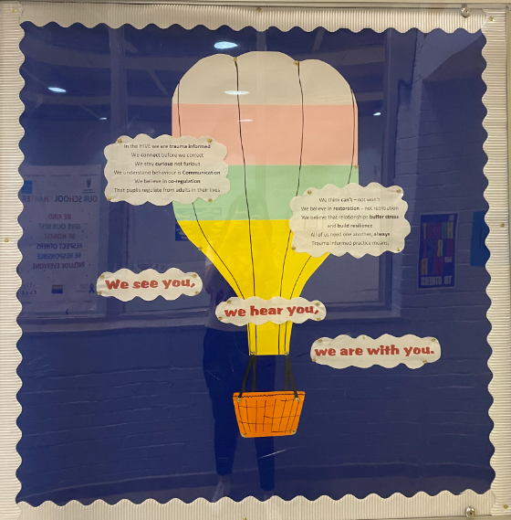

Knightswood Secondary School, Support for Learning ‘Hive’, is an area co-created by pupils where some young people access their learning. Young people who access the HIVE require additional support to ensure their emotional, social, mental and physical wellbeing rights are met.

Within the HIVE we aim to meet the needs of all learners and include everyone.

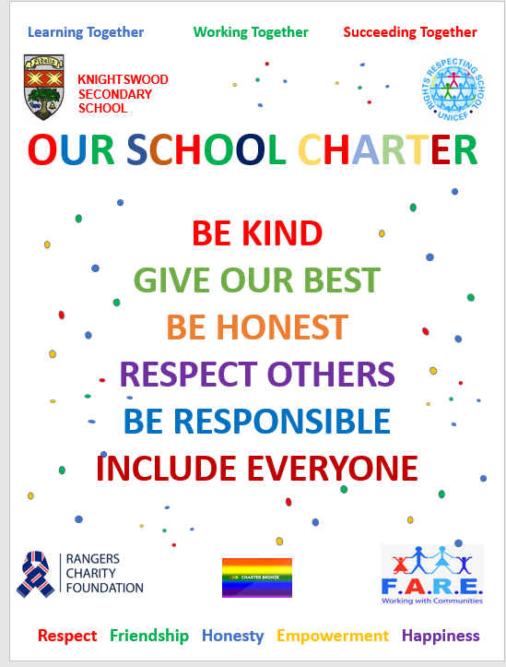

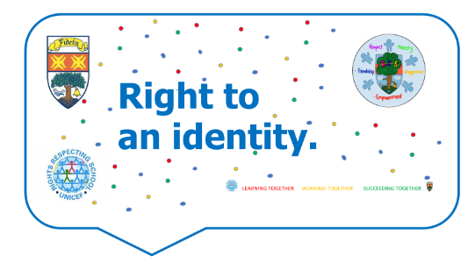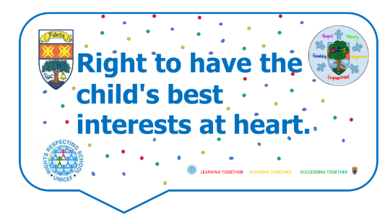The Right to…

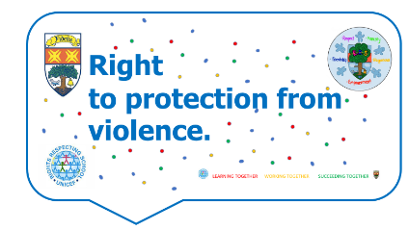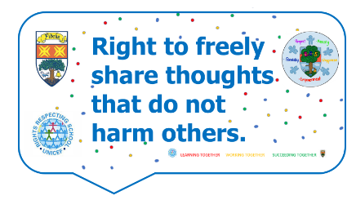

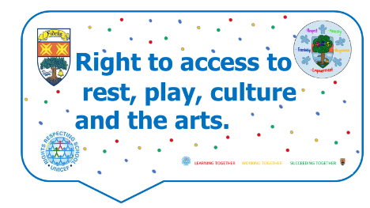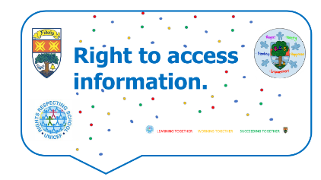

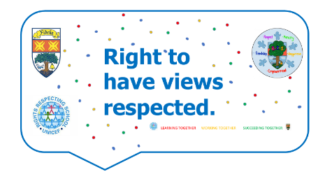

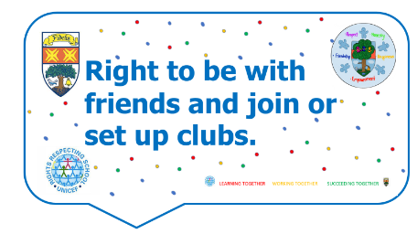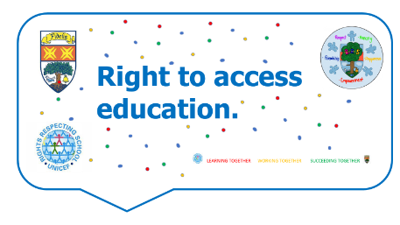

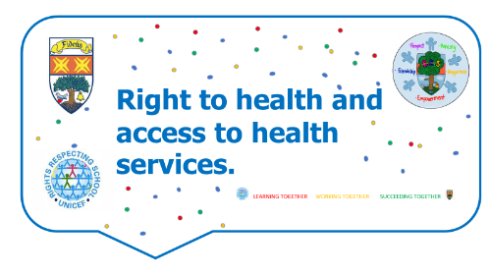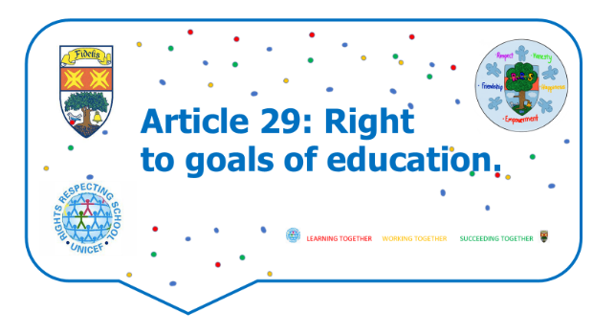

STAFF

|  |  |
| --- | --- |
| Mrs Gallagher | Principal Teacher |
| Mr Airdrie | Teacher |
| Mr Kay | Teacher |
| Ms Shepherd | Teacher |
| Ms Andrews | Support for Learning Worker |
| Mrs Archibald | Support for Learning Worker |
| Ms Connolly | Support for Learning Worker |
| Mrs Gorman | Support for Learning Worker |
| Ms Lai | Support for Learning Worker |
| Mrs MacArthur | Support for Learning Worker |
| Mrs McCammon | Support for Learning Worker |
| Ms McGill | Support for Learning Worker |
| Ms Pack | Support for Learning Worker |
| Mrs Rawat | Support for Learning Worker |
| Mr Stirling | Support for Learning Worker |
| Mrs Taleb | Support for Learning Worker |

In Knightswood Secondary School meeting the additional support needs of our young people is an inclusive, whole school approach. All teachers in the school are highly trained to meet the needs of the learners they work with on a daily basis where universal support is provided in all lessons. The HIVE offers more targeted support if required.

What you will experience in the HIVE

* Positive ethos/atmosphere
* Nurturing environment
* Highly trained/experienced staff (Teachers & Support for Learning Workers)
* Support/strategies to self-regulate
* Targeted support
* Your voice matters (pupil & parent/carer)
* Solution focussed outcomes
* Monitoring and tracking - aspirations for young people
* Assessment Arrangement consultation

SfL plays an integral role with all stakeholders which is inclusive of parent/carer support, primary transitions and working closely with all external agencies to ensure that our young people are at the core of any decisions made.

|  |  |
| --- | --- |
| **POLICIES AND PROCEDURES** | |
| 1 | Young person is identified/referred via:   * Primary Transitions * KIIM * SIIM * Parent * Self-Referral * SLT/PTPC/Teacher |
| 2. | Young person is supported according to their level of need:   * Nurture * Literacy & Numeracy * ASC * Anxiety * LIAM * Seasons * Drop in * Timetabled * One to one |
| 3. | All stakeholders informed:   * Pupils * Parents/carers * Teachers * External agencies |
| 4. | Process   * Pupil informed * Parental/carer letter sent home * Staff informed by email * KSS support spreadsheet update * Pastoral notes update * SEEMIS update |
| 5. | Evaluation   * Self-evaluation * Parent/carer evaluation * Focus groups * Glasgow Motivational & Wellbeing Profile * Educational Psychologist * Glasgow Dyslexia Support Service |
| **AUTISM SPECTRUM CONDITION (ASC)** | |
| Also known as Autism Spectrum Disorder (ASD), is neuro diversity within the brain. It can affect more than 1 in 100 people. Children and young people with ASC can have a different way of understanding the world around them. ASC means some people learn, communicate and socialise in different ways.  **ASC Groups (targeted support)**   * Pupils, parents, teachers informed * Small groups of 8 * 2 members of staff * Sessions 6 – 8 weeks * 1 period per week * Safe space * Organisational skills * Communication skills * Sensory space * Understanding of self * Parent/carers group     **Universal support**   * Teachers know pupil * Safe space in classrooms * Staff using ASC friendly strategies   Feedback from the recent ASC groups:  I liked the banter and the tasks  I want 3 periods a week  I made friends  Felt included & safe  Want to go on trips  **Useful links:**  <https://www.autism.org.uk/>  <https://www.scottishautism.org>  <https://www.mind.org.uk> | |

|  |
| --- |
| **DYSLEXIA** |
| ***Scottish Government Definition of Dyslexia***  Dyslexia can be described as a continuum of difficulties in learning to read, write and/or spell, which persist despite the provision of appropriate learning opportunities. These difficulties often do not reflect an individual’s cognitive abilities and may not be typical of performance in other areas.  **How do we assess for dyslexia?**   * Pupils, parents/carers and teachers can request an assessment * SfL make contact for an initial assessment (Pearson’s) * If there is evidence we carry out more assessments, gather evidence and contact parent/carer for more information * Report is written based on the above evidence * Link with GDSS for confirmation   **Post Diagnosis Support (targeted support)**   * 4-week group session * Course explores what is dyslexia and how does it affect me? * Session explores use of time, organisation, communication * Developing self confidence * Support techniques * iPad accessibility features * Potential exam support   **Universal support**  Teachers in Knightswood Secondary School use techniques and resources to support all dyslexic learners in their classes. All staff are aware of learners needs and use identified dyslexic support strategies to maximise pupil success.  **Useful links:**  [Glasgow Dyslexia Support Service (gdss.glasgow.sch.uk)](http://www.gdss.glasgow.sch.uk/)  [Dyslexia Scotland Dyslexia Scotland - Empowering people with dyslexia to reach their full potential](https://dyslexiascotland.org.uk/) |
| **EXAM SUPPORT** |
| At Knightswood we are dedicated to ensure all learners are supported to achieve their  full potential.  These guidelines are based upon the Glasgow City Council document: Assessment Arrangements Supporting the SQA Quality Assurance Process in Glasgow Schools.  We aim to:   * Support KSS pupils and staff in using the assessment arrangements that are approved by the SQA for those candidates identified as having Additional Support Need(s) and/or disability. * Consider evidence of an additional support need where an assessment arrangement is required. * A robust quality assurance process throughout * Provide pupils, parents/carers and staff with documentation support assessment arrangements.   Subject specific teachers provide evidence to Support for Learning and arrangements are agreed upon based on evidence and meetings with PT/FH and DHT.  Pupil, families and staff are made aware on any assessment arrangements throughout SQA exam periods and provide feedback on their experience.  Within the BGE phase, where appropriate, pupils who may receive an additional assessment arrangement are given the opportunity to hone these skills throughout classroom assessment periods.  **Useful links:**  [P:\Departments\SfL\AAA\Glasgow policy.docx](file:///P:\Departments\SfL\AAA\Glasgow%20policy.docx)  [Assessment Arrangements Toolkit - SQA](https://www.sqa.org.uk/sqa/100580.html) |
| **IMG_9458.jpg**  **NURTURE** |
| In Knightswood Secondary School we aim to ensure all young people feel nurtured, valued and safe. We practice nurturing approaches across our school community.  **Universal Nurture**   * Pupils welcomed to departments * Positive ethos * Safe spaces in classrooms   IMG_9457.jpg  **Targeted Nurture (HIVE)**  Where some young people are struggling with personal issues we know they may need the extra support in a Nurture Group. Children may need support in a Nurture Group for a variety of reasons; anger, communication skills, withdrawn etc.  Targeted Nurture Groups involve:   * S1 and S2 groups * 6-8 pupils per group * 2 members of staff * 3 periods per week   If your child is invited to participate in a Nurture Group, parents/carers are key partners and will be involved in their children’s education in order to fully support the child and measure their success. All targets set will be shared with pupils, families and staff to ensure we can support each individual across the school.  **Our Nurture Groups views:**  IMG_9460.jpgIMG_9461.jpg  If you would like more information on Nurture within Glasgow City council access the link below:  <https://www.glasgow.gov.uk/article/18943/Nurture>  <https://blogs.glowscotland.org.uk/glowblogs/glasgowpsychologicalservice/nurture/> |
| **TARGETED SUPPORT** |
| Our dedicated team of Support for Learning Workers target pupils across the BGE phase. They support them with their learning across curricular areas and offer an extra layer of universal support within the classroom environment.   * In class support * Small group for literacy and numeracy * 1-1 support * Small group in the HIVE * HIVE support * Support with assessments * Safe space * Re-integrate pupils back into classes   All targeted support undergoes a robust quality assurance process through internal systems such as the KIIM and meetings with Depute Head Teacher and PT Pastoral Care. These meetings ensure the individual needs of young people are continually reviewed and supports put in place.  Pupils, parents and staff are aware of any targeted support and work together to improve the teaching, learning and wellbeing of young people.  **Our pupils’ views:**   * **Out of 65 young people asked, 100% of them feel safe when in the HIVE** * **Out of the 65 young people asked if they felt the HIVE helps them, 100% of them gave positive feedback.**     **Useful links:**  <https://www.gov.scot/policies/girfec/> |
| **PRIMARY TRANSITIONS** |
| Alongside DHT, PTPC and a range of other stakeholders the SfL team are involved in the whole transition process from Primary to Secondary School.  We start gathering information required to ensure appropriate support in KSS at their early stage of Primary School. As they progress to their later Primary School experience, SfL teachers visit the Primary teachers to gather all information regarding upcoming pupils.  Support for Learning Workers visit all feeder Primary Schools at various stages throughout Primary 7 to build positive relationships with pupils and can become a friendly face when they arrive at Knightswood Secondary School.  Information is gathered and, where appropriate, this information is then disseminated to staff within the school to provide the necessary support to individual pupils.  **Enhanced Transition**  Some pupils may find the transition to secondary school more challenging and they will be identified by parents/carers and Primary teachers. All information is passed to KSS and enhanced transition visits are arranged for these learners who may benefit from attending during quieter times within a smaller group setting.  If your child is identified as benefitting from this the Primary School will notify you.  If you have any questions regarding transition periods please contact Primary/Secondary School office. |
| **READ, WRITE INC.** |
| Read Write Inc is a targeted reading recovery programme for pupils who have gaps in their literacy.  Pupils are identified and assessed in Primary 7 and the first few weeks of S1. A graded spelling test and a Single Word Reading Test (SWRT) are used to assess their reading ages.  RWI   * Assessment to decide starting module * Parents informed * 33 modules (can start at various module levels) * 3 periods per week in the HIVE * Small class size * Different story each week * Increase confidence in literacy * Target phonological awareness, spelling, comprehension, punctuation, grammar * Improve reading ability   Universal support by subject teachers   * Reading aloud for class * Introducing new vocabulary/words * Using ‘jump in’ technique * Using fingers to count out spelling/sounds * Chunking work * iPad accessibility features |
| **RECIPROCAL READING** |
| Reciprocal reading is another targeted support for literacy. Pupils are identified after Single Word Reading Test (SWRT) and consultation with staff. This support aims to provide pupils with the opportunity to develop their confidence and comprehension with their literacy skills.  Reciprocal reading (targeted support)   * SWRT and Suffolk tests to identify reading age * Pupils, parents and staff informed * Small groups of 4 and 1 adult * In the HIVE * 1 period per week * Approximately 8 weeks long * Different roles (summarising, clarifying, questioning and predicting) * Structured and discussion based   Universal support by subject teachers   * Reading aloud for class * Introducing new vocabulary/words * Using ‘jump in’ technique * Using fingers to count out spelling/sounds * Chucking work * iPad accessibility features   **Useful links**  <https://fft.org.uk/literacy/reciprocal-reading> |

|  |
| --- |
| **SEASONS FOR GROWTH**  In the HIVE we offer a programme called Seasons for Growth. Seasons for Growth is designed to help young people learn the knowledge, skills and attitudes required to understand, cope and respond to significant events in their life such as death, separation, divorce or other significant changes.  Seasons for Growth   * Pupils identified through consultation with PTPC and DHT’s * Pupils, parents and staff informed * 8 weeks long * 1 period per week * 4 – 7 pupils * 2 trained members of staff (companions) * In the HIVE * Safe space * Confidential programme   Pupil Views:    **Useful links:**  [Seasons for Growth](https://www.seasonsforgrowth.org.uk/) |

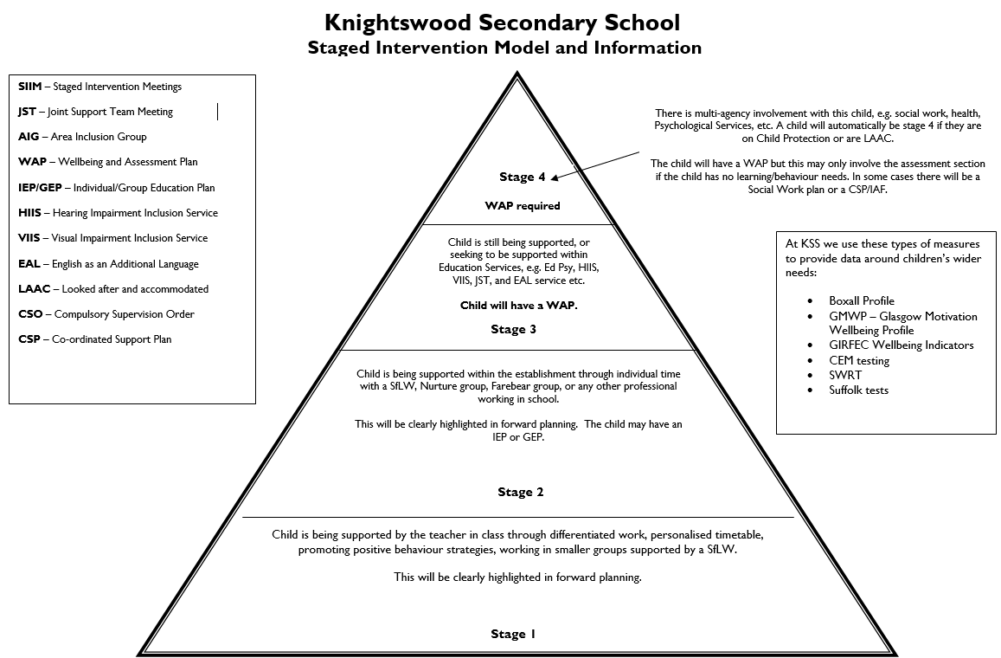

|  |  |
| --- | --- |
| ACRONYM HELP SHEET | |
| ADHD | Attention Deficit Hyperactivity Disorder |
| AIG | Area Inclusion Group |
| ASC | Autism Spectrum Condition |
| ASN | Additional Support Needs |
| CE | Care Experienced |
| CEM | Centre for Educational Measurement |
| CPC | Child Protection Coordinator |
| CPL | Continuing Professional Learning |
| CSO | Compulsory Supervision Order |
| CSP | Co-ordinated Support Plan |
| DIP | Departmental Improvement Plan |
| DYS | Dyslexia |
| ED PSY | Educational Psychologist |
| EAL | English as additional language |
| FAS | Fetal Alcohol Syndrome |
| FSM | Free School Meals |
| GDSS | Glasgow Dyslexia Support Service |
| HISS | Hearing Impairment Inclusion Service |
| IEP/GEP | Individual/Group Education Plans |
| IHP | Individual Healthcare Plan |
| JST | Joint Support Team Meeting |
| KIIM | Knightswood Intervention and Inclusion Meetings |
| PT | Principal Teacher |
| PTPC | Principal Teacher of Pastoral Care |
| RWI | Read, Write Inc |
| SEBN | Social, Emotional, Behavioral Needs |
| SfL | Support for Learning |
| SI | Staged Intervention Triangle |
| SIIM | Staged Intervention Meetings |
| SIMD | Scottish Index Multiple Deprivation |
| SIP | School Improvement Plan |
| SLT | Senior Leadership Team |
| VIIS | Visual Impairment Inclusion Service |
| WAP | Wellbeing and Assessment Plan |
|  |  |