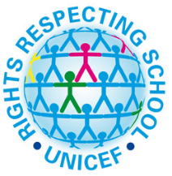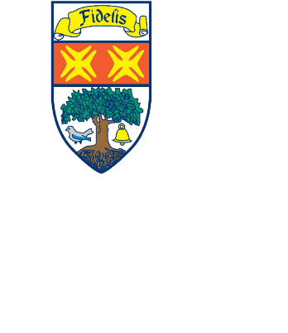Supporting Fasting During Ramadan

12th April – 12th May 2021



Young people at Knightswood Secondary will be able to access a separate space for prayer, reflection and fasting during intervals and lunchtimes over the period of Ramadan.

These will be supervised classroom spaces as below:

S14 – boys area

S15 – girls area

Please speak to your Pastoral Care teacher if there are any further supports or adjustments that you may need.

For information about Ramadan, watch the videos linked below:

<https://www.bbc.co.uk/newsround/23286976>

<https://www.youtube.com/watch?v=YUJYEGAt4cQ>

*UN Convention Child’s Rights #14 Freedom of thought and religion*

*UN Convention Child’s Rights #30 Minority culture, language and religion*