Mental Health Bulletin – October 2022
Monday 6th October is World Mental Health Day. The theme is ‘Make mental health and wellbeing for all a global priority’.
We plan to have some events running in school in the month of October which have a focus on positive mental health and well-being.
Year Group | Activity | Details
S1 | Outdoor learning and team-building day  Pastoral Care ‘Settling In’ Meeting | All pupils will be out of school for a day of outdoor learning at Kelvingrove Park and Art Galleries followed by team building sessions.  All young people will have a 1-2-1 meeting with their Pastoral Care teacher.
S2 | Reflective Space | All pupils will attend a reflective space period which will focus on mindfulness and reflection.
S3 | Blues Programme | Action for Children will lead an assembly with all S3 pupils to outline this support programme.  Pupils will participate in a screener which will help to identify those who will participate in further sessions from Nov-Dec.
S4 | Anxiety and Stress Management workshop | All pupils will participate in a workshop during PSE time. This will be delivered by our Health and Well-Being Support Officer.
S5/6 | Action for Children Workshop | Action for Children will lead an assembly with all S5/6 pupils.

Supports at KSS:
There are a number of supports at KSS which are available for all young people including:
- Personal and Social Education (PSE) programme to raise awareness and signpost to universal supports
- Principal Teacher of Pastoral Care (PTPC) support: 2 periods of contact with PTPC weekly
- Year Group Head (YGH) support
In addition, young people can access the following targeted supports:
- Action for Children counselling
- Health and Well-Being Support Officer (therapeutic support)
- Nurture Group
- Group work – Farebear Youth Workers
- Group work – Glasgow Life
These supports would be discussed with a young person and their PTPC in the first instance.

Well-being indicators:
All young people have participated in lessons focussing on the well-being indicators known as SHANARRI indicators. The well being web below will be completed several times a year and the information gathered will help us to identify any supports that your young person may need.
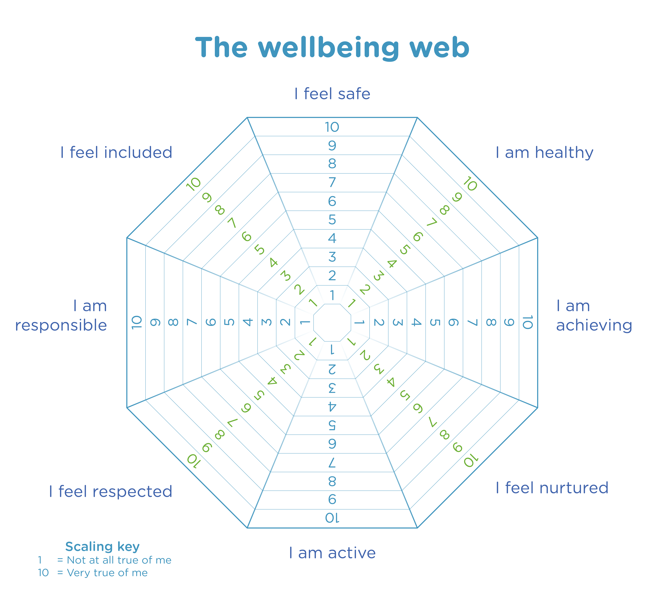

Supports for parent/carers:
Some excellent supports for parent/carers are linked below:
https://www.place2be.org.uk/our-services/parents-and-carers/
https://www.youngminds.org.uk/parent/
https://sleepscotland.org/
https://www.mentalhealth.org.uk/our-work/programmes/families-children-and-young-people/resources#:~:text=Education%20Support%20%E2%80%93%20Education%20Support%20provides,you%20immediate%2C%20confidential%20emotional%20support.

Future plans:
A staff Mental Health and Well-Being Strategy Group has been established at KSS. We are hoping to progress with:
- KSS Mental Health and Well-Being Policy
- Pupil Mental Health Ambassadors
- A weekly reflective space for pupils

If you have any ideas or wish to become involved in any way, please complete the Microsoft form at the link below:
https://forms.office.com/r/UKpazRChJC

