Dear Parents and Carers,

As we move towards the October break I thought it would be a good time to update you with some things that have been happening during what has been a very busy and successful first term.

Our S1 young people all took part in team building days based at Kelvingrove Park area. This is part of their on going transition as they get to know staff and each other. Our S1 have settled very well and are already making a positive impact in our school.

We had a group of young people enjoy a visit to Loch Insh Outdoor centre and they had a great time! There is a group of S4 pupils heading off to Blairvadach for a study weekend which will also include the opportunity to have a go at some outdoor activities.

There is a new Captaincy Team in place and they have exciting plans for how they can help make our school better for all young people. We are excited to see them develop their ideas.

There are lots of extra-curricular clubs on offer. There are details at the end – please encourage your young person to take part in these.

**Parents evenings Session 2023 – 23**

It was lovely to meet so many S1 Parents / Carers at the “Meeting your PT PC” last month and look forward to welcoming you again on the 30th November 2023, 4.00pm – 6.00pm, for the S1 Parent / Carer Evening.

We use an online booking system and you will be sent a link to book your appointments with staff. The appointments will take place in the Assembly Hall and surrounding classrooms to try and minimise your movement around the school. We will have guides available to help you get about the school that evening.

|  |  |  |  |  |  |
| --- | --- | --- | --- | --- | --- |
| **Term** | **S1** | **S2** | **S3** | **S4** | **S5-6** |
| **Aug – Oct** | Meeting your PT PC 20th September 2023 3.30pm – 4.30pm |  | Interim report issued |  | Interim report issued |
| **Oct – Dec** | Parent / Carer30th November 4.00pm – 6.30pm | Interim Report Issued  S2 & S4-5 Pathways Information Evening 5th December 2023 | Parent / Carer Evening  14th November 2023 4.00pm – 6.30pm | Full report issued  S2 & S4-5 Pathways Information Evening 5th December 2023  Prelims 11th – 22nd December 2023 | Full report issued  S2 & S4-5 Pathways Information Evening 5th December 2023  Prelims 11th – 22nd December 2023 |
| **Jan – Mar** | Interim report issued | Full report issued  Parent / Carer Evening 28th February 4.00pm – 6.30pm |  | Interim Report issued  Parent / Carer Evening 8th February 2024 4.00pm – 6.30pm | Interim Report issued  Parent / Carer Evening 30th January 2024 4.00pm – 6.30pm |
| **Apr - Jun** | Full report issued |  | Full report issued  S3 Exams |  |  |

**Prelims and SQA Exams**

Thank you to the parents / carers who attended our Exam Success Workshops in September where we shared information about how you can support your young people as they prepare for SQA exams. Young people are being supported in Social Education to formulate their study plans and are getting advice on various study techniques. Our Health and Wellbeing officer is also providing hints and tips on how to manage stress as young people prepare for their prelims.

Our prelim diet this year will run from 11th December – 22nd December 2023 inclusive. SQA Exams are scheduled to start on Monday, 22nd April and finish on Wednesday, 29th May 2024. You will find the SQA timetable here [2024 Exam timetable revision 4 031023.indd (sqa.org.uk)](https://www.sqa.org.uk/sqa/files_ccc/nq-2024-exam-timetable.pdf). It should be noted that there are exams scheduled on the May holidays.

**Supported Study**

Our programme of Supported Study is currently underway and started in September. Details will be emailed directly to young people via Glow and shared with Parent / Carers via Groupcall. Please encourage any young person in S4-6 to attend these sessions.

**Behaviour in the community**

Almost all of our young people behave extremely well and are ambassadors for our school in the local community. We regularly get emails and are stopped by local residents when we are the community at interval and lunchtime complimenting them on their behaviour. However, we do occasionally receive complaints about the behaviour of a small minority of our young people at lunchtime and at the end of the school day. These have included littering as well as throwing objects at vehicles and disrespectful behaviour on public transport. We continually re-enforcing the responsibilities of our young people when they are out in the community through assemblies and PSE lessons.

Our Campus Police Officer leads our S2-3 young people on twice weekly litter picks ensuring that we are playing our part in keeping our community tidy and the local residents do appreciate their efforts.

**Pastoral Care Staff**

Your young person sees their Pastoral Care Teacher twice a week in Personal and Social Education and they know your young person really well. If you have any questions then their Pastoral Care Teacher is ideally placed to answer these and should always be your first point of contact with the school.

Arran – Mrs. McLelland / Ms DiRollo Bute – Mr. Deveny Harris – Mrs. Schimmel

Islay – Mrs. Whelehan Skye – Mr. Shields Tiree – Mrs. Gray

**Parent / Carer Council**

Thank you to the Parent / Carers that can along to our first meeting. We agreed dates for the session and we are looking for new members to join our Parent / Carer Council. This is open to all parents / carers who have young people in Knightswood Secondary School.

|  |  |
| --- | --- |
| **Date** | **Theme** |
| 22nd November 2023 5.45pm – 6.45pm | School Improvement Plan, PEF & Learning & Teaching |
| 25th January 2024 5.45pm – 6.45pm | The role of Pastoral Care |
| 18th March 2024 5.45pm – 6.45pm | Supporting young people with Additional Support Needs |
| 14th May 2024 5.45pm – 6.45pm | School Improvement Plan for next session |

**What is the role of the Parent Council?**

The Parent Council helps to create an environment where all parents know that their views matter, and where they feel confident and comfortable putting them forward. They work on behalf of all parents to discuss educational matters that are of importance to all. They do not get involved in individual circumstances relating to children or staff in the school.

Thank you again for your continued support.



Maura McNeil

Head Teacher

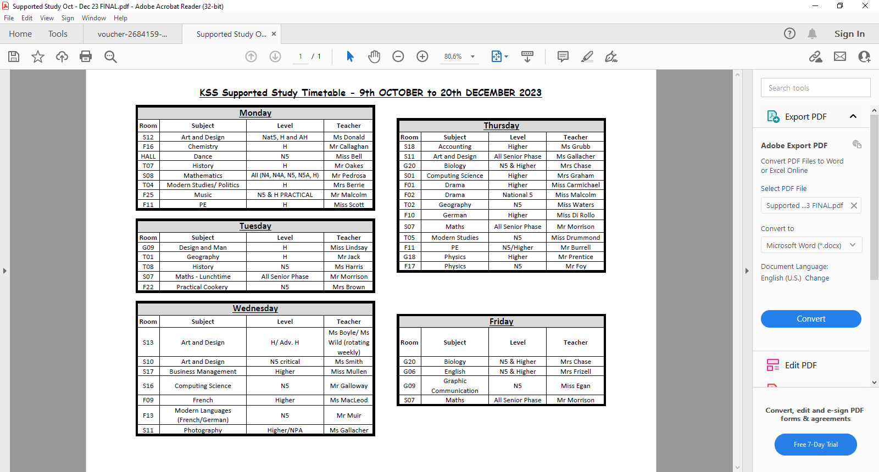

**Knightswood Secondary School – Extra curricular activities**

|  |  |  |  |  |
| --- | --- | --- | --- | --- |
| **MONDAY** | **TUESDAY** | **WEDNESDAY** | **THURSDAY** | **FRIDAY** |
| **LUNCH** | **LUNCH** | **LUNCH** | **LUNCH** | **LUNCH** |
| S1-3  **BGE DANCE**  Every Monday 1.15-1.45PM ***Location***: PE Gym 3  S1-6  **Monthly Newsletter** Mrs Frizzell  ***Location:*** English Base  S1-6  **EAL Buddy Club** Mrs Morgan ***Location***: F20  S1-S6  **School Orchestra**  Music Department | S1-6 **Set and Costume Design** Ms Gallagher ***Location***:S11  S1-6 **Coding Club** Mrs Graham  ***Location:*** S01  S1-6 **Chess Club** Senior PupilEvery Tuesday and Thursday Lunchtime ***Location:*** Library | S1-6 **Debate Club** Ms Teasdale/Mr Airdrie  ***Location:*** G06  S1-6 **Well-Being Drop In** Miss Di Rollo ***Location*:**F10  S1 **Craft Club *Location:*** G12 | S1-6  **Chess Club**  Senior PupilEvery Tuesday and Thursday Lunchtime ***Location:*** Library  S1-S6  **String Assemble**  Music Department | S1-6 **Running Club** Every Friday **7.30am-8.15am *Location*:** PE Base |
| **MONDAY** | **TUESDAY** | **WEDNESDAY** | **THURSDAY** | **FRIDAY** |
| **AFTER-**  **SCHOOL** | **AFTER-**  **SCHOOL** | **AFTER-**  **SCHOOL** | **AFTER-**  **SCHOOL** | **AFTER-**  **SCHOOL** |
| S1-6  **Garden and Painting Club** Ms Gallagher ***Location***:S11 | S1-3  **Drama Club** Mr AirdrieEvery Tuesday 3.30-4.30pm ***Location:*** Drama Studio | S1-6  **Netball** Every Wednesday3.30-4.30PM ***Location***: PE Gym Hall  S1-6 **Set and Costume Design**  Ms Gallagher ***Location*:**S11 | S1-6 **FAREBEARS**  **Fitness** ***Location***: Fitness Suite  S1-6 **FAREBEARS**  **Football**  ***Location***: PE ASTRO  S1-6 **FAREBEARS** **Badminton**  ***Location***: PE Gym Hall  S1-6 **Film Club** Mr Airdrie ***Location:*** F23 | **Boxing Club**  ***Location***: PE Dept |